John Hankinson
Plasma: Shooting the Sun into Trash
In the near future the world and especially the United States must address the growing problem of waste disposal. In 2001 the United States generated over 220 million tons of municipal solid waste (EPA OSW 15). This number does not include industrial and other wastes which brings the total to about 8 billion tons of waste a year (texasep.org). Of the 220 million tons of MSW, which seems to be the most closely studied form of waste, “68.0 millions tons (29.7 percent) of MSW were recycled, 33.6 million tons (14.7 percent) were combusted, and 127.6 million tons (55.7 percent) were landfilled or otherwise disposed” (EPA OSW 15). While recycling is a good method for waste disposal, it can only go so far, and landfills and incineration have significant negative impacts on the environment. Some long term solution for waste disposal is clearly needed. The development of plasma torch technology for waste disposal seems to be a promising long term solution for our waste management issues.
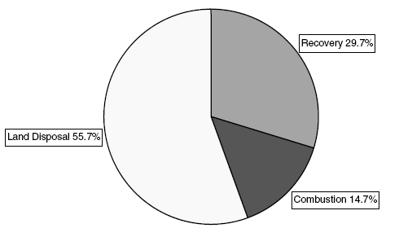
Figure 1: Management of MSW in the U.S. – 2001, obtained from an EPA report titled Municipal Solid Wastes in the United States: 2001 Facts and Figures.

Landfills:
Currently over half of our nation’s waste is landfilled. This is a serious problem as landfills have a number of detrimental effects on the environment. The main problem with landfills is leakage and the ensuing ground water contamination from this leakage. In an attempt to prevent leakage, modern landfills in the United States are designed with plastic liners and or compacted clay liners as well as groundwater monitoring systems. However Dr. Lee, author of several environmental studies regarding landfills, points out that the so called “dry tomb” method of landfilling is fundamentally flawed and will eventually lead to leakage and ground water contamination (“Solid” 1). First of all the plastic liners often have small pinholes created during manufacture as well as holes along the seams of sheets that have been welded together to form the liner (Montague #92). Also polyethylene, the material of choice for the liners, tends to become brittle and crack over time (Montague #92). Dr. Lee and Dr. Jones state that “while the long-term stability of geomembranes (flexible membrane liners) in landfills cannot be defined, there is no doubt that they will eventually fail to function as an impermeable barrier to leachate transport from a landfill to groundwater. Further, and most importantly at this time, there are no test methods, having demonstrated reliability, with which to evaluate long-term performance of flexible membrane liners” (Lee and Jones “Municipal” 22). Hence even if the liners are manufactured properly they will still eventually fail, effectively passing on our environmental problems to future generations to deal with. Using compressed clay as a liner will also only act as a temporary solution as various weather conditions and chemical reactions from the landfill contaminants will eventually wear down this barrier (Montague #92). Another problem is that the design of the leakage monitoring system is aimed toward detecting wide spread leakage and will likely not detect leakage from lined landfills since the tears, cracks, and holes in the plastic liner will lead to more concentrated plumes of contaminated leachate that will pass into groundwater undetected (Lee and Jones-Lee “A Groundwater”). Hence precious groundwater may be contaminated to the point where it is permanently destroyed by contaminants before the problem is detected (Montague #92).
While contaminated groundwater is a huge problem, landfills have a number of other negative effects. For one they are not attractive and smell. This leads to a devaluation of all of the property in the nearby area. Also landfills are often built in poor or minority communities as people in wealthier areas are often able fight the construction of a landfill in their area due to their economic and political assets. This system is not just as poor and minorities are forced to share an unfair burden of negative impacts of waste while the wealthy are in general creating more waste per capita. Landfills also release harmful gases such as methane and several known carcinogens into the air, creating health risks for those living in close proximity to the landfills (Lee “Solid” 9-10). Landfills also waste land that could otherwise be preserved in a natural state or used for residential, commercial, or industrial purposes. Overall one can see that landfills are not a good long term or even a good short term solution to waste management.
Incinerators:
Incinerators burn waste in an attempt to reduce the mass and volume of waste that must be landfilled. However waste is not magically destroyed through this process, rather it is converted into toxic ash and dangerous air emissions. Peter Montague lists off some of the carcinogenic and toxic chemicals released in incinerator emissions “including heavy metals (such as arsenic, lead, cadmium, mercury, chromium and beryllium); acid gases, including hydrogen fluoride; partially-burned organic material such as polyvinyl chloride (PVC), herbicide residues, and wood preservatives; other organic chemicals, including polycyclic aromatic hydrocarbons (PAHs); and dioxins and furans” (#592). In fact incinerator emissions are the leading source of atmospheric dioxin emissions. Dioxins, which several sources claim are the most toxic chemicals know to science, have been linked to a number of health problems including cancer, reproductive problems, developmental problems, birth defects, inability to maintain pregnancy, decreased fertility, reduced sperm counts, endometriosis, diabetes, learning disabilities, immune system suppression, lung problems, skin disorders, and lowered testosterone levels (ejnet.org). Hence the atmospheric emissions of conventional incinerators are a great cause for concern.
Other than these emissions, incinerators have the problem of creating ash equal to 25% or more of the original waste by mass (around 10% to 20% by volume). This ash also contains several toxic chemicals, including dioxins, as well as heavy metals. A 1988 Rutgers study concluded that in a 2000 ton-per day incinerator the total daily ash (around 500 tons per day) will contain 2935 pounds of lead, 48 pounds of chromium, 61 pounds of cadmium, and 97 pounds of arsenic (Montague #92). Extrapolating this out to a year (operating 5 days a week, 52 weeks a year), shows that such an incinerator will put out 12,610 pounds of chromium, 15,990 pounds of cadmium, 25,246 pounds of arsenic, and about three quarters of a million pounds of lead (Montague #92). This is very disconcerting as these are all metals that are toxic in microgram quantities. Despite the health risks of incinerator ash, incineration companies have fought hard to avoid having the ash classified as hazardous waste, which is more expensive to dispose of. Because of this the ash is dumped into standard landfills where its toxins will be able to seep into the groundwater.
Changing Waste Management:
Fortunately the public is becoming aware of the problems with incineration and several grass roots efforts have slowed the expansion of the incineration industry. In fact from 1982 to 1990, 248 incinerator projects were cancelled compared to a total of 140 plants operating in 1990. Also a 1990 EPA estimate claimed that by the year 2000 the United States would be incinerating 26% of its solid waste, but as mentioned earlier our current percentage of MSW being combusted is 14.7%, considerably lower than the 1990 estimate. Landfilling has also begun to slow in recent years due to the increase of recycling as an alternative for waste disposal, as can be seen in figure 2. These trends are promising in that they show that the public is interested in finding alternatives to the environmentally detrimental waste disposal methods currently in use. Unfortunately recycling can not deal with 100% of our waste due to as it may not be economically feasible or may not be feasible from an energy standpoint to recycle certain products, and due to the fact that it is often difficult to get the public to put in the extra effort to recycle. Hence we need some environmentally friendly method of dealing with our excess waste. Many hope that plasma torches will be the solution.
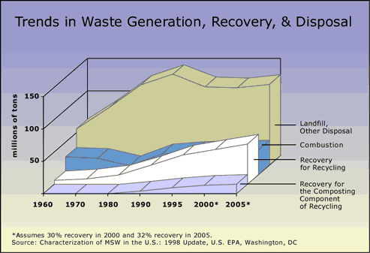
Figure 2: Trends in U.S. methods of dealing with MSW from 1960 to 2005. The levels for 2000 and 2005 are estimates assuming a 30% rate of recovery in 2000 and a 32% rate of recovery in 2005. The graph clearly shows the slowing of landfills and combustion for waste management as recovery for recycling has begun to pick up in recent years. Image obtained from http://www.zerowasteamerica.org/Statistics.htm

Plasma Technology:
Plasma technologies were widely developed in the 1960s by NASA in order to test heat shields. Plasma has also been used in various metallurgical processes. The torch works by creating an electric arc discharge between two closely spaced tubular electrodes. During the torch’s operation a process gas is injected between the electrodes while the arc is magnetically rotated at extremely high speeds. The high rotational speeds and high gas flow rates allow excellent heat transfer between the arc discharge and process gas, causing the gas to reach extreme temperatures of up to 10,000°C (Startech claims temperatures up to 30,000°F, average temperatures for waste processing would be lower than either) before exiting the torch (Westinghouse plasma). This process can be seen in figure 3. It is important to note that at no time is the process gas actually burned, rather it is heated to the point where the gas ionizes and enters the fourth state of matter, plasma. During use the torch components are water cooled in order to prevent them from melting under the extremely high temperatures of the plasma. Even with the water cooling the electrodes must be changed after every 200 to 1000 hours of use (depending on the torch and operating temperatures). However, this is a relatively easy and inexpensive 30 minute procedure. Today’s commercial torches operate on power levels ranging from 100kW to 10MW to cover a wide range of needs (“Plasma Arc…”).
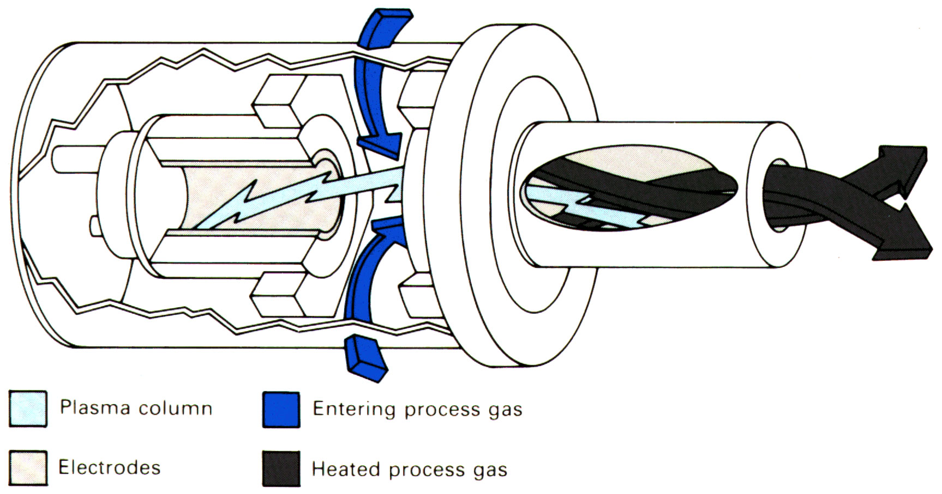
Figure 3: This depicts the process occurring within the plasma torch. The black lines (heated process gas) represent the plasma that exits the torch and is used to melt the waste. Image taken from http://www.westinghouse-plasma.com/

While this torch is running, waste is fed into a chamber with the plasma through a pump, screw feeder, or ram feeder. The chamber is lined with insulation and refractory materials in order to minimize heat loss and protect the walls from melting. Within this chamber, the extremely high temperatures cause the molecular bonds of the waste product to break down. This is fundamentally different than burning in which the products become oxidized. Precise amounts of oxygen can be added to create certain gaseous products but the actual pyrolysis does not require oxygen. Two main products are formed, a molten slag which hardens into obsidian-like stone and synthetic gas composed primarily of hydrogen and carbon monoxide. Figure 4 shows a breakdown of the potential inputs and outputs of a plasma processing plant.
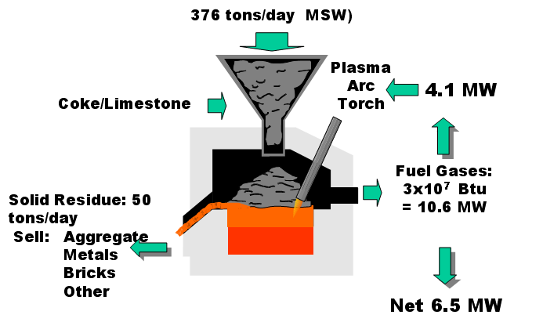
Figure 4: This shows the Georgia Tech Research Institute’s vision of how a plasma waste processing plant could break down waste and produce beneficial byproducts as well as be a net generator of electricity. Image courtesy of Sr. Research Advisor Kevin Caravati and Dr. Louis Circeo of GTRI.

Byproducts:
The volume of the slag will be approximately 250 times less than that of municipal waste that has been processed and a weight equivalent to about one ninth of the original weight (usplasma.com). More importantly the slag is non-toxic and has potential commercial uses, so it does not have to be landfilled. One potential concern is heavy metals that remain after the vitrification process; however the molten solid will be layered with a glassy silicate layer on top and the metals forming a layer on the bottom. These metals can be extracted and used for commercial applications or properly disposed of depending on the quantity and type of metal obtained. Any metals contained within the glassy silicate will pose no threat as the rock is non-leachable, so the metals will not be able to escape into the environment. The commercial uses for the glassy silicate include gravel, road fill, or potentially rockwool.
Rockwool is a very exciting potential use for the glassy byproduct. Rockwool is normally produced by melting down stones and then spinning the molten product into thin fibers. These fibers can be spun into a wool-like fleece and used for a variety of purposes. The exciting thing about creating rockwool at a plasma processing plant is that molten rock is simply a byproduct of the process; a great deal of the production process has already been done during the waste processing. One of the main uses for rockwool is insulation. It can be blown into walls or compressed into more solid board type forms and used for residential or industrial insulation. The composition of rockwool is such that it is very fire resistant and makes it ideal for insulating any industrial equipment or piping that reaches very high temperatures (rockwool.co.uk). Another exciting use for rockwool is for growing plants. It may sound strange, but rockwool is able to retain a great deal of air and water to supply to plant roots, and hence provides an excellent medium for plants to grow in (simplyhydro.com). One of the barriers to the widespread use of plasma waste processing for conventional waste is making it economically competitive with landfills and incinerators. Marketable byproducts such as rockwool would help increase revenues of a plasma plant and help speed the expansion of this technology.
The other byproduct of the process, as mentioned before, is synthetic gas or syngas.
After exiting the plasma chamber any acid gases are neutralized and particulate matter is removed through use of a cyclone and wet scrubbers (startech.com). The spinning of the gas in the cyclone causes the heavier particulate matter to be flung into the walls of the chamber and drop to the bottom while the rest of the gas continues through the chamber (continuingeducation.com). The gas is also rapidly cooled as it exits in order to prevent the formation of dioxins, furans, and other unwanted gases (startech.com). The final clean syngas is composed primarily of hydrogen and oxygen and can be used as a fuel or used directly in several manufacturing processes such as methane production (peat.com). For a full breakdown of approximate syngas composition see figure 5. The energy that can be gained from the gas, from harnessing its high initial temperatures and by using it as a fuel, is more than enough to power the torch. This means that the torch can be self-sustained and even output power onto the grid. Also with the potential emergence of the hydrogen economy in the future, this syngas will provide a readily available source for hydrogen once technology for purifying the gas is further developed. Although some harmful emissions will likely be unavoidable, as a whole the negative environmental effects from a rockwool plant are greatly reduced when compared to a conventional incinerator.
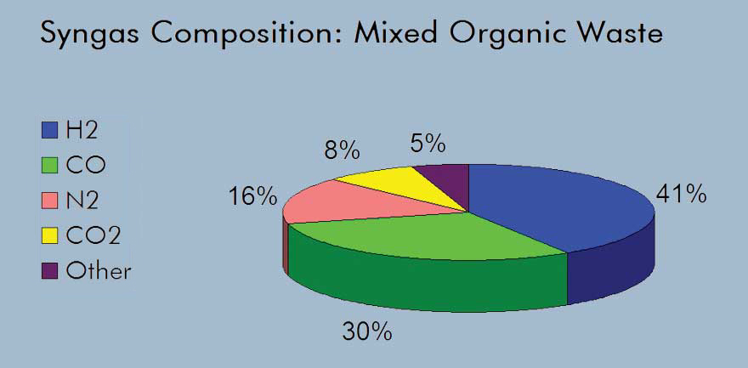
Figure 5: This figure shows the composition of the syngas produced from plasma processing of mixed organic waste. Image from http://www.peat.com/new/syngas.htm

Benefits of Plasma Technology:
Plasma has a great deal of benefits over incinerators and landfills. As discussed the solid byproducts of plasma are far superior to those of an incinerator as they do not need to be landfilled, are non-toxic, and are marketable. Plasma processing also has greatly reduced emissions when compared to incineration, and creates useful fuel gases for electricity generation. Its potential as a source of hydrogen will also be a major benefit if the hydrogen economy takes hold. Plasma processing plants are also nice in that they take a relatively small amount of land; a 1000 ton per day plant would only require about 10 acres of land, far less than that required by a landfill. Also from an economic standpoint, plasma plants offer well paying long term jobs to local citizens. Plasma also has the benefit in that it can be used for on site vitrification of waste or landfills. In addition plasma is ideal for destroying any hazardous waste as everything is irreversibly broken down. Any waste that may be diseased (such as dead animals) could be disposed of through plasma destroying the bacteria and potentially helping to contain the spread of the illness. As the technology takes off portable plasma torches may end up being used to melt down old landfills cleaning up the area and allowing something useful to be built in place of the landfill. Figure 6 depicts how a mobile torch could melt down a landfill into harmless slag.
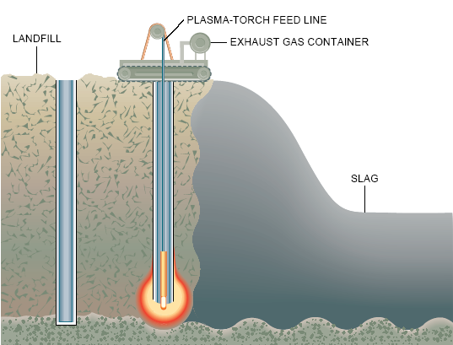
Figure 6: This shows how a mobile plasma torch could be taken to a landfill and used to melt it down. Image from “Garbage in, Gravel out.” Scientific American May, 1993.

Plasma Barriers:
With all of these clear benefits the main question remaining is why isn’t plasma being used today? The technology has existed for some time. The main problems are on the business end rather on the technological end. For one it is hard to convince investors to be the first to support a new technology. Fortunately a few companies such as Startech Environmental Corporation, Peat International, and US Plasma have begun developing plasma for commercial use in recent years. Another problem is that for standard waste it is still less expensive to place it in landfills or incinerate it. Scientific American states that “plasma can vaporize nonhazardous waste for about $65 a ton, whereas landfilling costs less than half that amount” (“Ultimate Incinerators” 180). However plasma vitrification of wastes is already less expensive than the rates for disposing of hazardous wastes and so the technology is beginning to find a market there. Also areas without much land such as Japan and Hawaii are looking into plasma as they must export their trash at high costs or waste valuable land on landfills. Japan already has some smaller plasma plants in operation. Hopefully in the near future research into marketable byproducts of plasma processing coupled with rising costs of landfills and incinerators will help close the gap on the cost for nonhazardous waste disposal throughout the country. Another problem in the U.S. is permitting for a new technology. Several governments are scared to be the first to allow this technology and want to see an operational plant somewhere in the U.S. before they will be willing to allow one in their community. This presents yet another barrier for this emerging technology as someone needs to let it in so that others will follow suit. Finally plasma is widely misunderstood by the public, and community groups have strongly opposed plasma waste processing plants in their area. People are fearful of something operating above the temperature of the sun near their home, and also associate it with many of the negative aspects of incineration. However plasma is safer than standard incineration in that it can be immediately shut off by turning off the electric power, and it has no where near the same level of negative environmental impacts. Hopefully as the technology expands businesses, governments, and the public will all better understand plasma and the benefits it has to offer and our society will be able to harness this technology as a solution to our growing waste problems.
References

“Air Pollution Control – Particulate Matter.” Continuing Education. <http://www.continuingeducation.com/engineers/airpollutionpm-2005/control_options.html>

“Dioxin Homepage.” EJnet.org. <http://www.ejnet.org/dioxin/>

EPA Office of Solid Waste and Emergency Response. <http://www.epa.gov/oswer/>

Gibbs, W. Wayt. “Garbage in, Gravel out.” Scientific American. May, 1993: 130.

Hawken, Paul “Resource Waste.” Mother Jones. March/April, 1997. <http://www.motherjones.com/news/feature/1997/03/hawken2.html>

Landes, Lynn. Zero Waste America. <http://www.zerowasteamerica.org/>

Lee, G. F. and Jones-Lee, A., "A Groundwater Protection Strategy for Lined Landfills," Environmental Science & Technology, 28:584-5 1994. <http://www.gfredlee.com/>

Lee, G. F. and Jones, R.A., “Municipal Solid Waste Management: Long-Term Public Health and Environmental Protection,” University of California, Davis Landfills and Groundwater Quality Short Course Materials, April 1991. <http://www.gfredlee.com/>

Lee, G. F. "Solid Waste Management: USA Lined Landfilling Reliability," An invited submission for publication in Natural Resources Forum, a United Nations Journal, New York, NY, December 2002. <http://www.gfredlee.com/>

Montague, Peter “#92 - New Study Shows Incinerator Ash More Dangerous Than We Realized.” Environmental Research Foundation Homepage. August 29, 1988. <http://www.rachel.org/bulletin/bulletin.cfm?Issue_ID=1053&bulletin_ID=48>

Montague, Peter #463 - Dioxin and Health.” Environmental Research Foundation Homepage. October 12, 1995. <http://www.rachel.org/bulletin/bulletin.cfm?Issue_ID=660&bulletin_ID=48>

Montague, Peter “#592 - Incineration News.” Environmental Research Foundation Homepage. April 02, 1998. <http://www.rachel.org/bulletin/bulletin.cfm?Issue_ID=526&bulletin_ID=48>

Peat International. <http://www.peat.com/>

“Plasma Arc Torch Technology.” Emerging Construction Technologies. <http://www.new-technologies.org/ECT/Civil/plasma1.htm>

Startech Environmental Corp. <http://www.startech.net/>

“The Ultimate Incinerators.” Scientific American. September, 1995: 180.

US Plasma Inc. <http://www.usplasma.com/>

Waste Not Table of Contents. <http://www.workonwaste.org/> Specifically I used articles 95, 315, 345, and 346.

Westinghouse Plasma Corporation. <http://www.westinghouse-plasma.com/>

A couple of bonus pictures of how a plasma plant runs:

