The Future of Ocean Thermal Energy Conversion

Physics 80
5/5/05
By Todd Taniguchi
Introduction
As the population of the world continues to grow and nations industrialize, so does the demand for energy. Energy demand means oil demand, which comes from the global economy and newly industrialized nations with rapidly growing economies, such as China and India. US demand is still rising, and, in this year alone, the Chinese demand for oil rose by 20% (BBC, 1). With oil prices rising and supplies peaking, OPEC is beginning to lose control over the price of oil (BBC, 1). The days of relatively cheap gasoline and fossil fuel power in the US appear to be numbered.
The United States’ energy portfolio must be diversified. Now, more than ever before, alternative energies have become an economic, social, and environmental necessity. The layout of this portfolio has not yet been set. As the United States pieces this together (hypothetically, this is not necessarily occurring), the costs and benefits of different types of sources must be considered. One of these energy sources is Ocean Thermal Energy Conversion (OTEC), which would tap a form of stored solar energy: the natural temperature gradient that exists between layers of the ocean. Some other sources of energy include wind power, solar photovoltaic cells, and geothermal energy. This paper will introduce the OTEC technology and attempt to determine the viability of OTEC as a part of a diversified energy portfolio for the United States. Criteria that will be examined are: the state of the art in OTEC power plants, economic viability relative to other energy sources, environmental impact, and large scale potential.

Section 1: An overview of OTEC
Historical Origins:
Modern heat engines are the base around OTEC systems are designed. Although the first steam engines were invented in 1698 by Thomas Savery, the development of today’s heat engines is given to James Watt, who improved the design of Thomas Newcomen (Avery and Wu, 53). Heat engines use thermal differences to produce mechanical or electrical energy. Many heat engines use the thermal energy from a heat source to create steam, which begins to flow through the system. The mechanical energy in the flowing steam spins a turbine, which turns this kinetic energy into electricity. So that the power generation can continue, the steam is converted back to liquid by transferring “waste heat” into a colder heat sink. In closed-system heat engines, this liquid is the working fluid that is re-evaporated at the beginning of its phase cycle.
The idea of OTEC was first proposed by the French engineer Jacques D’Arsonval in 1881 when he was studying the working fluids of low-temperature heat engines. D’Arsonval himself did not attempt to implement his theory, and until 1926, no attempts were made to utilize the ocean’s temperature difference (Avery and Wu, 54). The first attempt was made by D’Arsonval’s former student, Georges Claude, who attempted to use a modified approach to D’Arsonval’s original theory. Claude failed to produce net power production in his work, but he did prove that the technology could work to produce power (Avery and Wu, 56). The original method, proposed by D’Arsonval, is known as Closed Cycle OTEC (CC-OTEC), the second method, proposed by Claude, is known as Open-Cycle OTEC (OC-OTEC). While other methods for using the temperature gradient have been hypothesized, these two types of OTEC are the developed technologies closest to commercial feasibility.

The Technology: Two Types of OTEC

General Theory
Although the two types of OTEC are significantly different, a description of both first explains the common basics of any OTEC. As mentioned above, heat engines use thermal temperature differences between a heat source and a heat sink to produce energy. OTEC is one such heat engine. OTEC uses a gas turbine driven by low pressure steam derived from the evaporation of the systems working fluid. The power produced by the temperature difference has an upper limit that is a function of its temperature.
In the following equation, the Second Law of Thermodynamics, Sadi Carnot shows that any system that produces work via thermal energy transfer from a heat source (at temperature T₁) to heat sink (at temperature T₂) has the following theoretical efficiency limitations (Avery and Wu, 54):
Work performed = T₁ – T₂, where T is measured in Kelvins (1)
Heat consumed T₁
This maximum efficiency maximizes total work rather than power. Achieving maximum work would only occur at infinitesimally slow rates. In addition, this does not include system non-idealities such as friction. From the equation, however, one does see that this efficiency increases with larger temperature differences and hotter heat sources. Therefore, the optimal OTEC uses the warmest surface water for its heat source and the coldest possible water for its heat sink. The cold water is generally a function of ocean depth and while the warm ocean water is a function of the distance from the equator where the sun is warmest. Because of this, the OTEC can only be viable about the equator, ± 15˚ latitude (Avery and Wu, 1).
In regions near the equator, annual average water temperatures range from 27˚C to 30˚C at the surface. At depths of about 800-1000m, the temperature annually averages 4.4˚C (Avery, 126). The particular Carnot efficiency, as calculated using equation (1), ranges from 7.5% to 8.1%. This leaves a narrow margin for energy loss since the Carnot efficiency is never attainable due to internal friction in the pipes and other thermodynamically irreversible events. In addition to this, work represents energy, not an energy rate. Optimizing any system would maximize electrical power, energy flow rate, which would not maximize work. In fact, maximizing work requires drawing power at infinitesimally slow rates.
Common System Components
The following is a list of components involved in any OTEC system with a brief description of each (Avery and Wu, 215). See figures 1 and 2 for the location of each component.
- Evaporator: The evaporator uses the thermal energy from the warm ocean water to turn the working fluid into steam. For OC-OTEC systems, the evaporator is a flash evaporator.
- Condenser: The condenser returns the working fluid to its liquid state after it has passed through the turbine.
- Turbines: The turbine is driven by the steam to generate electrical power.
- Piping: The water transport to and from the OTEC requires pipes of diameters on the order of 10 m and lengths requisite for reaching depths of 1000 m.
- Water pumps: These pumps drive the flow of water through the system.
- Control systems (not shown in figures): These systems control things like water flow rates and any dynamic function.

In Detail
Closed Cycle OTEC (CC-OTEC)
CC-OTEC systems are defined by the separation of their working fluids from the seawater that drives it. This separation allows the working fluid to be a mixture of different liquids and allows the optimization of the fluid. Although the mixtures and concentrations of working fluid for CC-OTEC systems vary, all proposed working fluids have variable boiling points, one of the major benefits of CC-OTEC systems. Thermodynamically, a variable boiling point (as opposed to a constant boiling point) increases the overall work derived from the system.

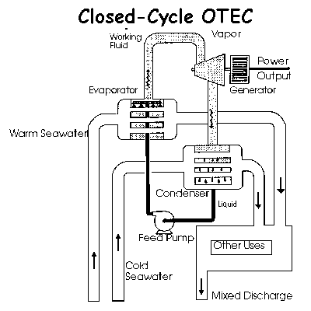
Figure 1: Generalized CC-OTEC system. Notice that the working fluid is separated from the seawater and is heated/cooled at heat-exchanger interfaces. http://www.hawaii.gov/dbedt/ert/otec-nelha/otec.html
CC-OTEC: Efficiency and Heat Exchangers and Thermodynamic Cycles:

The heat exchangers in a CC-OTEC system are vital to its performance. They are located at the separation points between the working fluid and ocean water; at the first junction, an exchanger facilitates the transfer of heat into the working fluid; at the second junction, an exchanger facilitates the transfer of heat from the working fluid into cold water. In the Kalina cycle and other new CC-OTEC designs, a third heat exchanger is used to further remove heat from the system, minimizing “waste heat”. Even lacking a deep understanding of heat engines, one should understand the importance of heat exchangers in power performance of CC-OTEC systems. The heat exchange rate is governed by the following equation:
(2)
where U is the heat transfer coefficient, A is the area of the exchanger, and ΔT is the temperature difference. The exchange rate directly impacts power production, which puts a more realistic cap on CC-OTEC energy efficiency.
When maximizing power, one must consider the reductions in efficiency caused by friction and heat losses. For a CC-OTEC system, maximum power production per unit water flow “requires both a high rate of heat transfer in the heat exchangers and a large pressure difference across the turbine (Avery, 126).” The following equation, proved by Dr. Chih Wu, shows the maximum efficiency when considering gross power output:
= 4.0-4.5% (3)
Where T_{c} is the temperature of the cold water, T_{w} is the temperature of the warm water, and η_{p} is the maximum efficiency when maximizing power. This efficiency number shows the dramatic difference between the Carnot efficiency and the efficiency for an OTEC system. A realistic efficiency of 3.4% is quoted by Sea Solar Power in their proposed100-MWe plantship design (described in section 2), further illustrating the difficulty of achieving high levels of efficiency (Sea Solar Power, Studies). In order to reconcile this difference, it is important to note that any no completely reversible thermodynamic events occur; therefore, even the lower 4.0%-4.5% level of efficiency is not attainable.
It is also important to remember that even though higher efficiency is desirable, the relatively low efficiency of an OTEC heat engine does not prevent it from producing net power. That is, since the source of heat is essentially “free,” an efficiency of 3.4% could be economically viable.
One of the major advantages of CC-OTEC designs are that they are smaller per unit power production, making them desirable for use on proposed “plantships,” floating OTEC power plants. CC-OTEC systems are required onboard plantships because size must be limited. These will be discussed further in Section 2, “Sea Solar Power’s Proposed Plantship.”
Open Cycle OTEC (OC-OTEC)

Although sharing characteristics with CC-OTEC systems, OC-OTEC systems are defined by their utilization of the warm surface water as the working fluid. Instead of having a closed-cycle, the warm water runs through the system, functioning as both the heat source and the working fluid. The system is referred to as “Open” because no liquid is permanent within it (See Figure 3 below).
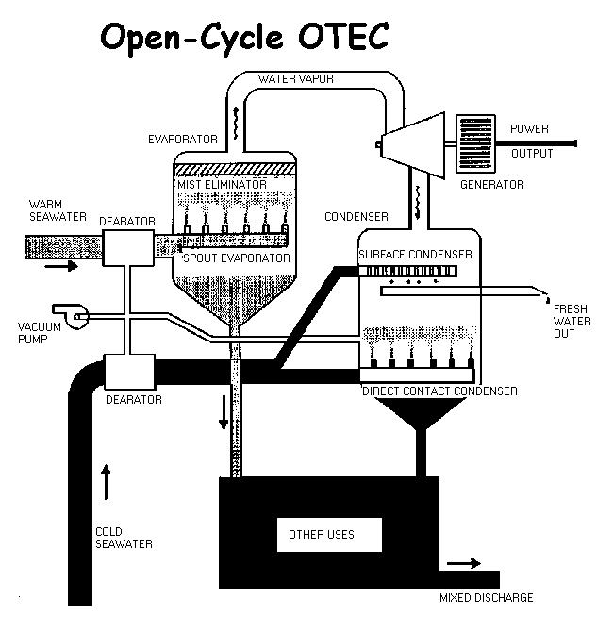
Figure 2: A Generalized OC-OTEC. http://www.hawaii.gov/dbedt/ert/otec-nelha/otec.html
The OC-OTEC design has several unique components that separate it from a CC-OTEC system (Avery and Wu, 215). The following is a list of these components and a brief description of each component (See Figure 2 Above for locations). In addition, other physical differences are mentioned (Avery and Wu, 81).
- The OC-OTEC system is composed of the following main components, each of which contributes to the overall cost. The evaporator flash evaporates the warm surface water to produce steam, the turbine and water pumps work in the same way that they do for the CC-OTEC system.

- Specialized Condenser (option): Unlike a CC-OTEC system, if a surface condenser is used to return the warm-water-steam back to liquid, it is a relatively pure and clean source of water. In addition, if a direct condenser is used instead, a higher level of thermal efficiency is possible.

- Fixed gas exhaust systems (Dearator): Removes dissolved oxygen and nitrogen in OC-OTEC systems that would otherwise lower heat transfer efficiency

- Water Pumps: Drive the in and out flows of the warm and cold water supplies

- The majority of the heat exchanger requirements are reduced since the working fluid is the ocean water itself. This reduces overall cost.

- The water ducts and turbines in the OC-OTEC system are very large relative to those in CC-OTEC systems because of the pressure difference in the two systems. Where the CC-OTEC system using ammonia has a pressure of about 125 psi, the nominal OC-OTEC system has a pressure of 0.45 psi. The difference in duct diameter for OC-OTEC is nearly 100 times that of CC-OTEC systems. Because of the large turbine necessary to operature at such a low pressure, no OC-OTEC system has been designed or built beyond 1 MWe. Both of these differences increase cost.

OC-OTEC: Efficiency
The overall efficiency of an OC-OTEC system is given by the following equation:
where P_{n} is the net power and is the rate of heat transfer into the system (Avery and Wu, 213). The potential efficiency of an OC-OTEC is higher because a larger portion of the temperature difference is available to produce power. In addition, it can also be used to provide drinking water. According to system analysis done in 1985, the condenser surface area of a plant produce 2 MWe of net power could produce about 4300 cubic meters of desalinated water each day (NREL, 1).
While OC-OTEC does have a higher efficiency potential, the technology itself is not yet mature. That is, OC-OTEC systems are not yet economically feasible. Research and Development of OC-OTEC systems have been stalled because of foreseeable problems with developing the technology on a commercial scale. As mentioned above, no OC-OTEC system has been designed or built because of the large turbine sizes.

Section 2: The Future of OTEC

Although OTEC technology is not new technology, a commercial power plant has yet to be built. To some, this fact might indicate that the technology will never be commercially viable. However, it is important to keep in mind that the technology does have the ability to tap into a large source of stored solar energy. Before throwing out (or accepting!) the further development and implementation of OTEC, one should consider the barriers to commercialization, the environmental impact of its implementation, and the other available energy alternatives.
Having stated these major concerns, however, it must be emphasized that the available data with which to address these concerns is somewhat vague. Because no commercial scale OTEC has been built, data analysis becomes a patchwork of small experiments that do not necessarily correlate well with each other. For example, combining data from the first net-power producing OTEC and the OTEC facility on the Big Island of Hawaii would not work well because of the technological advances made between the two. This would be analogous (though exaggerated) to gathering economic data from the first wind mill and those wind turbines used on wind farms.

Economics: An Economically Feasible OTEC?
When deciding whether to approve the implementation or development of an OTEC, one factor that one should consider is the economic feasibility of the process. While considering the economic feasibility of any commodity is under scrutiny, one must consider the total cost of the production of the commodity and the feasibility of substitutes for the commodity. In this case, the substitutes for OTEC are other forms of renewable energies and fossil fuels.
OTEC is a highly location dependent technology. Aside from the temperature differences associated with location, OTEC is best suited when looking at land-scarce environments with water supply issues. Island communities represent this scenario well. For example, an OTEC is proposed for Taiwan, where all of this is true (Odum, 389-390). However, from an economic standpoint, the author of this article looks at the emergy ratio of OTEC. Emergy is measures the sum of the energy redirected to produce a product or service, OTEC in this case. Howard Odum presents the idea that all energy inputs into the system, including external inputs must be included in the evaluation of an OTEC. He found that the particular OTEC proposal for Taiwan had a better emergy ratio that fossil fuels but that the capital investment is much higher per unit emergy (Odum, 393). For one considering this article, it is most important to look at two points: first, the capital investment of an OTEC will possibly be large relative to other . Second, however, the OTEC will require relatively small amounts of input after the investment. This makes sense because an OTEC, like other renewable energies such as geothermal and wind power, does not use a fuel that must be purchased, it uses “free” energy from a readily available resource pool. Still, the net power production of an OTEC is a key factor in its viability.
In fact, the first barrier to overcome in terms of economic feasibility was the production of a net power output. This was first shown to be possible in Hawaii in 1979 with Mini-OTEC (Avery and Wu, 63). However, a net power production at a high cost per unit energy (measured in kW) relative to other energy sources is not economically feasible. Research since then has introduced new processes in thermodynamics that increase the efficiency, and therefore viability, of OTEC systems. In addition to this due to the low-temperatures of OTEC operation, the theoretical initial cost of the systems has been reduced by the proposed (and tested) use of aluminum as a substitute for more expensive metals in heat exchangers and condensers. Other important technological advances have occurred in the energy conversion process for CC-OTEC systems. The Kalina and Uehara cycles are modifications of the Rankine Cycle used in heat engines to produce power. Advances like these increase the efficiency of the OTEC system and push it towards economic feasibility. As will be mentioned later, one company in particular, Sea Solar Power, has claimed that it has a CC-OTEC design that is economically feasible.
For OTEC, though, feasibility comes from more than just its power production. Unlike other forms of alternative energies, OTEC has the potential to facilitate the production of other useful co-products. The figure shown below (Figure 3) is an idealized land-based OTEC plant. Because cold seawater is naturally nutrient rich, particularly in phosphates and nitrogen, it can be used in aquaculture to grow cold-water marine produce in tropical regions under controlled conditions. It can also be used in piping to cool soil for temperate for agriculture, stimulating the growth of plants from these colder climates. Both of these benefits would create revenue streams that could not otherwise be achieved in the tropical regions where an OTEC would be implemented. OTEC can also reduce its energy output and instead produce water via desalination. The plant could also provide air conditioning to nearby buildings, significantly reducing the grid-load. This applies mainly to island communities where hot-weather increases the demand for air-conditioning and water is scarce (OCEES International, Co-Products).
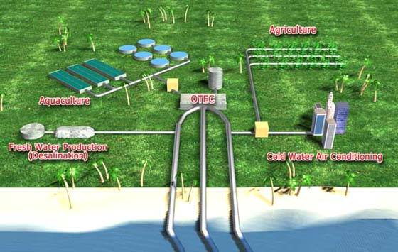
Figure 3: An idealized land-based OTEC with adjacent co-product sites (OCEES International, 1).
While co-products such as water and aquaculture products can add to the revenue generated by the facility itself, the end purpose is to replace power produced by oil with power produced by a cleaner renewable source. Therefore, the additional revenues must be viewed as reducing the overall cost per unit energy. That said, although the additional revenue gained from these co-products could indeed increase the revenue of an OTEC facility, the company promoting the use of these co-products failed to provide financial figures substantiating the magnitude of these revenues and the exact of these. Current research occurring at the National Energies Laboratory by private businesses is developing these possibilities (Environment Hawaii, 1), but the revenues from this cannot be guaranteed or easily calculated on a large scale. Therefore, before endorsing this portion of OTEC’s claim to feasibility, one would need to see a proposal that includes specific target co-products, their prices and their historical successes.

Sea Solar Power’s Proposed Plantship
One company, Sea Solar Power, claims that it has an economically feasible plantship design that is fully funded by private investors. At an estimated cost of $20 million, they claim that they it would take 4 years to build this plantship once a host client approves the OTEC (Sea Solar Power, Next Steps). In fact, they have proposed their 100-MWe design to at least one potential host, Hawaiian Electric Co. in Hawaii.
Plantship OTEC power plants have the advantage of upward scalability. Land is a scarce commodity on islands and in coastal regions where an onshore; therefore, there is definite motivation to move OTEC production offshore, which allows for a large facility that does not use precious land. The largest proposed land-based OTEC system is 40 MWe, while the largest proposed plantship has a hypothetical power production of 400 MWe (Avery and Wu, 416). While this is a good indicator that power production potential is larger for offshore plants. However, this would seem to limit the co-product production, which is one concern not fully developed by Sea Solar Power. They claim that the OTEC facility will increase fish production but do not say how. They also would not release their economic data to the author, which prevents a sound economic evaluation of their proposal. In any case, though, if the plan is actually fully funded by private investors, one should consider this proposal as a free test, if for no other reasons.
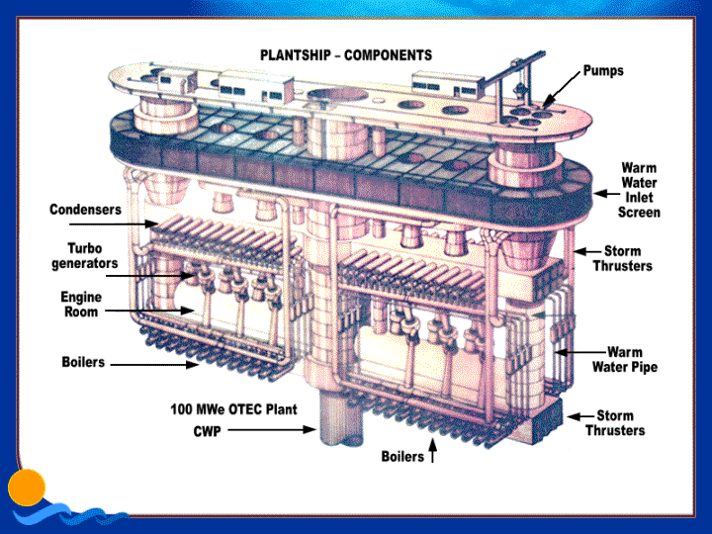
Figure 4: Idealized Plantship Design (Sea Solar Power)
The plantship is good because it does not use precious land. Plantships, however, also come with the additional challenge of transporting produced power to the onshore pipe. It is possible to run cable from an offshore OTEC to the nearby land, providing electricity directly. Another possibility is generating hydrogen or other liquid fuels to transfer the power into a portable form. In a model that includes large scale development of OTEC, the latter provides the ability for an island community to become a net exporter of energy. This, however, cannot be considered with any accuracy without first seeing data from a commercially productive OTEC plant. Sea Solar Power does not comment on this in great length, but if the cost of transferring energy from the plantship to the host client is included in their cost and method, then this should not be an economic issue.
OTEC vs. Other forms of Energy
In the end, any proposal must be weighed against the other possible energies. Land-based wind and solar sources may put stresses on land resources for land-scarce island communities. In other areas such as coastal states along the Gulf of Mexico, however, might choose wind or solar options over OTEC. In this case, the cost of OTEC would most likely be the negative against such a choice. The two proponents of commercial OTEC facilities point to water production and co-product production as some of the main benefits of OTEC (OCEES International and Sea Solar Power). This indicates to the author that their production methods do not yet compete well with other alternative energies in a non-island scenario.

Environmental Effects: Externalities and Additional Costs
There are three main concerns about OTEC’s environmental impact. The first is a concern about the temperature changes in the intermediate layer of water where an OTEC system would redirect water that has already been used. The second is a concern about the direct effect of OTEC on small marine life. The final concern is about trace element pollution. While these environmental concerns are well-founded, the low quality of available data (or lack thereof) prevents a holistic view of the magnitude of OTEC’s impact on the environment.
It is admitted that small marine life might become entrapped on screens and other filter systems, causing death or damage to these organisms. It is also expected that marine plankton and other small marine life will be subject to pressure and temperature changes that would occur in either OTEC systems. However, the effect of these problems cannot easily be estimated since no large scale OTEC facility is currently in operation. While there appears to be no complaints about the on-shore OTEC facility on the Big Island of Hawaii, any non-dramatic effect would not be noticed on such a small scale anyway. Therefore, knowing and quantifying the magnitude of the mortality cannot not be accurate until after the first OTEC is put into production. Proponents claim that there is a low density of life in deep oceans, which indicates to them that effects should be negligible (Avery and Wu, 419). This, however, does not convince the author because neither Avery or Wu have data available to support this claim.
For many proposed CC-OTEC systems, the working fluid is chosen to be ammonia. The use of ammonia itself does not directly bring up large environmental concern since trace amounts of ammonia leakage would not be harmful to the environment. However, ammonia based systems would require chlorine additive to prevent biofouling. Biofouling is the long term build up of organic matter on parts in contact with ocean water. Chlorine additive to the ocean water is proposed to prevent this and would be added at a daily average of 0.02 ppm. The EPA standard allows for up to 0.10 ppm of Chlorine. Therefore, this concern seems to have been effectively negated. However, it should be noted that EPA standards do not necessarily reflect a zero-impact scenario, which means that the long-term effects should be studied in any future OTEC facilities. In the case of Sea Solar Power, however, they neglect to mention that the working fluid, propylene, is not benign if leaked in trace amounts. Therefore, it should be noted that their economically feasible proposal may not be environmentally desirable.
Temperature change data is widely unavailable. With that in mind, when one looks at the mathematical models presented by Avery and Wu, it is important to realize frame any conclusions in that light. The model studies presented show that changes in local water temperatures would be minimal. That is, the temperature change over was minimized to .05˚C over 20 years of operation. The possible effects on the ocean environment have not been provided by the proponents, but at face value, the effect would seem to be negligible.
If what proponents they claim is true, then an OTEC is truly a green technology when compared to fossil fuels. Given these claims and no readily available arguments that OTEC’s impact will be largely negative, one might choose to endorse OTEC on an environmental level.

Conclusions:
After considering the environmental impact of OTEC technology, the economics of the technology, and the state of the art of technology, it is the opinion of the author that OTEC be given a tentative approval for further development. Given a favorable location with a public that supports its development, companies like Sea Solar Power should be allowed to build their proposed OTEC facilities. A public against an OTEC could be against it for many reasons. The foremost reason might be cultural, since island communities might not want an OTEC in a culturally significant area. Other possibilities include aesthetics, but this complaint seems to be true with any kind of new structure. The key point in this is that the company should have private investors fund the project for a community open to OTEC technology. Government funding to OTEC has already been cut off, and since private investors have apparently funded it, there is no reason to insist that government funding be allocated to support OTEC’s development.
If and when this plant is built, its operational economics and long-term environmental impact can be studied so that a better analysis can occur. Although the author does not believe that OTEC certainly should be in the United States’ renewable portfolio, it is his opinion that there is enough positive potential for the technology to be further explored on a commercial scale.
Works Cited
Avery, William H., and Chih Wu. Renewable Energy From the Ocean: A Guide to OTEC. New York: Oxford UP, 1994.
BBC MMV. Why Oil Prices Are Rising. 28 Sept. 2004. BBC NEWS. 27 Apr. 2005 <http://news.bbc.co.uk/go/pr/fr/-/1/hi/business/3708951.stm>
Environment Hawaii, Inc. OTEC Takes Back Seat to Aquaculture. 1997. Apr. 15 2005 <http://www.environment-hawaii.org/1197otec.htm>
National Renewable Energy Laboratory. Desalinated Water Date Unknown. 15 Apr. 2005 <http://www.nrel.gov/otec/desalination.html>
National Renewable Energy Laboratory. History of OTEC and How it Works 15 Apr. 2005 < http://www.hawaii.gov/dbedt/ert/otec-nelha/otec.html>

OCEES International. Co-Products. Date Unknown. 15 Apr. 2005 <http://www.ocees.com/mainpages/Coproducts.html>
Odum, Howard T. "Emergy Evaluation of an OTEC electrical power system." Energy 25 (2000): 389-393. 20 Apr. 2005 <www.elsevier.com/locate/energy>.
Sea Solar Power. Studies and Successes. Date Unknown. 30 Apr. 2005 <http://www.seasolarpower.com/studies.html>.
Sea Solar Power. Next Steps. Date Unknown. 30 Apr. 2005 <http://www.seasolarpower.com/studies.html>.

