Wave and Tidal Energy:
Technology, Potential, and Consequences

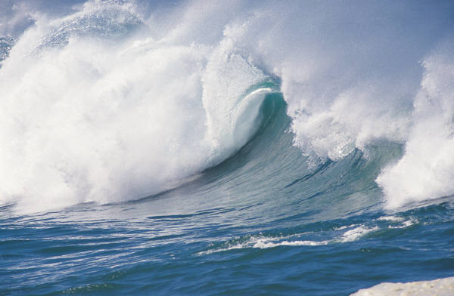

Jessica Riley

Physics 80: Energy and the Environment
Professor Saeta
April 28, 2005
Wave and Tidal Energy:
Technology, Potential, and Consequences

The ocean, covering 70% of the Earth’s surface, produces a vast amount of mechanical energy in the form of tides and waves. With increasing prices for fossil fuels, a growing demand for electricity worldwide, and increased concern with global warming caused by carbon emissions, ocean energy may soon find a place in the energy marketplace. This paper investigates the fundamentals behind wave and tidal energy, looks at a few technologies for harvesting energy from both, as well as the economic feasibility of these methods, and finally examines the consequences of using the ocean to produce energy.
A new technology, there are a large variety of devices that could conceivably be used to produce electricity from either wave or tidal forces. As the industry evolves, these will narrow down to a select few, based on their production levels, costs, and durability. However, it seems unlikely that a single device will prevail; the optimal device is largely dependent on the environment in which it will be used.
Like solar and wind energy, there is a problem with intermittency when using wave and tidal energy. This is a problem for communities solely dependent on these sources. It will also prove a difficulty when integrating onto the electrical grid. However, wave energy is much more constant than either solar or wind energy. There are seasonal variations, but these changes follow the energy consumption patterns: more energy is needed in the winter for heating, and this is when the power from waves is greatest. Tides are even more consistent than waves; moreover, they are completely predictable. Given the head start solar and wind technologies have had, it seems likely that any issues with intermittency will be ironed out before wave and tidal energy ever become significant energy producers.
To become competitive in the world market, the costs of manufacturing wave and tidal devices must be significantly reduced. Until this happens, it might be possible to reduce the costs by incorporating ocean devices with other offshore technologies, such as offshore wind farms. Even so, wave and tidal energy will be economically viable only for remote locations such as islands far from the main grid or offshore facilities until there is a significant reduction in cost, or until other sources of energy such as coal or oil rise in price. Regardless, there are only a few locations in the world with tidal levels and wave power large enough to warrant an energy plant. Even with increasingly efficient technology, wave and tidal energy will most likely be limited to only the most turbulent waters.
The environmental and social effects of both wave and tidal devices should be thoroughly considered before implementation of either type of device. While there are possible side affects from using these devices, they are largely dependent on the location of the device. As a result, each site must be analyzed separately to weigh the possible affects of an ocean energy device.

History
As early as the eleventh century, millers in Britain used tidal power as a way to grind their grain into flour. The first patent for a wave energy device was filed by a father and son by the name of Girard in Paris on July 12, 1799:
“The motion and successive inequality of waves, which after having been elevated like mountains fall away in the following instant, take into their motion all bodies which float on them. The enormous mass of a ship of the line, which no other known force is capable of lifting, responds to the slightest wave motions. If for a moment one imagines this vessel to be suspended from the end of a lever, one has conceived the idea of the most powerful machine which has ever existed…”
The Girards proposed a device that acts like a large lever, one end forced up and down by the power of the shifting waves, the other end then used to perform any number of tasks such as pumps. This device was never constructed, and indeed, it was not until, almost two-hundred years later in the midst of the oil crisis, that wave and tidal devices were seriously considered as a feasible alternative to fossil fuels. The power in waves and tides has been known from the beginning of seafaring, and probably prior. However, it is only now, with modern offshore engineering knowledge and a need to develop new, environmentally friendly energy sources that this technology is becoming feasible for more than small-scale applications.

Technology
There are many different methods of extracting energy from the waves and the tides. A relatively new industry, there are a large range of prototypes but very few devices are actually installed and producing electricity. In addition, many of the devices are designed specifically for a certain site, or for explicit wave and tidal conditions. While it would be expected that only some of these devices will actually prove marketable, it seems likely that wave and tidal devices will need to be specially designed to fit the ocean conditions of a given site.

Waves
Waves are produced by the transfer of energy from winds to the water. The winds are a result of solar heating. Both land and water act as solar radiation collectors, water being the more efficient of the two. When the water is warmed, it in turn heats the air above it. The warm air then rises, displacing cooler air, which descends to be heated by the water in turn. As a result, thermal air currents are generated. As these currents blow over the surface of the water, friction between the two causes the surface of the water to stretch, the result of which is small ripples, or capillary waves. This causes more surface area for interaction between the wind and water, causing more stretching, and increasingly larger waves. Waves can also be produced by seismic disturbances, resulting in tidal waves or tsunamis. While these are rare, they are still important when determining the maximum load wave energy devices must withstand.
It is estimated that all the power of waves breaking on the world’s coastline is approximately 2-3 TW. In the optimal locations for wave energy, wave energy density can average 65 MW for a single mile of coastline, or about 70 kW of power for every meter of wave crest length. During the winter, this number rises to 170 kW/m and can reach as high as 1 MW/m during storms. While wave power does vary greatly with the seasons of the year, the greatest power from the waves coincides with the greatest need. Waves have the most energy in the winter, and it is at this time that the most energy is needed for heating. For comparison, a single wind turbine can produce up to 3-MW of electricity and a standard coal-fired power plant produces on the order of 100 MW.
It is important to note that, once formed, ocean waves can travel great distances without a significant loss of energy. This gives wave power a certain amount of predictability: even in periods of little wind (and therefore little wave production) waves from further away can still be counted on for energy production.
Waves have two types of energy: potential and kinetic. As a wave moves in a circular motion, water molecules are raised above the water line, resulting in potential energy. This can be exploited by using such devices as oscillating water columns and floats and pitching devices. Kinetic energy results from the circular motion of the water itself. By using wave surge or focusing devices, this kinetic energy can be utilized.

Heaving buoys
Heaving buoys were originally developed for use in the military to recharge Navy robot submarines. These devices convert the orbital motion of surface waves into electricity. The heaving motion of the buoy drives an underwater piston and assembly that is attached o the buoy by a long rod. Figure 1 shows a diagram for AquaEnergy Group Ltd.’s heaving buoy device, the IPS Buoy.
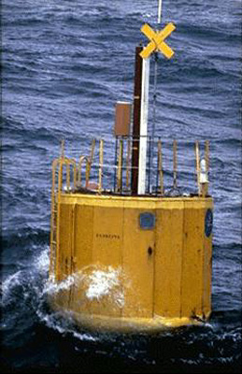
Figure 1: The IPS Buoy wave energy device. http://www.aquaenergygroup.com/home.htm
The buoys have diameters ranging from 3 m up to 12 m; they can be either act as individual power stations or connected to a central generation unit. A single 10-m IPS Buoy can produce as much as 150-250 kW, for more than 1.4 GWh of electricity for a year. However, this requires optimal wave power on the order of 50-70 kW/m and a minimum water depth of 30 m.

Floats and Pitching Devices
Floats, and pitching, devices bob or pitch, funneling water into a reservoir and thereby producing electricity. The Wave Dragon, manufactured by Wave Dragon ApS, is such a device. As is seen in Figure 2, the device consists of two wave reflectors that focus the waves towards the ramp where the water overtops into a reservoir. When the water enters the reservoir, the result is a height difference between the water in the reservoir and the sea level. The resulting pressure is converted into power through variable speed axial turbines located in the turbine outlet. This is a slack moored device, meaning that it needs only be attached with an anchor to the seabed in order to prevent drifting.
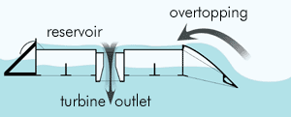
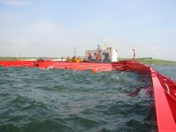
Figure 2: (Left) Basic diagram showing the function of the Wave Dragon. (Right) Picture of the Wave Dragon prototype being tested at the Danish Wave Energy Test Station in Nissum Bredning. http://www.wavedragon.net/technology/prototype.htm.
It is estimated that a single Wave Dragon unit will produce electricity ranging from 12 GWh/year in a 24-kW/m wave climate up to 52 GWh/year in 72-kW/m waves.

Oscillating Water Columns
Oscillating water columns generate electricity through the rise and fall of water in a cylindrical shaft. Waves cause the water in the column to rise and fall, which then drives air in and out the top of the shaft where there is an air-driven turbine. The turbine is then forced to move, resulting in the production of energy.
The Limpet, shown in Figure 3 is located on the Isle of Islay and is the first commercial wave generator in the world. Built by the Scottish company Wavegen, this machine is an oscillating water column. The waves produce a column of water inside the device that then creates a pneumatic pressure in the air chamber above the column, causing two counter rotating turbines to turn. Each of these turbines is linked to a generator capable of producing up to 250 kW, for a total of 500 kW.
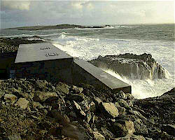
Figure 3: The Limpet. http://www.hie.co.uk/aie/wave_power.html.
The Limpet was constructed to withstand the worst possible ocean conditions. Built with a higher density of steel reinforcement than a nuclear bunker, the Limpet has survived the worst storms on Islay in living memory. The extreme ocean loads predicted are probably much greater than any actual loads the Limpet will experience. Because of this, it will be possible to make major cost reductions in the next model now that a better estimate of actual ocean conditions is available.

Wave Surge Device
Another wave energy device is the wave surge, or focusing device. These devices are mounted on the shore; they concentrate the waves and channel them into an elevated reservoir. Then, using traditional hydropower technologies, the water is released from the reservoir, turning turbines as it exits. These devices pose problems when building because the optimal locations are in cliffs, where the wave power is the strongest. This often requires blasting out part of the cliff to make room for the reservoir, which is an expensive endeavor. Also, access to these sites in order to install and maintain the device could prove costly.
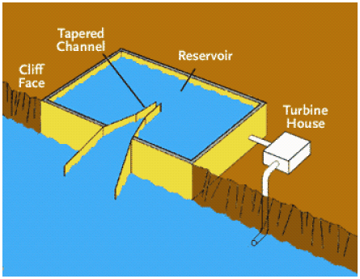
Figure 4: Wave surge device. http://www.hawaii.gov/dbedt/ert/wavereport/wave.pdf.

Tidal
Tides are primarily driven by the gravitational pull of the moon. All coastal areas get two high and two low tides in a little over 24 hours. Tidal energy is appealing in that it is completely predictable, making it much easier to incorporate onto the grid and more dependable to individual users.
The difference between low and high tides must be at least five meters – greater than 16 ft – for this method to harness tidal power efficiently. Unfortunately, only about forty places on earth have this necessary tidal behavior. Currently, cost effective power generation from tidal streams requires a mean spring peak velocity greater than 2.25 m/s, in a depth of water between 20 to 30 m. These restrictions also greatly limit the possibility of harnessing tidal power in much of the world’s oceans. However, as technology improves these limitations are becoming less stringent.

Traditional Method
Tidal power generation is much like the method used in hydroelectric plants. Gates and turbines are installed along a dam, or barrage, that stretches across the opening of a tidal basin, like a dam or estuary. The tides then produce a different level of water on either side of the dam. When this difference is great enough, the gates open, and the water pours through, turning the turbines and thereby producing electricity. Table 1 is a summary of all the tidal energy plants that have been constructed.
Table 1: Existing tidal energy plants. http://www.poemsinc.org/papers/pontes-oeconv.pdf.
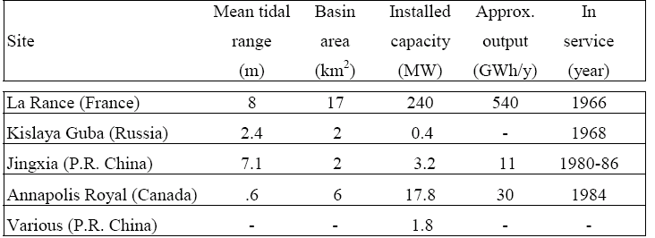
La Rance station, incorporated in a barrage across the estuary river Rance, in France, is the world’s only industrial-sized tidal power station. This station, shown in Figure 5, has been in use since 1966, producing on average 240 MW of power. This is about 90% of the electricity used in Brittany. The Annapolis Royal Station in Nova Scotia is an experimental tidal power station that produces 20 MW of power from the tides of the Bay of Fundy.
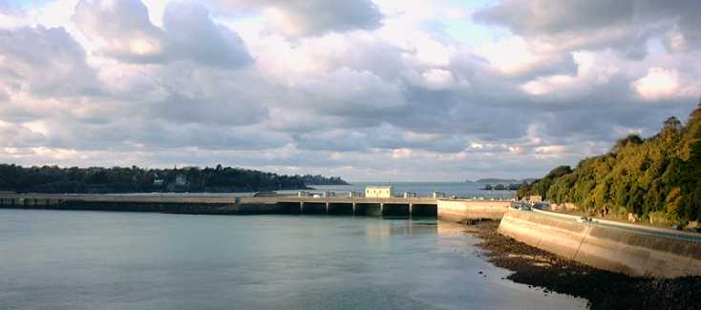
Figure 5: La Rance station. http://armorance.free.fr/barrage.htm
Due to limited sites with enough tidal range for tidal barrage systems, focus has shifted from these traditional estuary barrage systems towards capturing coastal currents. Some technologies that are being developed are the tidal fence and tidal turbines.

Tidal Fence
Tidal fences consist of series of turnstiles that turn by tidal currents that are typical in coastal waters. Blue Energy Canada has designed a tidal fence that uses a slow-moving vertical turbine; this is shown in Figure 6. Their design has several benefits: 1) generator components are accessible above the sea surface, thereby reducing the costs for maintenance, 2) the system allows fish and silt to move through, and 3) the surface on top of the tidal fence can be used for transportation.

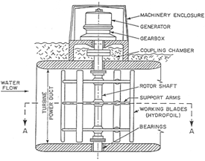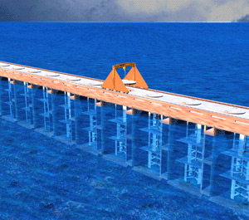
Figure 6: (Left) Diagram of a single turnstile. (Right) Artists rendition of a tidal fence. http://www.bluenergy.com/technology.html

Tidal Turbine
Marine turbines are much like submerged windmills. They are optimally located in the sea where there are high tidal current velocities; the huge volumes of flowing water turn the blades of the turbines, thereby producing electricity. Unlike wind, these turbines have the major advantage of predictability: not only are tides far more constant than wind, but tidal patterns can also be calculated years in advance. Figure 7 shows the 300-kW tidal turbine built by Marine Current Turbines (MCT) that was placed in he Bristol Channel in May of 2003.
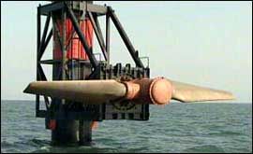
Figure 7: Tidal turbine. http://www.hie.co.uk/aie/itidal_power.html.
The newest tidal turbines proposed by MCT consist of twin axial flow rotors that are about 15 m to 20 m in diameter. Each rotor drives a generator via a gearbox. The two power units of the system are mounted on either side of the center steel beam. This beam is about 3 m in diameter and is dilled into the seabed to support the turbine. Figure 8 shows an image of what a row of tidal turbines might look like.

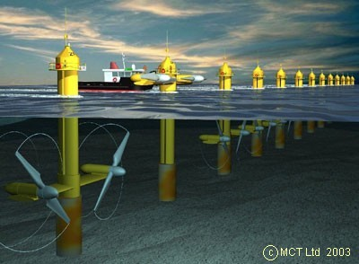
Figure 8: Artist’s rendition of a row of tidal turbines. The second turbine is raised for maintenance. http://www.marineturbines.com/technical.htm.
These tidal turbines have several advantages over wind turbines. First, they are much smaller. Wind turbines have a blade stretch of up to 300 ft, as opposed to the 15-ft to 30-ft diameter required for a wave device of equal production potential. In addition, the tidal turbines only have to turn about 30 revolutions per minute, about half the speed of wind turbines. These smaller sizes are possible because water has about ten times the density as air, and therefore has a higher energy density. Moreover, tidal turbines can be made from steel rather than the costly lightweight materials used for building wind turbines. Finally, tidal turbines are powered by a much more predictable source than wind turbines.

Potential
While there are many innovative ideas for harnessing the energy from the waves and tides, the question of feasibility must still be posed. The device must produce enough energy to be competitive in an energy market still dominated by cheap fossil fuel. Moreover, while there is a massive amount of energy present in the waves and tides of the world’s oceans, there are relatively few places with concentrated enough ocean energy to warrant installation of energy devices.
Another major opposition to ocean energy is the ocean itself. The best places for tidal and wave power devices are in the roughest waters. Many fledgling technologies have been torn apart when actually placed in the sea. Therefore, wave and tidal energy devices must be built to withstand the worst the ocean can produce. This requires extensive studying to determine necessary durability as well as major investment in structures and material that can withstand these loads.
Figure 9 shows a world map marked with the average wave energy along coastlines. It is evident from this map that there are relatively few locations worldwide suitable for wave energy devices given current technologies. Given current technology, wave energy is only feasible as an energy source for a few areas of the world: mainly Europe, parts of Australia, the southern most part of South America, and the northern reaches of North America.
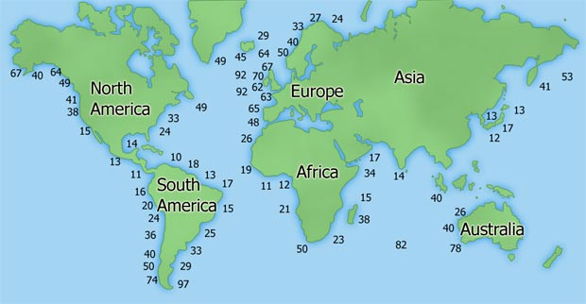
Figure 9: This map shows the average energy for waves along coastlines. The values given are in kW per meter of wave.
In the USA, there are only five states with good tidal flows and eight with strong enough waves to warrant ocean energy devices. With such limited possibility in the US on a national level, it seems unlikely that Congress would support ocean energy projects for this handful of states. Only a single company has received funding from the federal government for ocean energy technologies: $12 million was given to the US Navy for pilot buoy projects offshore of Hawaii. Nevertheless, small ocean energy projects have already begun in Massachusetts, New York, Rhode Island, Hawaii, Washington, and California. In San Francisco, the board of supervisors has called for 150 kW of tidal power by January 2006.
European Union (EU) officials estimate that by 2010, ocean energy sources will generate more than 950 MW. This is enough to power for a million homes in industrialized world. Between the islands of Jura and Scarba here is the Argyll’s whirlpool which could produce up to 2 GW of electricity if harnessed using tidal devices. Of course resources like this are extremely rare and the devices used would need to be specially designed to obtain the maximum amount of power.

Economics
The cost of ocean energy devices depends largely on three factors:
- the magnitude and dependability of the wave or tidal resource
- the cost of construction and maintenance of the conversion system
- energy transmission from the site to the user
Analyzing Figure 9, it is obvious that there are some parts of the world that will simply never have the magnitude of ocean power necessary for economical ocean energy devices. The dependability of the wave or tidal energy is also a main concern when considering the cost of an ocean energy device. While tidal energy is extremely predictable, dependence on wave energy could cause problems in the event of a completely calm ocean. However, this problem is also present in other renewable energy sources such as wind and solar. Moreover, it is far more an unlikely event for calm oceans than low winds or an overcast day. Nevertheless, the possibility is present and investments in backup systems might be necessary.
Capital expenditure is the largest factor in producing wave power. This is a marked difference from fossil fuel technologies, where the fuel itself is the major cost. However, due to research and modifications of existing designs, cost has declined significantly over the past ten years. The cost mostly goes to building the device, installing it, and connecting it to the electricity grid; the device must be durable, flexible, and weather resistant. Moreover, there are inherent costs in securing a plant location. For some devices, such as tidal turbines, a firm foundation is necessary for the devices, which is difficult to achieve on sandy ocean floors. Finally, there is some maintenance required due to the corrosive nature of seawater: rust spreads over the device, the force of heavy waves will tear on the joints, and salt-water corrodes the construction. Maintenance would also include removing any sea life that might attach to the devices and hinder production such as barnacles or sea stars. Nevertheless, the technology is available to build strong, long lasting ocean structures. One only needs to consider ships, piers, and oilrigs that have been in use for many decades and require only minimal upkeep to maintain functionality. In the case of oilrigs, especially, there seems a possibility that energy companies that have overseen their construction and maintenance could extend their expertise to this new, renewable ocean resource.
In addition, there are costs inherent in the transmission of the electricity produced by the ocean devices to the user. Dispersion and shoaling processes reduce the power per crest length of waves as these waves approach the coast. Wave energy devices are optimally located in ocean depths of at least 50 m; any closer to shore and waves begin to lose energy to friction with the ocean bottom. Therefore, more energy could be produced in deep waters than coastal, but it is then necessary to find an economical method of transmitting the energy to the energy market. A cost balance should be made comparing the extra costs of transmitting the electricity from devices farther away vs. the increase in energy available.
In order to become economical, the cost of building and installation must be reduced. This leads to a major quandary in designing wave and tidal devices. An extremely durable device will be able to withstand the worst possible conditions the ocean might produce, but will be too expensive to be economically competitive. On the other hand, if too much is cut back in building in order to reduce the cost, the device may not be able to survive the harsh atmosphere of the ocean. It is necessary to find a balance between the acceptable risk that a larger than average storm will damage the device versus the increased cost to make sure the device is strong enough to withstand such a storm. Some possible solutions to the problem of storms is intentionally sinking the device, towing it to shelter, or raising it out of the water onto the deck of a boat for the duration of the storm. Obviously, these would only work for unattached devices, such as floating buoys. For larger, secured devices, they must be built to withstand the ocean at its strongest.
It would be economical to create joint ventures between wave or tidal plants and other offshore devices. For instance, it would be possible to install wave turbines beneath offshore wind farms. Since the windiest places often have the largest waves, this would allow optimal working conditions for both technologies. Another possibility under consideration is using tidal fences as bridges.
An example of a current ocean technology is the Japan Marine Science and Technology Center’s (JAMSTEC) Mighty Whale. It is a floating, 50-m long, 1000-ton wave platform that produces on average 110 kW. Given the costs involved in constructing the Might Whale, it produces energy at a rate of about 28 ¢/kWh. For remote communities and offshore facilities, this can already provide competitively priced energy. Energetech of Australia predicts that their device, an oscillating water column device, will cost around 10 ¢/kWh, which will be competitive in some areas that are far away form the standard electrical grid.
Technology developments have reduced the predicted costs of wave energy by an order of magnitude in the last two decades alone. As more ocean devices are produced and installed, the cost of manufacturing will decrease. Moreover, many devices, such as tidal turbines, could be installed in a single site, much like wind farms. Then as that site develops, the marginal cost of adding more devices and maintenance would decrease.
Even with these improvements, however, it seems most likely that ocean energy devices will be economically competitive in areas that are far away from a common electrical grid, such as remote islands or ocean facilities as long as traditional fossil fuels such as coal and oil are available.

Consequences
As a renewable energy source, ocean energy has the advantage of reducing society’s dependence on fossil fuels. It is a clean source of energy – it produces no liquid or solid pollution – and free beyond initial capital cost and maintenance. However, there are several environmental and social impacts of this device that must be considered.

Emmisions
Table 2 shows an example of the total emissions that might be expected from a standard wave energy device.
Table 2: Example of emissions for wave energy device. http://europa.eu.int/comm/energy_transport/atlas/htmlu/wavenv.html.
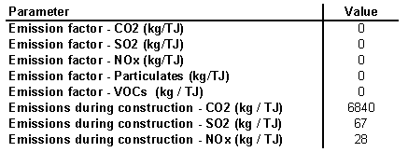
While these numbers would be expected to vary for different technologies, as a whole the devices would produce no emissions beyond those required for their construction. Most devices designed today use water hydraulics in order to eliminate the risk of oil spills inherent in standard hydraulic systems. Observably, these devices provide a much cleaner source of energy than any of the fossil fuel technologies, and even some renewable sources.

Ecological Effects
One of the biggest concerns with both wave and tidal energy is the impact they have on the ecology. However, the full effect that slight alterations of tides or wave patterns on an ecosystem is unknown; it will most likely remain that way until devices are installed and the effect can be observed. The La Rance barrage did change the local tide patterns slightly and any environmental impact was negligible. Unfortunately, this would probably not be the case for all such installations. Since the barrage separates the ocean from the water entering the estuary, the salinity in the estuary would be reduced. Moreover, the tides and within the basin are reduced by about half. The result is a change in water quality, sediment movement, and composition of the bed sediments. This in turn would affect the organisms that live in the water, which could result in an overall change in coastal animal habitats.
For example, the Bay of Fundy in Canada is a promising location for a barrage-type tidal plant. However, it is estimated that such a plant could decrease local tides by as much as 15 cm. Moreover, it is worried that the change in salinity in the bay could stimulate the “red tide” organism, or Gonyalaux excavata, which causes paralysis in shellfish. Such a barrage would also disturb the habits of millions of birds migrate through the Bay. While this is only an issue with this specific site, barrages of this magnitude could produce other, unforeseen effects.
On the other hand, it is theorized that such tidal barrages could provide protection against coastal flooding during very high tides, and work as a storm barrier. Despite this potential benefit, the focus has now turned to smaller wave and tidal devices in the belief that they will have a much smaller affect on the environment. The environmental impacts are largely dependent on sites and the research necessary to analyze each individually is daunting. By using smaller scale devices, it should be possible to avoid many of these environmental concerns.

Affect on wildlife
Interestingly, it seems that many wave and tidal devices would actually stimulate marine life. Floating devices could provide shelter to both fish and birds; since such devices would impede fishing boats, they would develop into a natural sanctuary. With an increase in fish, bird populations would prosper as well.
Currently there is actually a high demand for artificial reef structures in order to stimulate marine life. In 2000, New Jersey purchased over fifty subway cars to sink just offshore to stimulate fish populations. Furthermore, these structures provide not only an artificial reef environment, they are also avoided by large fishing boats; their nets and fishing gear might get caught or broken by the devices. If there is already a need for offshore structures, it seems a logical step to have those structures produce electricity as well.
On the other hand, tidal fences and tidal barrages can impede sea life migration. Tidal turbines and most wave power devices are less environmentally damaging because they do not block migratory paths. For all of these technologies, it is important to pick sites where environmental impact will be minimized.
Another drawback of devices such as tidal turbines is their rotating blades. However, on average the blades rotate from around 10 to 20 rpm. In comparison, a ship propeller typically runs over an order of magnitude faster than this. Furthermore, the tidal turbine is stationary, whereas many ships can move faster than sea creatures can swim. In this instance, ocean energy devices are less risk to marine life than the multitude of boats already navigating the seas.

Boat Traffic
Ocean energy devices could be obstacles to marine traffic and may become burdensome if employed in such quantity as to impede marine travel. This would especially be difficult for fishing boats, which would have to avoid areas with wave or tidal devices. It could also be a problem for areas with significant ocean recreation and tourism. These devices, while obstacles, should not prove hazardous given modern navigation tools such as radar warning devices.

Visual Impact
A major concern for all wave and tidal energy devices is aesthetic. In general, any obstruction to a view, especially an ocean view, is met with major opposition from residents. This is true not just for ocean devices, but for wind as well. However, most offshore ocean devices are not readily visible from the shore; they barely rise above the sea level and more often than not are obscured by waves. They are especially low profile when compared to oilrigs or offshore wind farms. Coastal devices, on the other hand, are visible from the shore. In this case, the advantage of having a clean, efficient energy source must be balanced with the visual impact.

Other effects
Both wave and tidal devices could result in a general increase in low-water levels and reduction in currents and turbulence. This should prove no impediment to areas like Northern Scotland. In fact, it might even be desirable if mellower waves open up areas to ocean recreation that were previously too rough. On the other hand, it could be a major problem for places, such as Hawaii, that draw tourists to its large, powerful waves.

Conclusion
Already, wave energy is becoming economic in niche markets, mainly in places far from the grid or on offshore facilities. As the technology improves, traditional sources of energy become more costly and environmentally suspect, and a successful track record is established by installed ocean energy technologies, wave and tidal energy may become a more commonly exploited resource.
In 1963 President John F. Kennedy said that
Man only needs to exercise his engineering ingenuity to convert the ocean’s surge into a national asset. … I think this (Passamaquoddy Tidal Power Project) can be one of the most astonishing and beneficial enterprises undertaken by the people of the United States.
Sure enough, people have learned how to harness the power of the ocean. The ocean is a very destructive medium in which to place any device but centuries of building ships, piers, and other ocean-based structures has given people the knowledge necessary to build strong, lasting ocean energy devices. Nevertheless, like many other renewable energy sources, ocean energy will unlikely to be economically competitive with traditional fossil fuels except for isolated communities that are far away from the grid. Even as the technologies become more developed and commercially viable, utilizing ocean energy will still be limited to such locations that have a significant amount of tidal or wave activity.
Works Cited
Background. Marine Current Turbines Ltd. 22 Apr. 2005. <http://www.marineturbines.com/ background.htm>
Clark, Peter, Klossner, Rebecca, and Kologe, Lauren. “Tidal Energy”. 13 Nov 2003. 22 Apr. 2005. <http://www.ems.psu.edu/~elsworth/courses/cause2003/finalprojects/ canutepaper.pdf>
Information Resources: Ocean Energy. 26 Apr. 2005. U.S. Department of Energy. 22 Apr. 2005 <http:// www.eere.energy.gov/consumerinfo/factsheets/nb1.html>
Johnson, Jeff. “Power From Moving Water”. C&EN.82.40. 4 Oct. 2004. <http://pubs.acs.org/ cen/coverstory/8240/ print/8240energy.html>
Jones, Anthony T. “Renewable ocean energy systems becoming more viable.” Financial Times: Energy. 20 Apr. 2001.
Kennedy, President John F. as read into Congressional Record, by Hon. Thomas J. Dodd; as reported in Congressional Record – Appendix; October 22, 1963; pp 6580-6581 [Proceedings and Debates of the 88th Congress, First Session]
Marine Energy – Wave Power. 5 May 2005. Argyll & the Islands Enterprise. 22 Apr. 2005 <http://www.hie.co.uk/ aie/wave_power.html>
Marine Energy – Tidal Power. 5 May 2005. Argyll & the Islands Enterprise. 22 Apr. 2005 <http://www.hie.co.uk/ aie/tidal_power.html>
Ocean Topics. 26 Apr. 2005. U.S. Department of Energy. 22 Apr. 2005 <http://www.eere.energy.gov/RE/ ocean.html>
OWEC – Offshore Wave Energy Converters. 8 Jan. 2002. Interproject Service. 22 Apr. 2005 <http:// members.tripod.com/Interproject/presentation.htm>
Prototype Project. Wave Dragon. 22 Apr. 2005 <http://www.wavedragon.net/technology/ prototype.htm>
Ross, David. Power From the Waves. New York: Oxford University Press Inc., 1995.
Technology. Marine Current Turbines Ltd. 22 Apr. 2005. <http://www.marineturbines.com/ technical.htm>
Wave Energy: A Concentrated Form of Solar Energy. Wave Dragon. 22 Apr. 2005 <http://www.wavedragon.net/ technology/wave-energy.htm>
Wave Energy Overview – The Market. ATLAS. 22 Apr. 2005 <http://europa.eu.int/comm/ energy_transport/atlas/ htmlu/wavomark.html>

Ross, David. Power From the Waves. New York: Oxford University Press Inc., 1995.
Ocean Topics. 26 Apr. 2005. U.S. Department of Energy. 22 Apr. 2005 <http://www.eere.energy.gov/RE/ ocean.html>
Wave Energy: A Concentrated Form of Solar Energy. Wave Dragon. 22 Apr. 2005 <http://www.wavedragon.net/ technology/wave-energy.htm>
Information Resources: Ocean Energy. 26 Apr. 2005. U.S. Department of Energy. 22 Apr. 2005 <http:// www.eere.energy.gov/consumerinfo/factsheets/nb1.html>
OWEC – Offshore Wave Energy Converters. 8 Jan. 2002. Interproject Service. 22 Apr. 2005 <http:// members.tripod.com/Interproject/presentation.htm>
Prototype project. Wave Dragon. 26 Apr. 2005 <http://www.wavedragon.net/technology/prototype.htm>
Marine Energy – Wave Power. 5 May 2005. Argyll & the Islands Enterprise. 22 Apr. 2005 <http://www.hie.co.uk/ aie/wave_power.html>
Information Resources: Ocean Energy. 26 Apr. 2005. U.S. Department of Energy. 22 Apr. 2005. <http:// www.eere.energy.gov/consumerinfo/factsheets/nb1.html>
Background. Marine Current Turbines Ltd. 22 Apr. 2005. <http://www.marineturbines.com/background.htm>
Jones, Anthony T. “Renewable ocean energy systems becoming more viable.” Financial Times: Energy. 20 Apr. 2001.
Technology. Marine Current Turbines Ltd. 22 Apr. 2005. <http://www.marineturbines.com/technical.htm>
Johnson, Jeff. “Power From Moving Water”. C&EN.82.40. 4 Oct. 2004. <http://pubs.acs.org/cen/coverstory/8240/ print/8240energy.html>
Johnson, Jeff. “Power From Moving Water”. C&EN.82.40. 4 Oct. 2004. <http://pubs.acs.org/cen/coverstory/8240/ print/8240energy.html>
Marine Energy – Tidal Power. 5 May 2005. Argyll & the Islands Enterprise. 22 Apr. 2005 <http://www.hie.co.uk/ aie/tidal_power.html>
Jones, Anthony T. “Renewable ocean energy systems becoming more viable.” Financial Times: Energy. 20 Apr. 2001.
Wave Energy Overview – The Market. ATLAS. 22 Apr. 2005 <http://europa.eu.int/comm/energy_transport/atlas/ htmlu/wavomark.html>
Clark, Peter, Klossner, Rebecca, and Kologe, Lauren. “Tidal Energy”. 13 Nov 2003. 22 Apr. 2005 <http://www.ems.psu.edu/~elsworth/courses/cause2003/finalprojects/canutepaper.pdf>
Clark, Peter, Klossner, Rebecca, and Kologe, Lauren. “Tidal Energy”. 13 Nov 2003. 22 Apr. 2005 <http://www.ems.psu.edu/~elsworth/courses/cause2003/finalprojects/canutepaper.pdf>
Clark, Peter, Klossner, Rebecca, and Kologe, Lauren. “Tidal Energy”. 13 Nov 2003. 22 Apr. 2005 <http://www.ems.psu.edu/~elsworth/courses/cause2003/finalprojects/canutepaper.pdf>
President John F. Kennedy as read into Congressional Record, by Hon. Thomas J. Dodd; concerning the Passamaquoddy Tidal Power Project; as reported in Congressional Record – Appendix; October 22, 1963; pp 6580-6581 [Proceedings and Debates of the 88th Congress, First Session]

