The Reprocessing of
Nuclear Fuels

Meghan Driscoll
May 5, 2005

The Reprocessing of Nuclear Fuels

Introduction
Nuclear power is responsible for nearly 20% of the electricity generated in both the United States and in the world (Hore-Lacy). Like oil and coal power plants, nuclear power plants need fuel to generate electricity. While most nuclear power plants use uranium as a fuel a few plants use a mixture of uranium and plutonium as a fuel instead. When uranium is used as a fuel, plutonium is produced as a waste product of one of the energy generating reactions. By chemically separating the spent fuel, the waste fuel that can no longer sustain the energy generating reactions, the waste plutonium can be reprocessed into plutonium fuel. Reprocessing both stretches the Earth’s supply of uranium ore, by reducing the rate at which the nuclear power industry consumes new uranium ore, and potentially decreases the amount of radioactive waste that must be stored, by reducing the rate at which plutonium wastes are generated by the nuclear power industry. However, estimates of the effect that reprocessing could have on the nuclear power industry are disappointing. A study conducted by MIT in 2001 found that reprocessing would only decrease the uranium ore usage of the nuclear power industry by about 15% (MIT 123). The study also found that while reprocessing would decrease the rate at which plutonium waste is produced, it would also increase the rate at which high level radioactive wastes are produced (MIT 123). While reprocessing perhaps benefits the nuclear fuel cycle by reducing both the amount of uranium used and the amount of wastes produced, it has many disadvantages outside of its use in the fuel cycle. Since most forms of reprocessing generate weapons grade plutonium, reprocessing is a proliferation and national security risk. Reprocessing is also very expansive and is economically unviable without some sort of government funding.
Governmental policy on nuclear reprocessing varies widely throughout the world. Britain and France both operate reprocessing plants, and Japan is currently in the process of building a new reprocessing plant. In the U.S., on the other hand, reprocessing of commercial spent fuel has been illegal for most of the past 25 years (Hippel). While, in May of 2001, Vice-President Cheney suggested that the U.S. reexamine its policies on the reprocessing of commercial nuclear fuels, the administration soon decided against reconsidering U.S. reprocessing policy (Hippel). Most governments that decide to build reprocessing plants seem to do so in order to improve their country’s nuclear fuel cycle. In this paper, I argue that the economic, non-proliferation, and environmental disadvantages of reprocessing far outweigh any advantages reprocessing might bring to the nuclear fuel cycle.

The Role of Reprocessing in the Nuclear Fuel Cycle
The nuclear fuel cycle describes the creation, handling, and possible destruction of the fissionable fuels and high level wastes that are used or generated by the nuclear power industry. For example, the nuclear fuel cycle currently employed by the U.S. includes uranium mining and enrichment, fuel rod fabrication, power generation, and spent fuel storage. The fuel cycle is particularly important in the nuclear power industry because the nuclear materials that it describes present potential security, health and environmental risks. While there are many different types of possible nuclear fuel cycles, only two such cycles are directly related to the issue of plutonium reprocessing, the nuclear fuel cycle in which plutonium is reprocessed and the nuclear fuel cycle that the world-wide nuclear power industry would most likely use in the absence of plutonium reprocessing.
Figure 1 shows both a plutonium recycling fuel cycle and a once-through, or no recycling, fuel cycle. The first four steps in both nuclear fuel cycles are the same. In both, uranium is mined and enriched, fuel rods are fabricated from the uranium, and then power is generated by fissionning the uranium in a nuclear reactor. The enriched uranium that is used in a nuclear reactor consists of about 3% to 5% of the uranium 235 isotope and about 95% to 97% of the uranium 238 isotope (MIT 102). The main energy producing reaction that takes place in the reactor is U-235 fissioning, in which a U-235 nucleus is broken apart to yield fission products, energy and a few free neutrons. While U-238 does not easily fission, it can transform into Pu-239 through the absorption of a free neutron (MIT 102). As long as the concentration of U-235 in the fuel rod remains relatively high, electricity can be generated from the uranium fuel. However, if the concentration of U-235 becomes too small than the fuel rod must be replaced and the old fuel rod discarded or reprocessed as spent fuel.
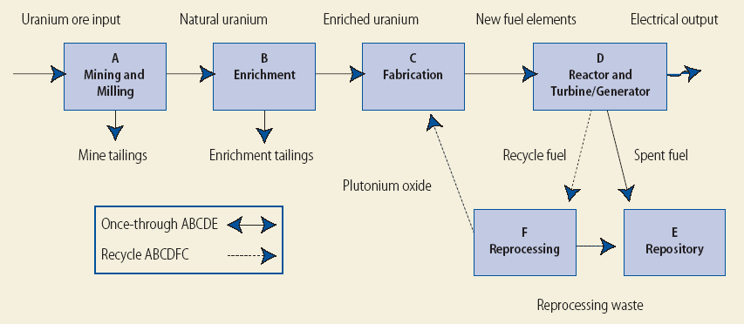
Figure 1 The nuclear fuel cycle (MIT 101).
Spent fuel consists of about 96% Uranium, 1% Plutonium 239 and 3% other highly radioactive wastes (BBC). Since Pu-239 is a fissionable fuel, the plutonium in spent fuel rods is a potential source of energy. Reprocessing plants isolate that plutonium so that it can be used as a fuel in nuclear reactors. A typical reprocessing plant utilizing the PUREX method reprocesses plutonium in the following way. First, the spent fuel is left to sit in pools of water near the reactor sites as it cools. Next, the spent fuel is transferred to a reprocessing plant where the cladding material that surrounds the fuel pellets is removed remotely. The fuel pellets are then dissolved in hot nitric acid and the uranium and plutonium are extracted from the spent fuel. Finally, the plutonium is mixed with natural or depleted uranium to create a mixed oxide fuel known as MOX (MIT 106). While most nuclear reactors burn uranium oxide fuel, UOX, some nuclear reactors can burn either UOX or a mixture of UOX 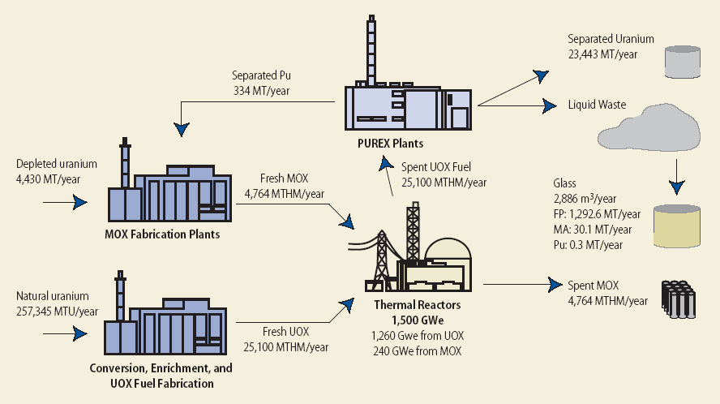

Figure 2 The plutonium recycling nuclear fuel cycle (MIT 106). The unit MTHM is an abbreviation of metric tons of heavy metal.
and MOX. Figure 2 shows the plutonium recycling nuclear fuel cycle. A full reprocessing infrastructure requires not only reprocessing plants, but also nuclear reactors that can use MOX as fuel (MIT 121). The estimates given in the diagram for the amount of materials and waste generated each year by the nuclear power industry are based on a nuclear reactor fleet size of 1500 GWe, in which all of the plutonium generated by the use of UOX fuel is recycled once. A nuclear reactor fleet of this type would require about 15 reprocessing plants with capacity comparable to the current La Hague COGEMA reprocessing plant in France (MIT 123).
The potential advantages of reprocessing are a result of the changes in the nuclear fuel cycle that come about from plutonium reprocessing. Since reprocessing separates spent fuel into uranium, plutonium and higher level wastes and then recycles the plutonium waste, in a reprocessing nuclear fuel cycle, there is far less spent fuel and plutonium wastes to store, but far more higher level wastes to store. Reprocessing could reduce the rate at which plutonium is generated by as much as 40% (MIT 123). Since higher level wastes are extremely radioactive, though, it is not clear that this change in the distribution of radioactive wastes is beneficial.
A change in the distribution of radioactive wastes is not the only change brought about by the addition of reprocessing to the nuclear fuel cycle. Since reprocessing recycles plutonium as fuel, less new uranium ore needs to be used each year to produce the same amount of electricity. Reprocessing could reduce the amount of uranium ore used by the nuclear power industry by 15% (MIT 123). While there is a finite supply of uranium in the world, and stretching that supply of uranium is certainly, on the surface, good, the cost of uranium ore is small compared to the overall cost of nuclear power (MIT 34). There is no need to reprocess plutonium now because of a perceived future shortage of uranium since, if the price of uranium rises significantly in the future, plutonium can then be reprocessed from stored spent nuclear fuel. The changes in the nuclear fuel cycle brought about by reprocessing seem to be of ambiguous value. The relative advantages and disadvantages of plutonium reprocessing, however, can be better understood quantitatively in terms of the economics of reprocessing.

Economics
Countries that build or operate plutonium reprocessing facilities do not do so because plutonium reprocessing is economically favorable. Reprocessing is currently not an economically viable technology, and it is not expected to become an economically viable technology in the near future. A study conducted by the OECD/NEA in 1994 found that a once-through fuel cycle in which no nuclear materials are recycled is abut 15% cheaper than a plutonium reprocessing nuclear fuel cycle (OECD). A similar study conducted by MIT in 2003 found that the once-through fuel cycle is about four times cheaper than a plutonium reprocessing nuclear fuel cycle (MIT 149). The disparate cost estimates of the two studies, the MIT report explains, is largely due to different estimates of the unit costs of reprocessing (MIT 150). Since no country has fully implemented the plutonium reprocessing nuclear fuel cycle, and since those countries that have implemented part of that fuel cycle heavily subsidize their reprocessing industry, the uncertainty in the cost of a reprocessing nuclear fuel cycle is large. Even though there is much uncertainty in the economics of reprocessing and those countries that do reprocess don’t seem to do so for economic reasons, considering the economics of reprocessing allow us to better understand the value of the effect that reprocessing has on the nuclear fuel cycle.
The cost of the reprocessing nuclear fuel cycle is mainly determined by the costs of five key components of that cycle. Those key components are uranium ore, plutonium reprocessing, MOX fuel fabrication, spent fuel long-term storage and higher level wastes long-term storage (MIT 148). Figure 3 shows the current costs of those key components, and the value that each component would need to have to make reprocessing economically sound if the cost of the components were varied independently. Figure 4 shows a set of possible values that together would make reprocessing economically sound.
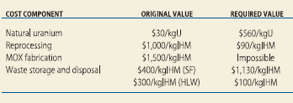
Figure 3 The breakeven values for the plutonium reprocessing nuclear fuel cycle. The “Original Value” column shows the current value of each cost component, while the “Required Value” column shows what that cost component would need to be in order for reprocessing to be economically viable (MIT 148).

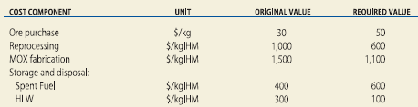
Figure 4 The breakeven values for the plutonium reprocessing nuclear fuel cycle, in which the cost components are adjusted simultaneously (MIT 148).

The set of component costs needed, however, suggests that reprocessing will not be economical in the near future. The cost of uranium is currently about $30/kg. According to the Uranium Information Center, the amount of uranium available worldwide that is recoverable at a cost of less than $80/kg is 30 million tons, which is far more than the nuclear power industry could reasonably consume in the next fifty years (MIT 34). Reprocessing is then unlikely to become economically sound as a result of higher uranium prices alone. While the costs of radioactive waste storage and disposal might increase in the near future, for reprocessing to become economically viable as a result of that increased cost, the cost of storing spent fuel would have to be significantly higher per kilogram of initial heavy metal than the cost of storing high level wastes. Even though high level wastes have a smaller volume per kilogram of initial heavy metal than spent fuel does, high level wastes release more radioactivity per unit of volume than spent fuel does. Since reprocessing is more expensive than a once-through nuclear fuel cycle, the changes in a nuclear fuel cycle brought about by the addition of reprocessing don’t seem to be beneficial.
Even though reprocessing doesn’t seem to be beneficial to the nuclear fuel cycle, for more than a decade, Japan has been shipping spent fuel to Britain and France to be reprocessed. In 2001, Britain, France and Japan together had amassed more than 25 tons of stockpiled plutonium that was ready to be turned into MOX fuel. Despite its already huge separated plutonium stockpile, Japan is currently building its own reprocessing plant at an estimated cost of more than $20 billion. The new plant will be capable of reprocessing 800 tons of spent fuel per year (Burnie). Currently, none of the 52 nuclear power plants in Japan is even capable of using MOX fuel, so, in the near future, the result of the Japanese government’s emphasis on reprocessing will be an increasingly large plutonium stockpile rather than a new supply of energy. A recent Japanese study concluded that even after the plutonium reprocessing nuclear fuel cycle is fully implemented in Japan, reprocessed uranium will remain more expensive than first use uranium in Japan (Cirincione). The Japanese government’s decision to reprocess doesn’t seem to be motivated by the economics of nuclear fuel cycles. Why, then, is Japan building a plutonium reprocessing plant?

International Politics: non-proliferation and national security
Governmental policy towards plutonium reprocessing seems to be influenced mostly by political concerns. For example, experts from the Carnegie Endowment for International Peace recently asked Japanese officials why Japan was building the Rokkasho reprocessing plant. The Japanese officials gave three main reasons for wanting to go ahead with the reprocessing plant other than that of the sunk cost of the plant. The officials described the storage of nuclear waste, energy independence, and national pride as the main reasons for building the plant (Cirincione). While the storage of nuclear waste might not seem to be a political reason to build a reprocessing plant, expanding upon the Japanese officials’ position, the Carnegie Endowment writers explain “The reprocessing plant is the key to solving [the problem of radioactive waste], at least politically. … Japanese industry officials believe that if the reprocessing plant did not go into operation, local opposition to the radioactive waste would re-ignite … and the nuclear power industry would collapse” (Cirincione). All three of the reasons given by the Japanese officials for the building of Rokkasho can then be thought of as political reasons.
While the Japanese are building a reprocessing plant due to political concerns, in the U.S., commercial reprocessing is banned because of political concerns. The U.S. bans most commercial nuclear technologies that produce separated plutonium because, in contrast to other nuclear materials such as uranium ore and spent fuel, it is relatively easy to build a nuclear bomb out of plutonium. According to the International Atomic Energy Agency, a nuclear bomb can be made from just 8 kg of separated plutonium (MIT 66). The U.S. government regards the ease with which a nuclear weapon can be built from the separated plutonium produced by plutonium reprocessing as both a non-proliferation and a terrorism risk. Commercial reprocessing is banned partly in response to an incident in which nuclear weapons were indeed built with the separated plutonium produced by reprocessing. In 1974, India tested a nuclear explosive that was built with separated plutonium from U.S. supplied reprocessing technology (Hippel). Three years after India’s nuclear explosives test, President Carter issued a presidential declaration that banned commercial reprocessing for the first time in the U.S. Carter stated that “The United States Government will indefinitely defer the commercial reprocessing and recycling of plutonium in the U.S.” (Carter).

Safety and the Environment
Plutonium reprocessing has a poor safety and environmental record. The rate of serious accidents at reprocessing plants is much higher than the rate of serious accidents at nuclear reactors. Worker and environmental safety is especially difficult to maintain at a reprocessing plant, because multiple types of nuclear materials must be maneuvered through the complicated separation process without any of those materials going critical or leaking radioactivity.

Conclusion
While the reprocessing of plutonium might, in the future, marginally benefit the nuclear fuel cycle, the economic, non-proliferation, and safety disadvantages of plutonium reprocessing far outweigh any advantages reprocessing might bring to the nuclear fuel cycle.

Works Cited

Burnie, Shaun and Aileen Mioko Smith. “Japan’s Nuclear Twilight Zone”. The Bulletin
of Atomic Scientists. 57.3 (2001): 58-62. April 19, 2005
<http://www.thebulletin.org/article.php?art_ofn=mj01burnie>.

Carter, Jimmy. Presidential Directive/NSC-8. March 24, 1977. The Nuclear Control
Institute. <http://www.nci.org/new/pu-repro/carter77/index.htm>.

Cirincione, Joseph and Jon Wolfsthal. “Producing Plutonium at Rokkasho-mura”. 2005.
Carnegie Endowment for International Peace. April 19, 2005
<http://www.carnegieendowment.org/publications/index.cfm?fa=print&id=15955>.

Hippel, Frank N. von. “Plutonium and Reprocessing of Spent Nuclear Fuel”. Science. 293
(September 2001): 2397-2398. May 2, 2005
<http://www.sciencemag.org/cgi/reprint/293/5539/2397.pdf>.

Hore-Lacy, Ian. The Future of Nuclear Energy. May 4, 2000. Uranium Information Centre.
April 12, 2005 <http://www.uic.com.au/opinion6.html>.

The Economics of the Nuclear Fuel Cycle. 1994. The Nuclear Energy Agency. May 5, 2005
<http://www.nea.fr/html/ndd/reports/efc/efc09.pdf>.

The Future of Nuclear Power: An Interdisciplinary MIT Study. July 29, 2003. MIT. April 12,
2005 <http://web.mit.edu/nuclearpower/>.

“What is Nuclear Reprocessing?”. BBC News Online. February 19, 2000. The BBC. April 19,
2005 <http://news.bbc.co.uk/1/hi/uk/647981.stm>.

