Landfill Gas to Energy: Putting Waste to Good Use

Conrad Harter

With the specter of global warming on the horizon, the nations of the world are starting to more closely examine their emissions of carbon dioxide and other “greenhouse gases.” These gases trap heat in the earth’s atmosphere, raising the global mean temperature slowly but surely. Though carbon dioxide is by far the most prevalent of the greenhouse gases, it is not the sole culprit. Methane is another greenhouse gas emitted by human societies, industry, and agriculture. One particular source of anthropogenic methane is the decomposition of organic waste in landfills. With expanding urban populations worldwide, and the corresponding increase in organic and other waste filling their attendant sanitary and other landfills, nations are faced with a possible increase in methane emissions from these sources. The situation has both possible negative and positive effects, as gas harvested from landfills and other anthropogenic sources can be used to generate energy in the form of electricity or purified into usable natural gas, which consists mainly of methane with a few impurities. This landfill gas can help provide power to growing populations, especially in the face of rising energy and fossil fuel prices. How would this use contribute to greater global warming problems, or help alleviate them by offsetting other “dirtier” sources of energy such as coal? How is the gas generated? How much is produced on an annual basis? Is there enough energy value in this gas to be of any real use?
Landfill gas is generated in nearly all sanitary landfills across the world, in both industrialized and developing nations. The only real requirement for these landfills to produce LFG is the existence of anaerobic conditions within the landfill. Sanitary landfills as used in most nations consist essentially of large holes in the ground that are filled with waste and covered with layers of soil or dirt to isolate the waste from the open air. Because these layers of dirt do an effective job of isolating waste from the atmosphere, for the most part “sanitary landfills are considered completely anaerobic”(Doorn Barlaz 1). Estimates of LFG production and emissions are based upon this fundamental assumption.
The landfill gas, which consists of methane, often nitrogen, and impurities, is produced by microorganisms in a two stage process, in anaerobic conditions. The methane generation process requires the existence of three interacting metabolic groups, the first two of which are bacteria. The third and final metabolic group, which actually produces the methane itself, are mircoorganisms from the group Methanoarchaea. The first two groups of bacteria convert organic waste to H₂, CO₂, formate, acetate, and probably smaller amounts of other products. The methanoarchaea convert a large amount of these intermediate compounds to methane, CH₄ (Ferry 143). Not all of the intermediate stages are converted to methane, which is one of the reasons pure methane is not emitted from sanitary landfills. There are also other compounds in LFG which are most likely due to competing decomposition processes, and also from nonorganic waste.
The time taken by the microorganisms to produce methane is heavily dependent upon the conditions. Not surprisingly, this leads to very different timescales for methane production in laboratory and real-life conditions. In laboratory conditions, with the experimental method designed to maximize methane production in the shortest period of time possible, 80-90% of the methane generation potential is usually generated from high-quality organic waste within the first 8-10 days. Here, for the particular experiment quoted, methane potential was defined as the maximum methane generated during the first 50 days of experiment. (Hansen 395-6). The figure below shows time versus methane data for these samples. The samples are food oil, pork fat, and gelatine (to simulate protein). Controls were paper bags, and “chemically produced starch and glucose” (Hansen 396).
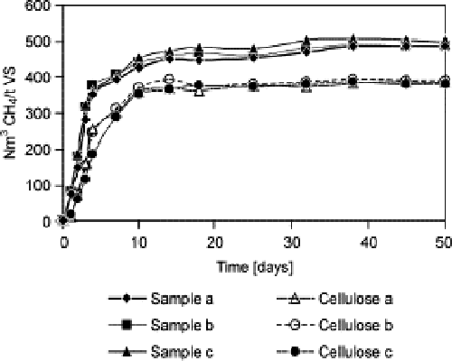Figure 1. Laboratory timescale for methane generation. Hansen, 396.
This very short time scale has very little to do with actual methane production under less-than-ideal conditions, such as those found within a typical sanitary landfill. However, it does give a good idea of the efficiency of the microbes in their task. In landfill conditions, most studies of LFG production and emissions assume a 25 year lifespan of methane emissions for waste (Peer 5). There are many reasons for this longer lifespan. Most likely landfills have a lower concentration of methane-producing microbes, the composition of the average landfill waste is not completely organic and as easy to convert to products such as methane. Even on this expanded time scale, however, much of the methane production is done within a relatively small fraction of the total lifespan of the waste, shown by EPA studies finding a “negative correlation between refuse age and CH₄ per ton” (Campbell 1). The longer organic waste sits in the landfill, the less methane it produces. The studies were not able to give an exact figure for methane production half-life or a similar measurement for actual landfills.
As with the large difference between timescales for methane production in laboratory and field settings, there appears to be a similar disparity between total methane generation in these two situations. However, if one is looking to maximize methane generation (to maximize the energy that could be harvested), then it is necessary to turn back to laboratory experiments to determine how efficiently we could produce methane from our municipal waste. In a laboratory setting (the same as above), an average of 495 ml CH₄ / g VS (volatile solid) for household waste was produced. For the cellulose control samples, a yield of 379 ml CH₄ / g VS was obtained (Hansen 396). More detailed information on these experiments and their conditions will be presented later on.

The amount of methane produced by both US and other landfills around the globe is a figure with incredibly large error bars, due to many problems with real-world measurements and estimates. In an attempt to improve the precision of these methane emissions estimates, in 1990 the Air and Energy Engineering Research Laboratory, an organization within the US Environmental Protection Agency, began studies of six US landfills to calibrate their estimates, and rapidly added over a hundred other landfills in the study in an attempt to develop an accurate statistical model (Campbell 1). In the early 1990’s, the current global estimates for landfill production of methane were 10-70 Tg/yr (teragrams per year, or million tonnes). This figure for landfill generated methane was part of a total 360 Tg/yr for anthropogenic sources (Doorn Barlaz 1). Of these total landfill methane emissions, it was estimated that the US alone contributed approximately 39% of the world total (Doorn Barlaz 2). Industrialized countries in general produce more landfill gas than developing nations, primarily because of their higher percentage of anaerobic sanitary landfills rather than open dumps. In 1992, for instance, the estimate of US landfill methane production was 9-18 Tg/yr of methane (Doorn Stefanski 1). The imprecision of the estimate for the US is telling of the problems involved in making global estimates. The US is a nation for which decent data on landfill size and composition is available, and the estimates still can’t be nailed down to anything better than a factor of two. Current estimates do not appear to be so readily available from the EPA.

As mentioned above, accurate global estimates, and those on a nation-by-nation basis, are even more difficult to obtain. The EPA uses a relatively simple (on the surface) equation to estimate methane emissions from each country.
Y = L * F *P/P_{US} * 47 * 10⁻³ * M - Y_{R}
where M = municipal solid waste generation rate * municipal population, Y_{R} is methane recovered or flared, and F is a country specific factor (Doorn Barlaz 2). It should be noted that in EPA project summaries dealing with landfill generated methane, sometimes the term “methane” is used, and sometimes the term “landfill gas” or LFG. Unfortunately, the terms are not interchangeable, as most LFG is only about 50% methane. This nomenclature issue is especially difficult to unravel in the oldest reports examined, those from the first few years of the 1990’s. Often in these reports, the actual gas that is meant seems unclear.

The country specific factor F provides the most problems when examining this calculation. It obviously depends on accurate statistical data taken from the country itself, which is often not possible in developing nations. Besides the aforementioned landfill/open dump problem, the exact composition of municipal solid waste can vary highly from nation to nation. The percentage of organic versus nonorganic waste makes a huge difference in methane production, as well as the percentage of easily converted organic wastes such as cellulose. For example, developing countries probably emit less methane from their landfills, because of a lesser percentage of paper (Peer 5). Paper is likely not the only major difference in waste generation between developed and developing nations. There is data available from some other nations on their own LFG generation, and some is presented below to contrast with the figures from the US.

India is a rapidly developing nation, with a burgeoning population, especially in its urban centers. In response to this demographic trend, they have done much examination and analysis of the issues involved with municipal waste and sanitary landfills, and correspondingly have developed decent estimates and models of their own landfill gas emissions. Estimated methane emissions from Indian landfills in 1999 were between 400 and 500 Gg/year (Kumar 3485). Though this is still about half a million tonnes a year of methane emissions, it is strikingly less than those of the US, especially considering the difference in population size.

Italy has also spent time researching LFG emissions from their landfills. Based on their research and data collected, they estimate that their sanitary landfills produce LFG at a rate of approximately 0.350 m³/ kg of solid urban waste. These researchers have also collected the most detailed information on quality of LFG that was readily available. Their test landfill services an urban area of approximately 400,000 inhabitants, has a surface area of 234,000 m^{2,} and has a total allowed capacity of 2,000,000 m^{3.} It has been operating since 1984, and receives about 160,000 tonnes of waste per year (Desideri 1970-71). Below are figures detailing their LFG collection from 72 different wells on the site, showing composition of the gas.
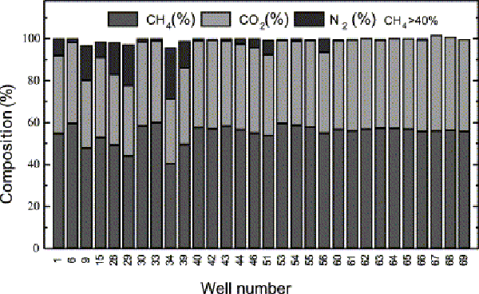Figure 2. Wells with greater than 40% methane content. Desideri, 1974.

As can be seen, nearly half of the wells produce high-quality LFG. The wells with the lowest methane content also have the highest nitrogen content, meaning that there is more air penetrating underground and the conditions are not perfectly anaerobic.
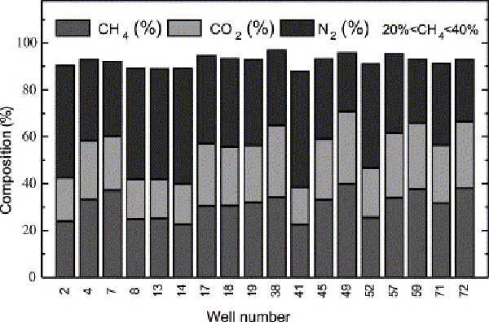Figure 3. Wells with 20%-40% methane content. Desideri, 1974.
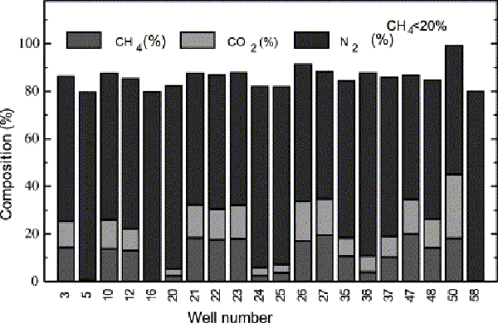Figure 4. Wells with <20% methane. Desideri, 1975.
Obviously, the amount of methane produced in a nation’s landfills depends upon the amount of solid waste deposited into the landfills. Approximately 248 Tg/yr of solid waste is deposited into US landfills (Doorn Stefanski 1). The estimate for the total amount of waste that had been landfilled in the US, up to and including the year 1986, was 4.7 x 10¹⁵ g, or 4700 Tg of solid waste (Doorn Stefanski 2). Obviously, the rate of solid waste deposition in US landfills has increased drastically through our history, as it would take less than 20 years at our current rate of waste to match our historic total. This is neglecting loss of mass due to methane generation, but it is still a shocking value.
The history of landfill gas recovery for energy generation purposes is actually a very short one. Landfill gas has most likely been captured and flared off for somewhat longer, for purposes of safety and odor control, but the exact date for this procedure is unclear. The first actual LFG to energy project came online in the US in 1975. The initial site was the Palos Verdes landfill, in Rolling Hills, CA. In this particular project, landfill gas was purified into pipeline quality natural gas and shipped offsite for use (Thorneloe 4). This is not the case with the majority of LFG to energy projects, however. Since the early 1980’s, most projects have been LFG direct to electricity, or some other onsite or local use of relatively unpurified LFG. Fifty three percent, over half, of LFG to energy projects use reciprocating internal combustion (RIC) engines (Thorneloe 5). There has been an evolutionary change since the first RIC’s as well. The oldest models used high pressure fuel delivery systems, while the majority of modern designs utilize low pressure (<2 psi) LFG (Thorneloe 11). Because of the not-entirely-predicable flow of LFG, the low pressure designs would be more reliable.
Even before the push for more accurate estimates of methane emissions in the early 1990’s, the EPA did have computer simulations and models running. However, their “deterministic kinetics-based model” was acknowledged as having some flaws, and needed calibration with better data (Peer 2). Thus, the AEERL studies were conducted. The computer model utilized the equation
Q_{CH4} = L₀ R (e^{-kc} – e^{-kt})
where L₀ is potential generation capacity, R is Mg/yr of solid waste deposition in landfills, k is 1/yr, c is years since closure, and t is years since opening. C=0 would be an active landfill (Peer 4). The AEERL studies attempted first to find simple correlations with easily measured factors. They determined that a usably precise model, not necessarily the best but one with simple factors, was
CH₄=4.52W
with CH₄ in m³/min, and W is waste in 10⁶ Mg (Peer 2). Using this simple statistical model, they managed to calibrate the EPA computer model for the US with L₀=162 (Peer 4). However, this is still useless for outside the US.
Whether or not enough of this LFG is recovered to produce a useful amount of energy is another story entirely. In 1992, ~1.2 Tg of LFG was recovered, presumably for energy generation purposes, and ~0.5 Tg/yr was flared off (Doorn Stefanski 2). As of December of 1994, 137 LFG to energy projects were running in the US (Thorneloe 2). There were estimated to be 270 sites in 20 countries that were recovering LFG (Doorn Barlaz 1). In accordance with provisions of the Clean Air Act, from 1995-2000 all sanitary landfills with 2.25 million tonnes of solid waste were supposed to install LFG extraction systems (Thorneloe 3). The aim by 2000 was to have emissions controls in place at approximately 500-700 sites, with the stated goal of reducing emissions by some 5-7 Tg/year, a sizable reduction (Doorn Stefanski 2). Whether this occurred as it was supposed to is debatable. According to the EPA website, by the end of 2004 there were some 380 operating LFG to energy projects in the US (http://www.epa.gov/lmop/proj). However, how many total LFG recovery systems, including those that simply flare it off, is not stated. As an aside, the New Source Review considers LFG recovery systems to be pollution prevention projects (Thorneloe 7).
LFG is not pure methane, and as such has a lower energy value than natural gas. Calculations of energy potential from LFG sources need to take this difference into account. Pure methane is has an energy value of ~37 MJ/m³ (Doorn Pacey 2). LFG, on the other hand, with its lower proportion of combustible compounds, has an energy value of only ~19 MJ/m³. Besides the methane, nitrogen, carbon dioxide, and other gases mentioned earlier, LFG also contains some corrosive nonmethane compounds, including some chlorine compounds (Doorn Pacey 1). These corrosive compounds, and their affect on equipment, add another layer of difficulty to LFG to energy projects, and will be discussed below.
Obviously, because of impurities present in landfill gas, before any burning can take place there must be some scrubbing of the gas. Modern cleanup systems reduce LFG to 3ppmv (parts per million by volume) chlorides, and 3 ppmv sulfur (Doorn Pacey 2). Even with this purification of the gas, there are still major issues with corrosion within equipment such as RICs. However, many of these problems can be avoided with proper materials. Primarily, concerns include avoiding carbon steel wherever liquids could be present, and chrome plating important parts of RICs (such as valves) (Thorneloe 8). These simple material modifications can drastically reduce the chances and rate of corrosion, making the equipment more reliable and the entire operation more economical.
Increasing the methane yield from decomposing organic waste beyond what could just be recovered from existing landfills would require either improved landfill designs, or the creation of purpose-built biogas plants. There has been research into purpose-built landfills (PBLF) in India for increasing methane yields. As they have relatively few existing sanitary landfills, and more open dumps, they have the advantage of starting with a clean slate rather than trying to retrofit existing landfills. The Indian PBLF design statement calls for “a semi-engineered landfill with gas recovery and leachate collection system targeting at methane harvest” (Yedla 501). They claim that in tropical countries, with the warm, wet climate that would be amenable to the microbes, and shredding of organic waste, they can achieve a yield of 720 m³ LFG/ tonne of waste. They further believe that they can produce a higher quality of LFG than average, with 60% methane content (Yedla 505). The leachate collection would most likely be similar to those installed in Taiwanese landfills, where the leachate is collected at bottom of landfill through piping system. The leachate could then be either pumped back up to the top of the landfill and allowed to drain and filter through the landfill again, run through a separate water treatment system, or just evaporated to the extent possible (Weng 184-5). Allowing it to filter again through the landfill would be an economical option, as well as keeping the soil and waste moist for peak microbe conditions. It does increase the possibility of accidental leachate leaks into the surrounding soil, however.
In purpose-built landfills or biogas plants, the conditions would be easier to control for peak methane production. Experiments have shown that the prime operating temperature is 55 °C (Hansen 393-394). With extensive pretreatment of waste, including shredding, and mixing with water to “an appearance as thick gravy,” experiments have managed to yield as high as 94% of theoretical maximum, though this is with the glucose control samples. For more probable waste, such as paper, a yield of ~60% is more realistic (Hansen 394-397). It should be noted that the experiments used an inoculum from an existing Danish biogas plant to obtain their microorganisms. As such, there may have been a higher than average microbial content than would be found in a typical sanitary landfill (Hansen 394). However, these results do give at least a general idea of what the possible efficiency could be.
The social aspect of landfill methane generation is important, because the source is mostly household waste. Any attempts to either increase or decrease the amount of methane generated in sanitary landfills would require some changes in the way that Americans dispose of their garbage. Specifically, to effect any significant change in landfill gas generation would require manual presorting of waste, into compostable and noncompostable solid waste (Yedla 503). Because of the enormous effort, and thus probably expense, that it would take to do this sorting at the landfill, segregation would almost certainly need to happen at the level of the individual household. In the example of the Italian landfill, 78.4% of the waste was “normal household waste” (Desideri 1971). Thus, presorting at the household level makes a large difference in the composition of the landfill. Similar efforts have been made to separate recyclables from normal garbage over the last few decades, with some success. Using this social trend as an example, it does not seem improbable that organic and nonorganic waste could be successfully sorted at the household level. As an interesting aside, the Indian PBLF also requires extensive presorting of waste to attain its high methane levels. However, due to major differences in Indian and American society this is fairly easy for them to achieve. Specifically, in the city of Mumbai that they studied (population 12 million), there is a population of some 100,000 “ragpickers” who each collect about 12 kg of noncompostable solid waste per day (Yedla 504). This makes any effort to sort at the landfill unnecessary.
To this point, this essay has focused on usage of LFG for energy purposes. Many landfills do not do this, and instead simply flare off the LFG that collects to prevent buildup of toxic and dangerously combustible gases. Is this truly a good option? The question of what is the best-case scenario for dealing with LFG also requires examining what is the best way to deal with organic waste. As stated at the beginning of the paper, methane is a far more destructive greenhouse gas than is carbon dioxide, at least on a ton by ton basis. It is approximately twenty times as potent as CO₂ in its ability to warm the Earth’s atmosphere (Doorn Stefanski 1). Only anaerobic conditions produce methane. Under aerobic conditions, essentially only carbon dioxide is produced. This is the case in composting, for instance.
If the aim is to reduce methane emissions from existing landfills, and not utilize landfill gas for energy purposes, there are several options. The first is that of passive biofilters, or layers of soil covering the landfill containing methanotrophs. Methanotrophic microorganisms all utilize the enzyme methane-mono-oxygenase to consume methane and convert it back to carbon dioxide and other products, both gaseous and nongaseous (Streese 573). One of the main problems with passive biofilter systems, such as this, is the issue of aerobic versus anaerobic conditions. The methanotrophs require aerobic conditions to live and operate, thus making them a problematic match for the primarily aerobic conditions of current landfills.

Active biofilter systems are also a possibility. These systems require tapping the landfills, as is done in other LFG recovery systems, and running the resulting gas through a reactor system including methanotrophs. In research done in Germany, it was necessary to install both air pumps to feed oxygen to the methanotrophs, and an automated sprinkler system to keep the exothermic process from drying out the filter material (Streese 574-5).The filter material used, in which the methanotrophs were embedded, consisted of yard waste compost for its nutrient value, peat for its moisture retention value, and squeezed wood spruce fibers to mitigate clogging by exopolymeric substances. These substances are a byproduct of the methanotrophs, and tend to clog up filtration media (Streese 573-5). This may seem like an excessive amount of effort to be expending to oxidize methane when it is nearly as simple to utilize it for energy. This particular biofilter system was designed to be utilized in old landfills, where it would no longer be economically feasible to extract LFG for energy purposes (Streese 573).
Home composting is another option for reducing LFG emissions, by reducing the amount of organic waste sent to landfills in the first place. It produces high-quality mulch for gardening, and could reduce the waste sent to landfills each year by approximately 23 percent, according to the EPA’s website on home composting (http://www.epa.gov/epaoswer/non-hw/composting/index.htm). However, aerobic decomposition as in home composting does still produce carbon dioxide, and would not seem to reduce greenhouse gas emissions considerably better than recovery systems for LFG. Most studies of landfills assume a recovery efficiency of 75%, and oxidation of methane of 10% (Doorn Stefanski 2). This does still leave 10% of LFG that is assumed to escape into the atmosphere, and it is this fraction that could be reduced by home composting. Unfortunately, this option requires an even greater lifestyle change, and effort, from the average American than does waste presorting.
Another option, and one that is already in use some places, is the construction and operation of biogas plants. These plants could do a more efficient job of converting organic waste to methane and thus energy, with most likely lower risks of accidental emissions, and would also produce effluent that would be useful for fertilization purposes (http://www.eere.energy.gov/consumerinfo/factsheets/ab5.html). Unfortunately, these plants would have even higher operating costs than LFG recovery systems, and a higher capital investment cost, making them less likely to be funded and built in the current political climate. They are also mainly outside the subject of this paper.
With all of this detailed information on LFG production, the question is still yet to be answered: how much energy can we reap from this source? Assuming a fairly conservative figure for US LFG emissions, 10 Tg/yr, a recovery efficiency of 75%, a utilization efficiency of 50%, and the energy value of 19 MJ/m³, we can make a simple calculation.

$$\text{10}\frac{\text{Tg}}{\text{yr}}∗1\text{.}\text{33}\frac{L}{g}∗\text{19}\frac{\text{MJ}}{m^{3}}∗0\text{.}\text{75}∗0\text{.}\text{50}=9\text{.}5x{\text{10}}^{\text{10}}\frac{\text{MJ}}{\text{yr}}≈3\text{GW}$$

This is assuming a fairly high quality of gas, and a simple composition of 50% methane and 50% nitrogen. The density of the gas is an estimate, based on the density of N₂ at STP, 1.145 g/L (CRC 4-72). The CRC did not have a density for methane at STP, so some reasoning was used. As the composition of LFG can vary highly, this figure should suffice for a simple estimation. Italian researchers estimated that, using only currently operating wells and capture systems, global energy production could be as much as 100 GWe / yr, and an additional 7.3 GWt if cogeneration setups are used (Desideri 1981). This seems like an overly optimistic figure, if the US produces 2/5 of the LFG and only has a possible 3 GW of capacity. Their estimate did not specify how they arrived at their figure.
Utilizing the information above, it should be safe to say that energy utilization of landfill gas is a useful aim and project. Modern societies generate a tremendous amount of waste, much of it organic in nature. The best case scenario for the decomposition of this waste results in carbon dioxide emissions into the atmosphere. Our choices appear to be emission of carbon dioxide, or capture of landfill gas, eventual combustion, and then emission of carbon dioxide. An estimated 100 GW of electricity may not be a tremendous amount, however, it is a case of putting our waste to use in what is an environmentally benign manner. This steady source of methane could become even more important as fossil fuel supplies dwindle. It can be used to produce natural gas, electricity, heat, or even hydrogen in steam methane reformation. If landfills are required to recover their LFG to prevent emission into the atmosphere anyway, utilizing it for power generation is a small step. Landfill recovery projects operating for three decades now show it to be a proven source of energy, and one that will become more and more economically attractive as fossil fuel prices continue to rise.

References
Campbell, Darcy, et al. "Project Summary: Analysis of Factors Affecting Methane Gas Recovery from Six Landfills." Research Triangle Park, NC: Air and Energy Research Laboratory, Environmental Protection Agency, 1991.

Composting. 10 Dec. 2004. Environmental Protection Agency. 24 April 2005. <http://www.epa.gov/epaoswer/non-hw/composting/index.htm>

Desideri, Umberto, Francesco Di Maria, Daniela Leonardi and Stefania Proietti. "Sanitary Landfill Energetic Potential Analysis: A Real Case Study." Energy Conversion and Management 44.12 (2003):1969-1981.

Doorn, Michiel R.J., and Morton Barlaz. "Estimates of Global Methane Emissions from Landfills and Open Dumps." Research Triangle Park, NC: Air and Energy Research Laboratory, Environmental Protection Agency, 1995.

Doorn, Michiel, John Pacey, and Don Augenstein. "Landfill Gas Energy Utilization Experience: Discussion of Technical and Non-Technical Issues, Solutions, and Trends." Research Triangle Park, NC: Air and Energy Research Laboratory, Environmental Protection Agency, 1995.

Doorn, Michiel R.J., Leonard A. Stefanski, and Morton A. Barlaz. "Estimation of Methane Emissions from US Landfills." Research Triangle Park, NC: Air and Energy Research Laboratory, Environmental Protection Agency, 1994.

Hansen, Trine L., et al. "Method for Determination of Methane Potentials of Solid Organic Waste.” Waste Management 24 (2004): 393-400.

Information Resources. 14 June 2004. Department of Energy. 24 April 2005. <http://www.eere.energy.gov/consumerinfo/factsheets/ab5.html>

Kumar, Sunil, et al. "Estimation Method for National Methane Emission from Solid Waste Landfills." Atmospheric Environment 38.21 (2004): 3481-3487.

Landfill Methane Outreach Program. 27 April 2005. Environmental Protection Agency. 5 May 2005. <http://www.epa.gov/lmop/proj>

Lide, David R., ed. CRC Handbook of Chemistry and Physics, 85th ed. Boca Raton, FL: CRC Press, 2004.

Peer, Rebeccca L. "Project Summary: Development of an Empirical Model of Methane Emissions from Landfills." Research Triangle Park, NC: Air and Energy Research Laboratory, Environmental Protection Agency, 1992..

Streese, J., and R. Stegmann. "Microbial Oxidation of Methane from Old Landfills in Biofilters." Waste Management 23 (2003): 573-580.

Thorneloe, Susan A., John G. Pacey, and Michiel Doorn. "Technical and Nontechnical Issues Regarding Landfill Gas to Energy - What is their Impact on the US Landfill Gas Industry." Presented at the Fifth International Landfill Symposium, Cagliari: Italy, 1995.

Weng, Y.C., and Ni-Bin Chang. "The Development of Sanitary Landfills in Taiwan: Status and Cost Structure Analysis." Resources, Conservation and Recycling 33.3 (2001): 181-201.

Yedla, Sudhakar, and Jyoti K. Parikh. "Development of a Purpose Built Landfill System for the Control of Methane Emissions from Municipal Solid Waste." Waste Management 22 (2002): 501-506.

