Photovoltaic Cells and the Role of Solar Power in Energy Production
David Mar
Phys. 80, Spring 2005

The idea of generating electric power from sunlight has been around for over a hundred years. However, photovoltaic technology emerged as a significant player during the 1970’s oil crisis when much effort began to go into decreasing our dependence on fossil fuels for electricity. After oil prices settled, solar power was used primarily for special applications such as on spacecraft and not for generating consumer electricity. In more recent years the technology has developed and the cost of PV technology has become more competitive (albeit with government incentives) with traditional energy sources. Combined with the heightened awareness of the limited supply of non-renewable sources as well as environmental concerns, some consumers (residential as well as utility) are choosing to install PV systems of their own. The current PV market is dominated by two cell types, crystalline and amorphous silicon. Demonstrations with alternative materials show potential for cost reduction to help PV technology compete with other energy sources.

Photovoltaic Physics and the pn-Junction
We can make electron-rich “n-type” as well as electron-poor “p-type” semiconductors by adding trace amounts (doping) a standard semiconductor material (say, silicon) with other substances, generally IIIB or VB elements like gallium (p-type) or arsenic (n-type). When p and n-type semiconductors are placed in contact we create what is known as a pn-junction. Through doping, we change the structure of the allowed energy states for electrons in the materials and when placed in contact, charge imbalance and a resulting electric field is generated spanning the junction. When light radiation strikes the n-type semiconductor, electrons from the full and stable valence energy band may be excited to the conduction band and flow through the intrinsic electric field to generate a current. If we connect the two semiconductor types through an external contact completing the circuit, then there is charge flowing through a potential difference generates power output according to P = IV.
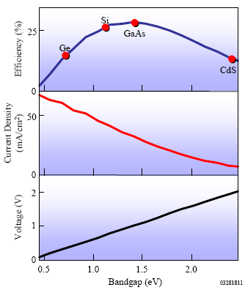
Bandgap Energy
The specific semiconductor property that most influences how a pn-junction responds to incident light is the bandgap energy (E_{g}). This is the energy required to excite an electron from the top of the valence electron band to the conduction band. Therefore, any photon with energy less than E_{g} will pass through the semiconductor unabsorbed. On the other hand, light with at least the bandgap energy may be absorbed by an electron. However, excess photon energy beyond E_{g} will result in electrons being excited deep into the conduction band and quickly falling to the lowest open energy state in that band, giving off thermal energy not transferred to power in the circuit. As shown in the above figure, a material with large bandgap will have a large potential difference since electrons must pass through an electric potential proportional to the bandgap energy in order to complete the circuit. However, fewer photons will be absorbed with such large bandgap energy which results in a smaller current. Notice that the current (a measurement of photon absorption rate) does not depend on bandgap linearly, as in the case of voltage. This is due to a third factor involved: the non-uniform intensity of sunlight over a range of wavelengths. Based on a blackbody spectrum, the sun emits most strongly near the visible and UV range of light, so it is important that the semiconductor be able to absorb these photon energies. In the figure efficiency is a rough proxy for power output and it should be noted that this efficiency is an ideal conversion ratio of total incident light energy. It turns out that the optimum bandgap energy is about 1.4 eV, corresponding to a light wavelength of 880 nm, slightly beyond the low (energy-wise) end of the visible spectrum into UV light.
Theoretical voltage and current flow based on bandgap energy. Current, which is proportional to # absorbed photons, decreases, while the voltage increases with larger bandgap. Using relation between power, current, and voltage, we see efficiency maximum E_{g} ~1.4 eV. (Figure from National Renewable Energy Laboratory multijunction PV cell report)
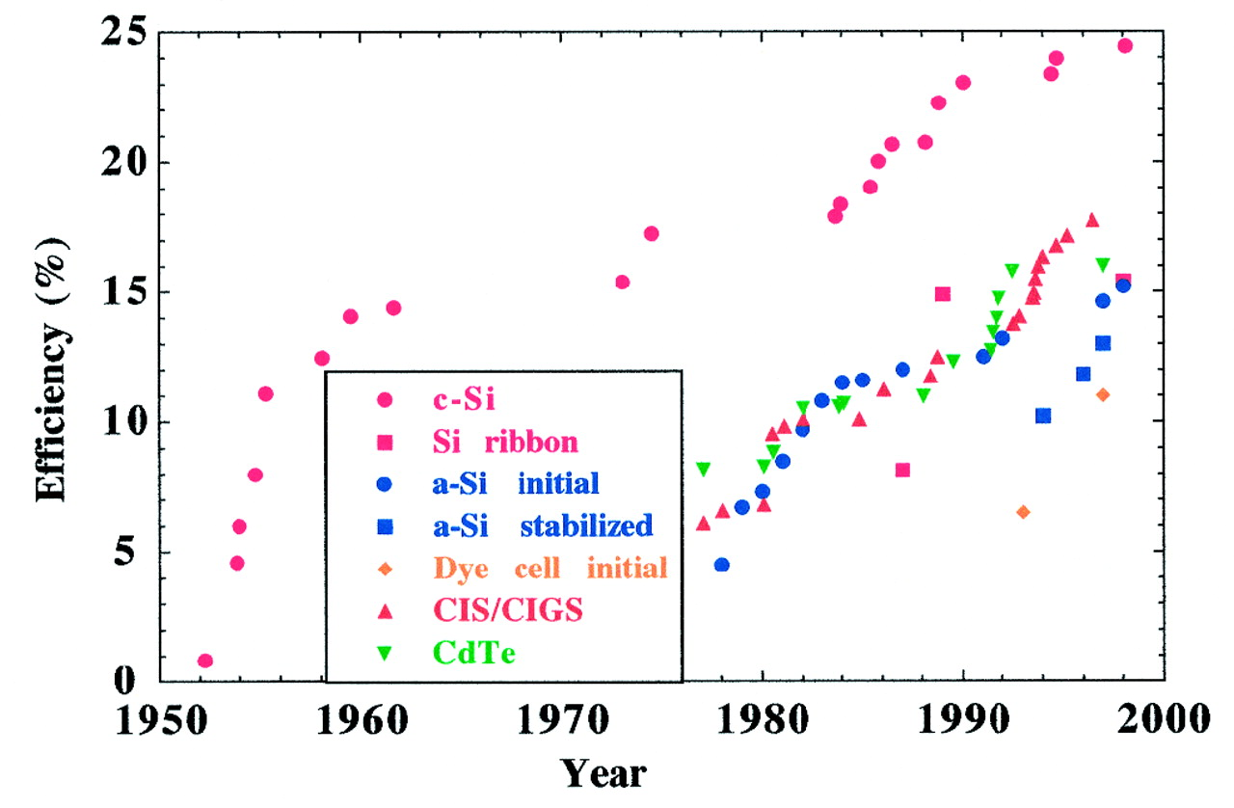
Conversion Efficiency
The topic of bandgap energies limiting potential power extraction from sunlight leads to a discussion of other factors influencing conversion efficiency and ways to enhance efficiency. A given surface will receive a total amount of radiation energy from the sun, however, as shown above, a PV cell cannot convert the entirety of this to electric power, since a given bandgap size results in photons being excluded from absorption or loss of energy beyond E_{g}. With the simple single-junction PV-cell, the technical efficiency maximum lies at 20-30% depending on material used, with typical commercial module efficiencies <15%. The figure above shows the evolution of cell efficiencies over the past half century.
Efficiency evolution for various types of PV cells. The high-efficiency cells (and oldest) are single-crystalline silicon. The younger, less efficient (and generally cheaper) types are shown as well. (Figure from Science magazine)
One technique to increase this value is through using a “multijunction” cell, which effectively consists of stacking cells in order of descending bandgap energies. This way, the top cell, with largest bandgap, will absorb the most energetic photons and allow lower energy photons to pass through to the second cell with a slightly smaller bandgap, and so on. The waste of excess energy above bandgap levels is decreased. While expensive and more difficult to produce, current multijunction cells can reach conversion efficiencies (under concentration, explained later) of 35%, making them ideal for situations limited by absorption area, such as on satellites or spacecraft. Efficiencies of up to 42% are projected with materials engineering yielding ideal bandgap energy candidates for cell layers. Currently, tandem or triple-junction cells are implemented for practical applications. Along a similar vein, research is being done on increasing total conversion efficiency by adding impurities (not doping) to the semiconductor, giving rise to energy levels in the previously forbidden band between valence and conduction (Brown). This allows electrons to be excited in two-steps (or more) to the conduction band, and the subsequent absorption of lower energy photons that are normally unavailable.
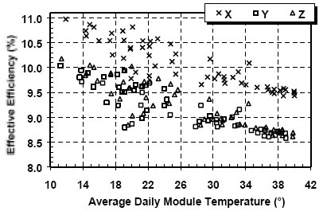
Another important contributor to conversion efficiency is the cell operating temperature. As the temperature increases, semiconductor resistance decreases and this results in a reduction of cell power output. The cells will be heated from absorbing photons with E > E_{g} (where excess energy becomes thermal energy) as well as from low energy infrared light. The theoretical result is affirmed experimentally, as shown in the figure to the right, which shows among each module X, Y, and Z a systematic efficiency reduction at higher temperatures. Temperature effects are generally unavoidable as the cells must be placed in direct sunlight, as opposed to shade. In some cases where the efficiency is significantly affected, it is worthwhile to expend energy cooling the cell for the resulting efficiency gains.
Efficiencies for 3 PV modules as a function of temperature. There is a decrease in efficiency for greater temperatures. (Figure from National Renewable Energy Laboratory: Polycrystalline Silicon Cell Performance, prereport)
There are other power loss factors that decrease cell efficiency. For example, any light reflected from the outer cell covering or otherwise blocked from absorption (perhaps from dust or other buildup) is lost to the cell. Similarly, light may be reflected from the semiconductor material itself or pass through unabsorbed. We also see power losses from circuit resistance in the conductors completing the external circuit, particularly at the boundaries between semiconductor materials and front/back conductor contacts. One other influential factor in efficiency is related to the semiconductor material used. While we are interested in a current of sunlight-excited electrons, there is a small “recombination” current in the opposite direction. The recombination current effect is heightened by the presence of minute defects in the periodic crystal structure, so a pure and highly organized atomic structure is desired for highest efficiency. Finally, if the owner of a PV module would like to be able to sell excess electricity back to the grid, a DC – AC inverter is required, which decreases power output by about 6% depending on the inverter.

Photovoltaic Cell Designs
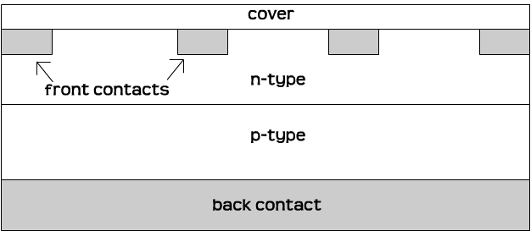
A very simple photovoltaic cell capable of generating a direct current from incident light consists of an n-type material layer stacked over a p-type layer with the external circuit completed through front and back contacts. An opaque front (side of incident light) contact cannot cover the entire surface or it would block all incident light, while the back contact usually spans the entire bottom surface. The entire module is covered by a transparent encapsulation material to protect the semiconductor material from the environment. One alternative design consists of a pin/nip-junction, in which undoped “intrinsic” semiconductor material is placed in the center, across which the electric field is stretched. The result is that excited electrons do not have to depend on diffusion for movement, as the electrons are excited directly in an electric field.
Example layering scheme for a simple PV cell.
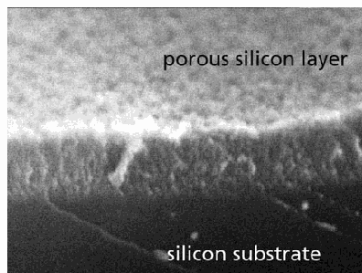
In addition to the layers in the figure shown above, PV cells may have an antireflective coating below the encapsulating cover to reduce the amount of light reflected from the cell and help improve efficiency. An example is using porous silicon (PS) to reduce reflection from the semiconductor. This consists of an etched silicon surface with small variations on the order of nanometers. The PS layer is formed through “electrochemical etching” of the silicon by submerging it in a highly acidic solution for a short time. This is a relatively easy production process and results in a significant reduction in reflectance in the visible range as shown in the figure below. We can also use a reflection enhancer below the p/n layers increase utilization of photons that are not absorbed by the semiconductor.
Magnified view of porous silicone antireflective coating over standard substrate. (Fig. credit: Martin-Palma)
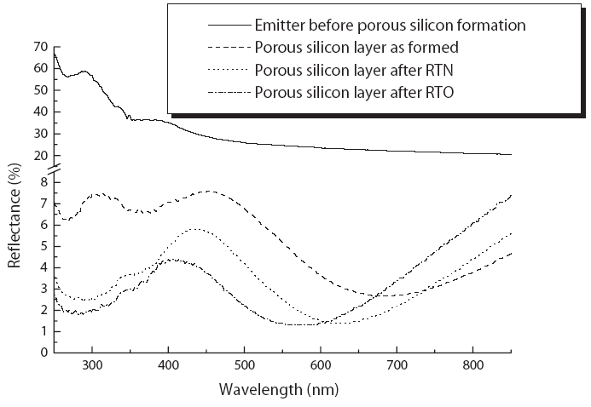
Semiconductor reflectance before and after application of PS layer. RTN and RTO are further treatments. (Fig. credit: Martin-Palma)
Another improvement over the basic layering is made by replacing the front contact with a transparent conductive oxide (TCO) such as tin oxide. With a transparent front contact with low rate of absorption, more of the total incident sunlight is able to reach the semiconductor. We also see a reduction in resistance as the contact area covers the entire cell and we know resistance is inversely proportional to conducting cross-section area. Ideally, the TCO has low resistance and high optical transparency (>90%). Losses from absorption should be offset by efficiency gains from decreased resistance. This will also make production easier and less resource intensive, as the front contact can be formed through chemical deposition instead of mechanically forming a grid of a standard conducting metal.

Photovoltaic Cell Materials and Production
The first widespread and still the most prominent photovoltaic semiconductor material is silicon. Silicon has a band gap energy of E_{g} = 1.07eV, near the optimum 1.4eV for solar radiation, making it a good candidate for use in PV cells. Unfortunately, without surface texturing (as described above) it is quite reflective in the visible wavelength range of light which we are primarily interested in for solar cells. Silicon can take a variety of forms including Single-Crystal, Polycrystalline, and Thin-Film (Amorphous). In each form the silicon must be purified to electronic grade polycrystalline silicon with impurity rate of 1 part in 10 million. The primary cost for PV cell production lies in the feedstock cost for this silicon and in recent years the bottleneck to PV production growth has been the availability of solar-grade silicon. For example, the price of solar-grade silicon was $9/kg in 2000 and jumped to $25/kg last year and is currently $60/kg (Reuters).
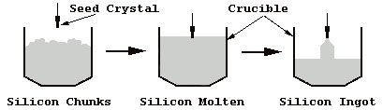
As the name implies, Single-Crystal silicon is formed from one large silicon crystal, meaning that the atomic structure is uniform throughout the material. This results in less structural defects and fewer recombination events at defect sites. The primary method of production of Single-Crystal Si is through the Czochralski (choh-KRAL-skee) process. A small seed crystal is placed in contact with molten n/p silicon (melted at 1400 degrees) then withdrawn very slowly, pulling behind it a cylindrical single crystal that follows the pattern of the seed. This process is difficult and must take place in an inert environment to avoid contamination. After the silicon ingot is formed it must be sawed into wafers 200-400 μm thick, making the production even more complex and resulting in 40-50% of the silicon material being lost as sawdust. Polycrystalline silicon, on the other hand, consists of many silicon crystals, which leads to a high level of recombination due to the crystal boundaries and efficiencies 2-4% lower than single-crystalline. This type is produced much more easily, however, as molten silicon can be cast directly into a mold and subsequently sliced into wafers. Also, we can obtain square wafers this way, allowing a more efficient use of absorption surface over the circular wafers.
Czochralski process for producing a silicon ingot. (Figure from wikipedia.org)
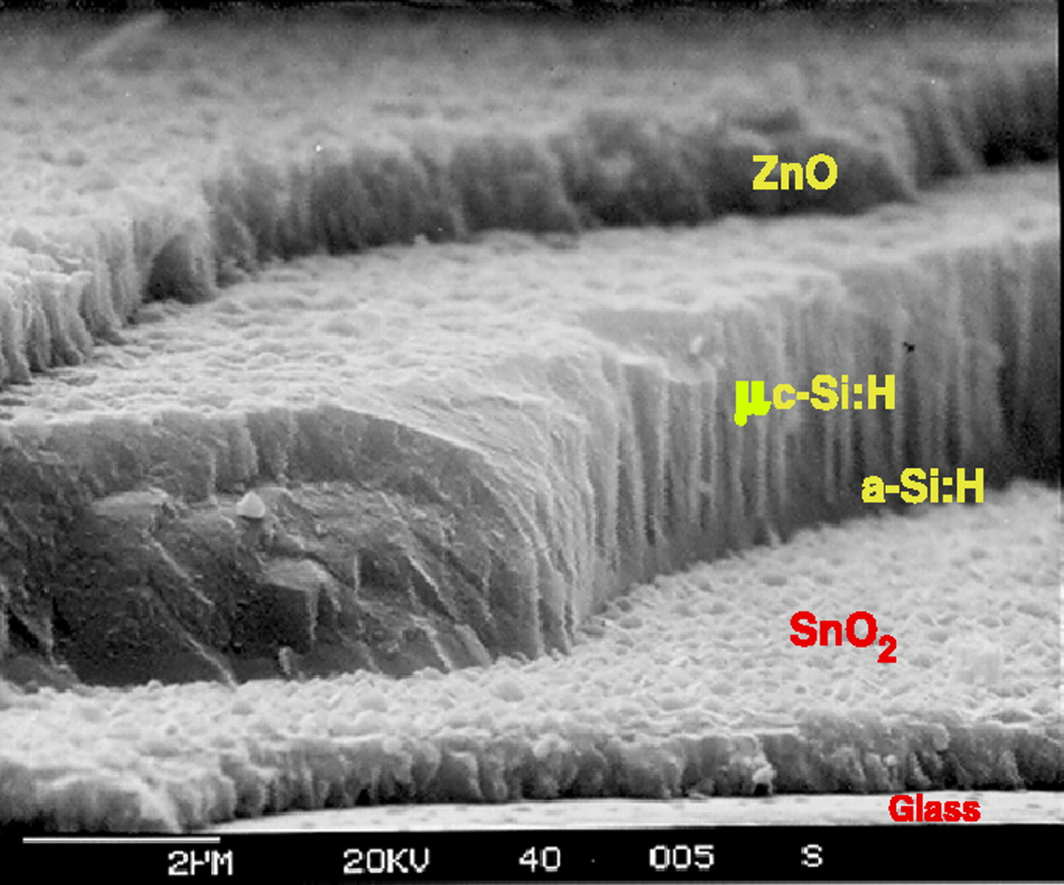
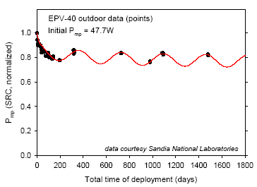
Thin-film cells are currently emerging as the substitute for the traditional silicon wafers in photovoltaic cells. The main advantage with thin-film silicon is inexpensive production processes via vapor deposition of atom-thick layers on top of one another. As a result, much less semiconductor material is required (or wasted). The entire cell stack can be formed by deposition of contact material (TCO), semiconductor layers, and antireflective coating one on top of another. Deposition rates via plasma-enhanced chemical vapor deposition are on the order of a few angstroms per second, but research is being done on processes allowing rates of hundreds of angstroms per second. Since layer thickness for thin-film cells are less than 10μm, total deposition time for a layer would be a few hours. The first widely produced thin-film cells were amorphous silicon, which does not have a periodic atomic pattern, as with the crystalline forms, but is instead like glass with no particular crystal structure. This results in a large number of defects and dangling bonds (due to Si atom bound to <4 other atoms) that hinder electron flow and increase the probability of recombination events. As a result, amorphous silicon has lower conversion efficiencies of 13% in lab and 4-8% observed commercially. One way of moderating this effect is through hydrogenation, in which added hydrogen atoms interact with the dangling bonds, making the material more uniform to facilitate smooth electron flow. One interesting attribute of hydrogenated amorphous silicon is the Staebler-Wronski effect, through which the solar cell output is degraded by up to 20% during initial exposure to sunlight, as shown in the left figure (bottom). Sources of this effect are still speculative. Other than relative ease of production through low-temperature deposition on simple substrates (plastic, glass), an advantage of amorphous silicon is its high absorption rate, allowing desired absorption levels with layer widths of even 1 μm (compared to hundreds for crystalline wafer forms). Cheap production processes and efficient absorption make this form well-suited for small consumer devices like watches and calculators that do not require large power inputs. Amorphous silicon cells are produced in quantity second only to single-crystal cells and will continue to play a large role in the PV industry as long as production costs are a concern.
Magnified view of amorphous silicon and microcrystalline (thin-film) silicon in tandem (2-junction) cell. In this case, tin oxide acts as TCO and zinc oxide acts as back contact. (Figure from Science magazine)
Long-term outdoor performance of amorphous silicon. Notice an efficiency drop from initial levels (Figure from Sandra Nat’l Lab)
Despite the prevalence of silicon in photovoltaic cells, there are other materials emerging in the PV market with advantages over silicon. For example, Cadmium Telluride (CdTe) is highly absorptive, so it can be used in thin-film cells and it has a nearly ideal bandgap of 1.44 eV with record laboratory efficiency of 16.4% (NREL) and commercial efficiencies of 8-9%. While cadmium is a toxic material, CdTe modules contain only 0.1% cadmium by weight, with as much contained in an 8 sq. ft. module as a single nickel-cadmium battery. Cheap thin-film production of CdTe cells and low material costs make CdTe a good option for cheap PV systems in the future. Currently, researchers are trying to solve the problem where the contacts in a CdTe cells grow unstable and resistive. Another material used in thin-film cells, Copper Indium Diselenide (CIS) has extremely high absorptivity such that 99% of incident radiation (of the proper energy) is absorbed in 1 μm of the material. The natural bandgap energy is 1.0 eV, but this can be increased by introducing impurities. Despite the multicrystalline nature of the thin-film, CIS has the record thin-film efficiency of 19%. An interesting PV material is Gallium Arsenide, a “III-V” compound semiconductor that consists of a mixture of IIIB and VB elements. The bandgap energy of GaAs is 1.43 eV, quite near the optimum, and has high absorptivity, as well as low temperature sensitivity. GaAs can also be alloyed with other materials to tweak the bandgap energy, making it ideally suited for multijunction devices, which can reach efficiencies of 30%. Unfortunately, Gallium is rare and quite expensive, making large-scale implementation difficult. However, the high efficiencies make GaAs cells fitting for satellites and other space operations.
Photovoltaic Cell Life Cycle
One of the primary goals in developing PV technology is to reduce our use of fossil fuel for energy. At this point, the energy required for PV production generally comes from fossil fuel sources. Depending on how much energy is required in production and how much energy is produced over its lifetime, PV cells may not be energy efficient. Primary energy inputs for putting PV cells to use include constituent material production, fabrication, and transportation. The electricity production efficiency of the cell is then the lifetime energy generation divided by input energy costs. In terms of material costs, aluminum framing and encapsulation make up the majority of both cell mass and energy costs, as well as transportation costs. For the fabrication of the cell, encapsulation is quite energy intensive, but in the case of thin-film cells, deposition of various layers is most energy costly. On net, it turns out that energy inputs for frame material is the single most significant cost, as opposed to semiconductors or other deposition materials. The energy payback time is highly dependent on the climate (annual kWh of incident light) as well as cell efficiency, but ranges from 2-3 years (high annual light & efficiency) to over 13 years (low light & efficiency). Net lifetime electricity production efficiencies have similar dependence on annual energy output, as well as the module’s expected lifetime. Average values for this are 3-7. It is apparent from the energy-economics of PV cell production that we achieve a reduction in net fossil fuel use even if the initial energy inputs are from fossil fuel sources.

Photovoltaic Cell Systems
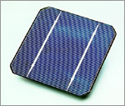
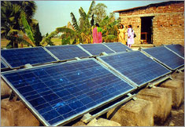
Individual PV cells in the form of crystalline wafers, or thin-film sheets are just the building blocks for photovoltaic modules capable of generating usable electricity. For most residential use or other building-integrated systems, cells are arrayed on a large flat surface attached in series such that the small individual cell voltages combine to generate a useful DC voltage. Flat-panel systems themselves lack any moving parts, greatly reducing the need for maintenance and extending the expected lifetime of about 20 years for most cell types. Taken to the extreme, flat-panel systems may play a role as Building-Integrated Photovoltaics, where PV cell arrays also act as construction materials for a building, such as windows, skylights, awnings, etc. Rooftop systems do not track the sun’s path across the sky and will generally be oriented southward facing and tilted up from horizontal by about 30 degrees to receive both direct and reflected (from ground) sunlight.
A single PV cell. (Picture from U.S. DOE Solar Energy Technologies Program site)
A full rooftop PV system located in Bengal, India. (Picture from U.S. DOE Solar Energy Technologies Program site)
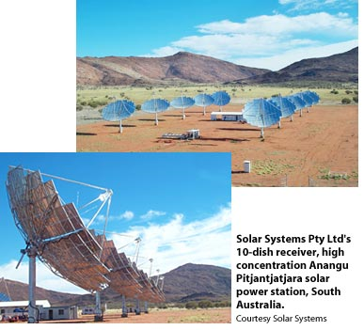
In contrast, concentrator systems have very few actual PV cells and rely instead on mirrors and lenses to focus a large area of incident sunlight on a small PV module. One of the primary motivations for this is obviously to reduce the number of PV cells required. This cuts down on the cell production costs, which can be particularly high for GaAs, and explains why GaAs is used almost solely in concentrator systems. Concentrator systems will generally use more expensive materials and have higher efficiencies than flat-plate systems. We also experimentally observe an increase in efficiency when cells utilize concentrated sunlight (level of concentration is measured in “suns”). Multijunction systems often utilize concentrations of up to 2000 suns and record efficiencies of 32% were obtained at 300-500 suns. Due to the nature of concentrator systems, it is necessary to install a tracking device on reflecting mirrors to best utilize light as the sun moves across the sky. The tracking system adds to the system installation cost, but requires no fuel as it is powered by the solar cells. Prominent concentrator setups include trough concentrators and parabolic dish concentrators.

Residential Photovoltaic System Applications
Flat-plate PV systems are best suited for residential purposes. Given average sunlight levels, a 2 kW residential system can fit on the roof of the house. Customer cost of the system and components, installation, and lifetime maintenance is currently estimated at about $18,000 (ignoring any government incentive programs/funding) corresponding to solar electricity costs of between 30 and 80 cents/kWh, depending significantly on climate conditions. Demonstrations have been done with coupling PV electricity generation with water heating to make investment in a PV system more worthwhile. In this system, the framework of the PV flat-plate allows flowing water to absorb heat. The water can then transport the energy for space heating, or simply use as heated water. This would also have a cooling affect on the PV cells, helping to improve efficiency. Larger “industrial” systems of 500 kW would cost $2.4 million with electricity costs as low as 21 cents/kWh in agreeable climates.
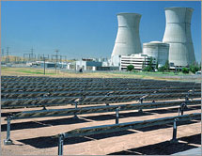
Often, the owner of a residential system will still be connected to the grid so that any electricity generated beyond consumption can be “sold” back to grid (in the form of electricity credits) via net metering. In this case, a DC – AC inverter is required for properly “formatted” electricity. This carries a significant up front cost, depending on the intended generation capacity, as well as a small power loss. Similar considerations would have to be made for a solar plant designed specifically to supply electricity to the grid. Also, centrally generated electricity (in coal or nuclear power plants) carry significant power losses due to long transmission distances, while small-scale residential PV systems generate electricity at the same place it is consumed. This furthers the idea that solar power is would best fit in a distributed energy economy as opposed to our current localized plants. An interesting application for PV technology is remote, off-grid installations in rural areas or developing countries. The only electricity supply in these areas would normally come from small generators dependent on fuel delivery. Solar power offers a sustainable source of electricity generated where it is needed and on the scale needed. Unfortunately the technology is still rather expensive and would require significant government subsidization.
A 2 MW solar power plant at Rancho Seco, CA. (Picture from U.S. DOE Solar Energy Technologies Program site)
Solar power, as with other renewables like wind power and hydro to a lesser extent, suffers from the fact that sunlight is only available for a few hours each day. Fortunately, the peak operation time of PV systems in California, for example, aligns with peak load on the grid. In an energy economy that relies on intermittent sources to any extent, a system for storing generated energy is necessary to allow an even level of distribution or respond to fluctuations in demand. Possibilities for energy storage are batteries, hydrogen, flywheels, gravitational (pumping water), or compressed air. Although battery technology has been improving significantly in recent years to respond to demand for portable electronics, large scale solar power would strain the materials required for batteries. For small residential systems hydrogen looks like a good storage candidate, as the resources needed a generally available. It is certain that for solar power to take on a significant share of the energy market, some method of energy storage will be necessary.
Additionally, the energy output and therefore lifetime energy efficiency for solar cells is highly dependent on the amount of incident sunlight. Daily solar radiation levels vary significantly across the U.S. ranging from 1.5 to 6 kWh/m² total sun energy per day. This seriously limits the viability of solar power in many low-light regions. This will likely limit widespread use of solar cells to only the best suited areas, until potential efficiency gains or cost reductions occur. The figure below shows different daily light radiation levels in the country, with high amounts in the Southwest and much less in the East and Northeast.
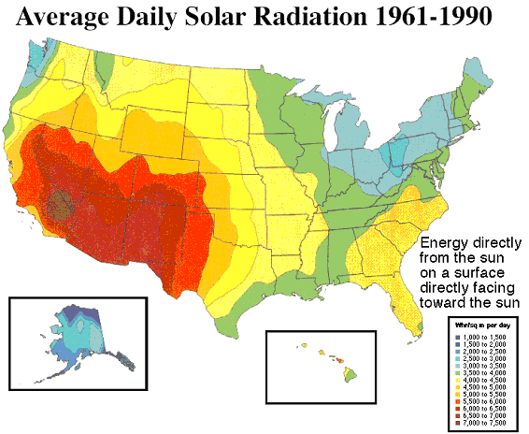
U.S. solar radiation levels per square meter. Red areas receive an average of 5.5+ kWh/day, yellow regions receive 4-5 kWh/day and blue/green regions receive 1.5-2.5 kWh/day.

Recent Market Trends
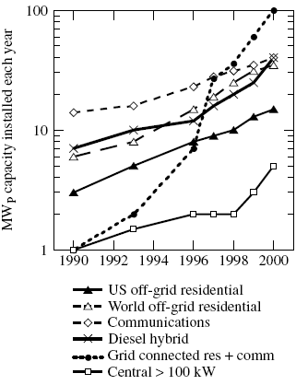
In the past decade, and most notably in the past few years, there has been remarkable growth in the PV industry. While total PV power generation makes up only 1% of renewable energy sources (which itself is only 6% of total electricity) industry growth rates of upwards of 20% per year in some countries is a sign to some that solar power could have a major role in the future energy economy. Recent growth has largely come from increased demand for small-scale PV systems in residential applications as subsidies and incentive programs have increased. For example, tax deductions and loan incentives exist in many U.S states. The most direct help comes in the form of state and local governments offering rebates of over $4 per watt installed, or even covering half of the entire system installation cost. Depending on a variety of factors such as efficiency, climate, storage systems, grid net metering, and available incentives, the payback time (of money investment) can be as low as 5 years (ideal conditions) and can potentially be longer than the expected lifetime of the system (poor conditions). This means that generally PV technology will only flourish with agreeable environmental and economic conditions.
Annual installed PV capacity in MW. While all areas are growing steadily, most rapid growth occurs in grid-connected residential systems. (Hegeda)
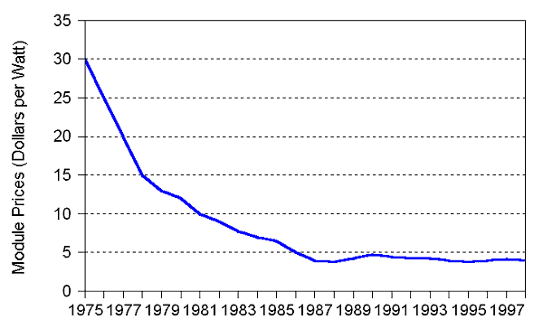
We have also seen significant price decreases since the inception of PV technology in the 1970s. However, average world module prices have stabilized at around $5 per watt (after installation, net system price per watt is higher) in the 1990s. Currently, the lowest production costs for modules are around $3.50 per watt. The figure below shows the more recent price behavior of solar modules. Notice the trend reversal in 2004; this is probably explained by heightened module demand by consumers (originating from utilization of government incentives) and a delay in supply response. Another possibility is the above mentioned constraints in silicon supply. The PV industry has traditionally used surplus or rejected material from the computer chip industry and now this is limiting growth in supply.
Historical module prices in $ per watt. (U.S. DOE)
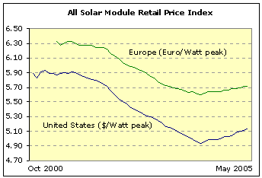
5-year retail price history of solar module. (SolarBuzz)

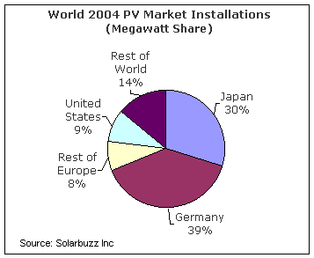
Despite Japan and Germany both having worse light conditions for solar power, they currently dominate the PV market in both use and production. The U.S. federal budget for photovoltaic R&D declined significantly from the 1970s and has rebounded only slightly in the past several years. Meanwhile, Japan and Germany have increased spending are currently nearly even. The primary factor in more PV use in other countries is the relative price of standard residential electricity. With our eager use of coal and other fossil fuels, the average residential electricity price in the U.S. is less than half the other countries, making the currently expensive PV technology less appealing to consumers. The figure below shows that most of total U.S. PV production is exported. This supports the idea that demand for PV systems is greater in other countries where traditional electricity is more costly than in the U.S.

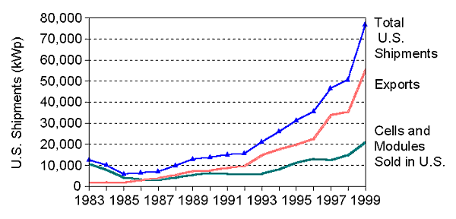

U.S. PV module production in kW. (U.S. DOE)

Conclusions
Photovoltaic technology continues to evolve and develop. With PV systems already on the cusp of being competitive as a major energy source, future efficiency gains or cost reductions can make the technology a major player in both on- and off-grid electricity generation. Solar power also shows promise for sustainability in rural and developing regions to give a level of energy independence. PV technology shares intermittency as a common obstacle with several other renewable energy sources and solving this problem (with hydrogen, perhaps?) is a prerequisite to heavy reliance on solar power. A sustainable future should contain a significant fraction of solar power to deliver energy when and where it is needed.

Works Cited
The A to Z of Materials.
http://www.azom.com

Alamri, S. N., Brinkman, A. W. “The effect of the transparent conductive oxide on the performance of thin film CdS/CdTe solar cells.” Journal of Physics. D, Applied physics. 33 (2000): L1-L4.

Bright, V.M. et. al. “Reflection characteristics of porous silicon surfaces.” Optical Engineering. 36 (April 1997): 1088-93.

Brown, Andrew S. “Impurity photovoltaic effect: Fundamental energy conversion efficiency limits.” Antioch Review. 92 (2002): 1329-36.

Carrol, John and Gouchoe, Susan. “Renewable Energy Incentives.” Mother Earth News. 207 (2005): 56B, 72B.

Carrol, John and Gouchoe, Susan. “Renewable Energy Incentives.” Mother Earth News. 208 (2005): 80B-F.

Chow, T.T. and He, W. and Ji, J. “Hybrid photovoltaic-thermosyphon water heating for residential application.” Solar Energy. 7 Feb. 2005.

Gong and Kulkarni. “Design optimization of a large scale rooftop photovoltaic system.” Solar Energy. 78 (2005): 362-74.

Hegedus, Steven and Luque, Antonio. Handbook of Photovoltaic Science and Engineering. John Wiley & Sons Ltd. England. 2003.

Karimov et al. “A simple photovoltaic tracking system.” Solar Energy Materials and Solar Cells. 87 (May 2005): 49-59.

Lewis and Keoleian. “Life Cycle Design of Amorphous Silicon Photovoltaic Modules.” EPA.
http://www.umich.edu/~nppcpub/research/pv.pdf

Martin-Palma, R. J. et. al. “Antireflective porous-silicon coatings for multicrystalline solar cells: the effects of chemical etching and rapid thermal processing.” Semiconductor Science and Technology. 8 (August 2001): 657-61.

“The Basic Physics and Design of III-V Multijunction Solar Cells.” U.S. Department of Energy.
http://www.nrel.gov/ncpv/pdfs/11_20_dga_basics_9-13.pdf

“Energy Production and Performance of Polycrystalline Silicon Technology Photovoltaic Modules in the Field.” Prereport. National Renewable Energy Laboratory. 2001.
http://www.nrel.gov/docs/fy02osti/30822.pdf

“Technology and Market Challenges to Mainstream Thin-Film Photovoltaic Modules and Applications.” Arya International, Inc.
http://www.nrel.gov/ncpv/thin_film/docs/rajeewa_arya_2004_thin_film_overview.pdf

“Fundamentals of Photovoltaic Materials.” National Solar Power Research Institute. 1998
http://userwww.sfsu.edu/~ciotola/solar/pv.pdf

Reuters: Solar power sees cost crunch. April 14, 2005.
http://www.msnbc.msn.com/id/7502547/

Shah, A. “Photovoltaic technology: the case for thin-film solar cells.” Science. 285 (1999): 692-8.
http://www.sciencemag.org/cgi/content/full/285/5428/692

SolarBuzz
http://www.solarbuzz.com

SolarExpert.com System Performance Factors
http://www.solarexpert.com/grid-tie/system-performance-factors.html

Special Materials Research and Technologies website.
http://www.specmat.com/

U.S. Department of Energy: Energy Efficiency and Renewable Energy website.
http://www.eere.energy.gov/solar/pv_basics.html

