Solutions to Suburban Sprawl:
Sustainable Communities Benefits & Barriers

Prepared by:
Sara Al-Beaini

Physics 80: Energy & Environment
Professor Saeta
May 5, 2005

The current land development and community structure in the US, also known as suburban sprawl, has an unsustainable growth pattern that has been quite destructive in terms of financial demands and environmental and social impacts. Sustainable communities have emerged as an effective solution to address problems due to urban growth and the creation of suburbs. They use land sustainably and develop communities that are healthy for the people and the environment. Suburbia began after World War II and grew with the advancing transport technology and urban road network. The shortage of housing after the troops returned home led to the introduction of Levittowns, in recognition of William Levitt who planned towns outside the big cities. These towns, which are called suburbs today, had a standard setup with their identical and mass-produced housing complexes, shopping centers, recreation facilities, civic buildings and schools. Meanwhile, the automobile was facilitating long distance travel. Thus, the demand for more housing and the expanded road network with highways connecting cities continued the suburban growth, also known as suburban sprawl. Suburbia became clusters of homogenous sections (residential section, commercial section, civic section, etc.) intentionally separated from each other. Such urban dispersal was also motivated by “the Federal Housing Agency and Veterans Administration loan programs, which […] provided mortgages for over eleven million new homes. These mortgages, which typically cost less per month than paying rent, were directed at new single-family suburban construction. Intentionally or not, the FHA and VA programs discouraged the renovation of existing housing stock” (Duany) and (Brancheau).
This separation by function system of suburban sprawl, where the residential areas are separated from the commercial areas makes it very appealing in terms of construction. Developers are simply producing numerous copies of the same structure. It is more feasible, cost-effective, and efficient to buy a lot of the same materials and repeat the same process in construction. Nevertheless, a consequence of this consistency is the obligation for the residents to spend a lot of time and money driving from unit to unit in order to accomplish daily needs. Any event, from taking the kids to the park to picking up a few items from the grocery store, requires a vehicle, and accordingly contributes to traffic congestion, noise and air pollution. Additionally, a sense of community is lost as people hardly interact with each other on a regular basis unless they have set the time aside to do so. Otherwise, they spend most of their time commuting. The suburban sprawl has isolated people from each other and has made it harder for people to lead a healthy way of life. People are less likely to walk and enjoy outdoor activities due to the extra efforts required to do so, where everyone in a household needs to get ready to drive out. Environmentally, suburban sprawl is a great burden, for it has a high land consumption rate (Duany). The system of separated units promotes an energy-inefficient lifestyle since it does not facilitate combining tasks and consuming less power. With the need to drive more, traffic congestion and its associated air pollution become more severe. As opposed to customizing land development according to the natural form of the land and investing in more energy efficient configurations for the community, developers plan and build according to their predefined codes and standards that are inconsiderate to environmental impacts and the need for a sense of community. They focus on the “cities’ physical systems, short-term economic considerations, and the interests of the development community” (Judy Corbett, 3).
Recognizing such issues, many have investigated urban and regional planning strategies that can overcome such problems and promote a healthier, more economical, and more sustainable solution to urban growth. Ebenezer Howard (1850-1928) started the trend with his concept of a garden city. The British practically abided by his emphasis on “open and agricultural land around the town.” Moreover, they used the garden city idea as the “plan for Greater London in 1944 and – following passage of the New Towns Act of 1946 – the creation of a ring of new towns beyond the London Greenbelt.” Figure 1 illustrates Howard’s perception of a garden city and what features it entails using his Town-Country magnet. His scheme “incorporated a unified system of community landownership, green belts, and a balance of land use, including industry and housing for workers, a balance between industrial and residential areas, self-government, and intimate relationship between city and countryside” (Judy Corbett, 4). Thus, he combined advantageous features from both the city and countryside to create a self-sufficient planning unit that can also be attached to a city (135).
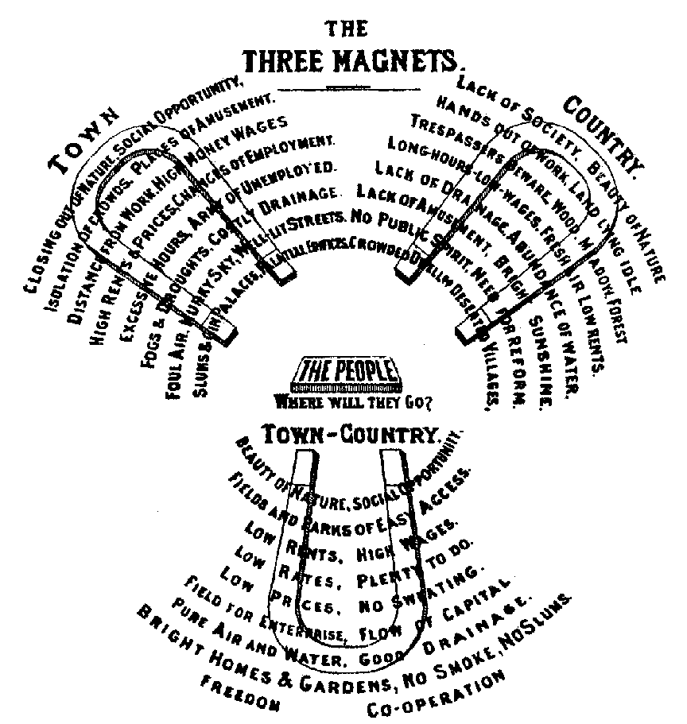

Figure 1: Ebenzer Howard’s concepts for a garden city, also known as the town- country magnet.<http://architecture.about.com/od/communitydesign/a/suburban.htm>

The concept of garden city then evolved into that of sustainable communities, when the focus on sustainable development emerged. The World Commission on Environment and Development coined the term sustainable development in 1987 as a mission “to equitably meet the vital human needs of the present without compromising the ability of future generations to meet their own needs by preserving and protecting the area’s ecosystems and natural resources” (American Planning Association). In the US, sustainable communities follow the principles of Smart Growth as specified by the American Planning Association:
Smart growth means using comprehensive planning to guide, design, develop, revitalize and build communities for all that: (a) have a unique sense of community and place; (b) preserve and enhance valuable natural and cultural resources; (c) equitably distribute the costs and benefits of development; (d) expand the range of transportation, employment and housing choices in a fiscally responsible manner; (e) value long-range, regional considerations of sustainability over short term incremental geographically isolated actions; and (f) promote public health and healthy communities.

In other words, smart growth fosters land use that integrates solutions to be environmentally, economically and socially sustainable. In line with this ideology, planners, developers, and builders of Village Homes in Davis, California, Judy and Michael Corbett co-authored “Designing Sustainable Communities: Learning from Village Homes” to share their success story in answering the grand question of sustainable land planning.
Village Homes sets an example on how to counter suburban sprawl and focus on instilling a sense of community and making it easier for the community to lead a healthier and more environmentally friendly lifestyle. It can maintain an “automobile-free neighborhood” and provide more common open space for bicycle and pedestrian paths (Judy Corbett, 155). The community can grow its own produce that could serve as an enterprise for it to profit from and benefit the community with its revenue. People can live comfortably without air conditioners; have a child-care cooperative at no cost; and walk for an average of 10 minutes to get to the local grocery store (US DOE).
Parents would greatly appreciate the convenience of not having to drive their children around everywhere and not having to worry about their children’s safety when they play outdoors due to cars driving. Village Homes makes this feasible along with other advantages, namely due to its circulation layout. Instead of the traditional grid network of “residential streets connected to larger arterial streets,” Village Homes’ streets “feed outward to a peripheral ring road rather than inward” while bicycle and pedestrian paths feed inward from the peripheral neighborhoods to the “geographic center of the town, where the transit stop and commercial and civic facilities people visit most often are located” (Judy Corbett, 153). Thus, this creates more pleasant pedestrian routes separated from the automobile paths and their exhaust fumes. Figure 2 shows a conceptual drawing of the circulation system.
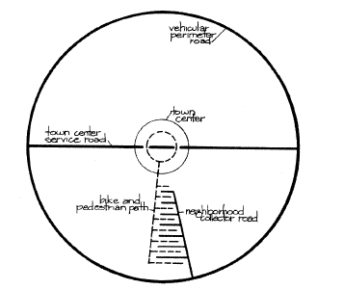

Figure 2: Conceptual drawing of Village Homes circulation layout. Dashed lines indicate the direct pedestrian and bike access. Solid lines are the indirect auto access. (Judy Corbett, 156).
The town service center road directly connects both ends of the town, which has neighborhoods no greater than 500 to 1000 people. Hence, bicyclists and pedestrians benefit from the practical travel distances. In Columbia, Maryland, which is designed according to this scheme, residents “drive thirty fewer miles per month than do residents of neighboring communities. Studies of European garden cities show similar results” (154-155). Thus, residents can lead a life that is more economical. With the neighborhood-surrounding greenbelt, more common open space is available that functions in many ways to cultivate a sense of community. The children can play close by their homes and be safe from vehicles. The residents are more likely to cross paths and interact during their walks around the town. Additionally, agricultural land is allocated for local farmers who have the advantage of profiting from the local market that is based on personal relationships and acquaintances gained from community interaction and events.
Besides the sense of community and sociability, the availability of open space facilitates using a natural drain system, which is integral to the ecological and aesthetical values of the society. It brings about natural beauty and preserves wildlife habitat, the results of which can “reduce costs, conserve water, reduce flooding problems, and actually increase property values.” It avoids the necessity of building storm drains that seem to maximize runoff water and steer it to rivers or evaporation ponds. Natural drainage replenishes the soil and satisfies the watering demands of neighborhoods. People don’t need to spend money installing and maintaining artificial methods for natural waterways such as ponds and fountains (169-171). Moreover, the circulation layout assists in using treated wastewater for subsurface irrigation, thus reducing water consumption for irrigation (155). Since the roads are not used as much for automobiles, the road width can be narrowed to cut the cost of materials and maintenance, just as long as it is wide enough “for emergency access and walking room” (158).
The circulation layout and the manner in which Village Homes has implemented it achieve many of the Smart Growth objectives and the concepts behind sustainable communities. The primary idea is being conscious of humans’ responsibility towards their surrounding environment. Devall and Sessions write about their deep ecology philosophy that emphasizes this approach. To think in terms of deep ecology, humans must recognize and actually endorse the fact that they are a part of the “organic whole [… and thus, must] live with minimum rather than maximum impact on other species and on the Earth in general” (Devall, 1985). Having a cooperative mindset supports the ethics of respect, sharing, and responsibility, all of which humans expect to apply amongst themselves. It is simply a matter of humans extending these virtues to their external environment.
To further strengthen the bond between it and nature, Village Homes incorporates cul-de-sacs in its design. Their environmental advantages are to reduce the amount of pavement needed and add more land for agricultural growth and other uses. Fifteen percent more land is available using the cul-de-sac design in Village Homes compared to the standard development in Davis (38). The cul-de-sacs orient the houses “away from the street and […towards] the heavily vegetated private and shared land. […] Neighborhood design guidelines prohibit the use of fences in these areas, but hedges, trees, and shrubs give a feeling of privacy where it is desired. […] From inside the house, automobile traffic is invisible” (37-38). Indeed, who would not cherish the tranquility and beauty immersing one’s surrounding instead of the usual noise and chaos people have become adapted to in the huge cities?
Sustainable communities gain a lot of public attention for their energy conservation innovations. Village Homes has served as a solar energy technology laboratory, with all the types of solar houses built “from passive solar cottages to sophisticated, active solar designs using water or air as heat storage medium” (US DOE). Nevertheless, some of the simplest strategies have been the most successful, such as properly orienting homes along the north-south axis. This maximizes heat gain in the winter and minimizes it during the summer based on the sun’s position relative to the northern hemisphere. “With properly oriented houses, good insulation, a majority of south-facing windows shaded in summer with carefully calculated overhangs, many high-mass materials, and good ventilation, [the] home utility bills have been reduced by almost 50 percent” (34-35). The following demonstrates the strategies used in achieving this 50 percent reduction:
Almost every roof in Village Homes [supports] a solar water heater, making the houses fully self- sufficient with regard to water heating for seven months of the year. During the remaining months, solar energy provides 40 to 50 percent of water heating. The solar water-heating systems are installed along with reasonable water conservation devices. These include such inexpensive and readily available equipment as constrictors on shower heads and faucets, pressure reducers, aerators, better pipe insulation, and other measures. Strict application of all such measures can reduce hot water consumption to 20 to 25 percent of existing use. (35)

In other words, Village Homes supplies its energy by balancing between renewable solar resources and using energy efficient devices. These simple measures illustrate how a community can work with nature and act according to its awareness of and caution towards its impact on its surroundings.
With all the features described and their advantages, one would expect to hear more of these concepts and designs being implemented and supported. Currently, Village Homes has been an inspiration to
“Civano in Tucson, Arizona, labeled as a grandchild of Village Homes on a much larger scale, [which] is now under construction. Other sustainable new development projects, either proposed or under construction, include Prairie Crossing near Chicago, Illinois; Haymount in Virginia; Coffee Creek Center in northern Indiana; and Dewes Island, a vacation retreat in South Carolina built under the principles of sustainable development” (50).

Additionally, the California Pollution Control Financing Authority developed a Sustainable Communities Grant and Loan Program that provides “over $4 million for locally sponsored smart growth initiatives which incorporate creative approaches and provide models that can be replicated in other communities” (Angelides). It is very encouraging to see that sustainable development and sustainable communities have begun to take their roots and become more widespread. Nevertheless, one questions why it is taking so long to implement them and increase people’s awareness of them. That is to say, what is hindering the conversion to sustainable communities today? Would everyone accept them? Are there people who would prefer to continue living in large cities and be immersed in the city noise and lifestyle full of crowds? Is it feasible to convert current communities into more sustainable ones without incurring too much cost? Additionally, given that sustainable communities do become the common route in development, would it be best that they be mandated and controlled by the state government or the local government?
Janet Maughan addresses some of the challenges facing sustainable communities, most importantly is their interdisciplinary nature. Due to the fact that sustainable communities are “not a new field, but a bringing together of many different fields,” it is necessary to educate the government and businesses, both of whom play a significant role in advancing or hindering the movement for sustainable communities. On a governmental level, there are numerous policies and regulations that weaken local community endeavors, such as “funding for highways, […which], undermines the strongest efforts to build and maintain downtown communities.” These regulations support the expansion of the road network and suburban sprawl, while they hinder the progress towards sustainable development. Economically, finance is another barrier since most capital-driven and economic decisions are made in “corporate boardrooms,” without the community’s involvement or feedback. Most private funders and government agencies do not have funding programs that support the pro-community, interdisciplinary ideas that are essential to invest in sustainable communities.
The best way to direct and organize the way towards sustainable communities is on a local level in line with the community-oriented approach, where people from the community can share their “experience and expertise and build enthusiasm” (Judy Corbett, 49). However, the local groups need the cooperation and support of the government. The government needs to “explore how programs and policies can be fundamentally changed so they serve to strengthen communities’ abilities to manage their resources effectively, […for] it controls resources, provides policy incentives, and implements community and environmental programs” (Maughan). Similarly, businesses need to demonstrate their environmental leadership by supporting such local groups and governments and investing in sustainable business practices. The free market nature of the US economy is very advantageous in driving and implementing sustainability as a national mission that benefits all.
In terms of further implications, if the shift towards sustainable communities is actively pursured, there could be a major transformation in how policies and regulations are handled. Transferring the leadership of sustainable communities to the local level might help dissolve the problems associated with bureaucracy. Going through the multi-level hierarchy of people and paperwork required to accomplish tasks, whether simple or complex, is the major drawback of bureaucracy. Developing and directing sustainable communities from a local level could bypass the issues with a bureaucratic system and make policy management more efficient, which parallels the sustainable communities’ philosophy. This is possible because the local agents would be community members who are enthusiastic about their society and are more knowledgeable about and aware of the conditions they are dealing with. Additionally, they are more likely to accomplish the project to serve the best interest of the community and not their own political interests. The local agents would be consciously accountable to their fellow neighbors and friends, not to mention the fact that the results of their actions are affecting their living condition as well. Therefore, the mission towards sustainable communities has advantages that could extend beyond solving suburban sprawl.
A main impetus to defeat in this endeavor towards sustainable communities is ensuring that the concept of sustainable development is accepted. There are people who are not convinced by the sustainable development mission and actually see it as a threat and intrusion to their freedom. At the fifth annual Freedom 21 Conference, president of the American Policy Center, Tom DeWeese addressed the threat and defeat of sustainable development. He stated that, “Sustainable Development isn’t just some land use policy. It is a complete transformation of American society; away from the rule of law; away from the ideals of property ownership, free enterprise, free travel and even free association.” He sees it as way of dictating people’s lifestyle and threatening their land of opportunity. It is quite sad to know that he works at demoting sustainable development, is entrenched in consumption, and does not have a true sense of social responsibility, as implied in his conclusion of the address:
To save liberty in America, Sustainable Development must be stopped. We have to start at the local level where our grassroots efforts are strongest. Where it’s easiest to win. We can find five county commissioners. We can get them elected one at a time. And then get more to join them. And we can begin to build a prairie fire across the nation. Do these things my friends; first understand that whatever issue you have chosen to fight for is actually part of the Sustainable Development scheme. Arm yourselves with that knowledge, and then step-by-step work to elect local representatives who will resist the Sustainabilist agenda and its money. The money is the key. Take back your communities and in that way, step-by-step, take back America.

Whether it is Tom DeWeese or the Sustainablists, as he calls them, each of their movements is greatly dependent on the people’s activism and willingness to pursue these initiatives. Even those who would support either of these ideas, very few of them would put the effort in advancing their cause as is evident from the percentage of voters in presidential elections. Thus, the expectations of rapid progress and acceptance of sustainable development are unfortunately mistaken. In other words, the beautifully painted picture of sustainable communities has a long way before it transpires. Given all the compelling benefits of sustainable communities, there still are people who truly do not favor them and consider them too idealistic, especially with their community-oriented concept. Those are the people who prefer to be lost in the crowd and only interact with the few they like. They do not necessarily appreciate the opportunity to partake in the decision-making process for any community-related issue, for example to allocate the usage of a lot or invest in new equipment or a new center. Instead, they might consider it to be an uncomfortable situation if the majority of the people are enthusiastic and active in the community. It becomes a burden for those who choose not to be involved at all since they might feel like the odd ones out. To some degree, choosing to live in Village Homes is similar to the situation of a student deciding between a large or a small college. Sustainable communities combine features of both small and large campuses. They are very similar to a small college campus, such as Harvey Mudd College, in terms of the community dynamics. However, they are almost like a large college as well when considering their total area and neighborhood sizes. Some students find that the college they attend is not the right place for them. Sustainable communities might be the same case for a certain portion of the population. The majority of these people are characterized by their apathetic attitude toward the environment.
Along with climate change, diminishing natural resources and fossil fuels, pollution in all its forms, humans have added suburban sprawl to the mix of problems they have induced due to their encroachment on nature. Sustainable development has become the new framework that can redirect humans on the path that’s more harmonious with nature. Following the same approach are sustainable communities that can redirect humans to better handle urban growth and the resulting suburban sprawl. Several cities in the US are based on the Ebenezer Howard’s garden city idea, such as Radburn, New Jersey; Greenbelt, Maryland; Greenhills, Ohio; and Greendale, Wisconsin (Judy Corbett, 5). The garden cities focus more on providing better living environments for people, and don’t emphasize the environmental and energy conservation aspects as sustainable communities. Village Homes in Davis, California has been one of the most prominent sustainable communities, setting the stage for the feasibility and marketability of sustainable communities. Its circulation layout achieves several objectives of smart growth, especially a sense of community, reduced and efficient energy consumption, reduced material consumption (with the help of cul-de-sacs), better air quality, and ecological preservation. To overcome the barriers of sustainable communities, a lot of education and increased awareness is needed to eliminate misconceptions of sustainable development and sustainable communities. Additionally, local agencies, which are the most appropriate candidates for leading sustainable communities, need the aid of state and federal governments who can provide them with the necessary resources and funding. Businesses should also benefit from this shift towards sustainability as they invest in and promote profitable sustainable business practices. Doing so will help the local agencies as they increase their network of service providers, and potentially overcome the barriers created through bureaucracy. Developing sustainable communities will be a long-term, national project, which must gain a strong foundation with the help of governments and businesses to ensure their inevitable success.

Works Cited

Angelides, Phil. “Sustainable Investment for Our Future.” California State Treasurer Remarks to Environmental Entrepreneurs Forum. May 5, 2003. Apr. 26, 2005. <http://www.treasurer.ca.gov/news/speeches/20030505.htm>
American Planning Association. Policy Guide on Planning for Sustainablility. 17 Apr. 2000. 23 Apr. 2005. < ttp://www.planning.org/policyguides/sustainability.htm>
American Planning Association. Policy Guide on Smart Growth. 15 Apr. 2002. 16 Apr. 2005. <http://www.planning.org/policyguides/smartgrowth.htm#I>
Brancheau, Josh, Abi Wharton, and Firuz Kamalov. “A Brief History of the Growth of Suburbs.” The Impact of the Automobile on the 20th Century. 1998. 22 Apr. 2005. <http://l3d.cs.colorado.edu/systems/agentsheets/New-Vista/automobile/suburbia.html>
Corbett, Judy and Michael Corbett. Designing Sustainable Communities: Learning from Village Homes. Washington, DC: Island Press, 2000.
Bill Devall and George Sessions, Deep Ecology, Gibbs Smith Publishers, 1985, pp 65-70
DeWeese, Tom. “’Sustainable Development’ is the Evil You Face.” American Policy Center.
23 July 2004. 27 Apr 2005 <http://www.americanpolicy.org/more/evil.htm>
Duany, Andres, Elizabeth Plater-Zyberk, and Jeff Speck. “About Nation.” Suburban Nation. 1 July 1999. 22 Apr. 2005 University of Colorador at Boulder. <http://architecture.about.com/od/communitydesign/a/suburban.htm>
Howard, Ebenezer. “Garden Cities of To-Morrow” (London, 1902. Reprinted, edited with Preface by F. J. Osborn and an Introductory Essay by Lewis Mumford. (London: Faber and Faber, [1946]): 50-57, 138- 147. <http://www.library.cornell.edu/Reps/DOCS/howard.htm>
U.S. Department of Energy, Energy Efficiency and Renewable Energy. Smart Communities Network: Creating Energy Smart Communities. “Success Stories”16 Apr. 2005. <http://www.sustainable.doe.gov/success/village.shtml>

Maughan, Janet. “Sustainable Communities: An Idea whose time has come?” U.S. Department of Energy, Energy Efficiency and Renewable Energy. Smart Communities Network: Creating Energy Smart Communities Wingspread Journal. 18(2) Spring 1996.

26 Apr. 2005. <http://www.sustainable.doe.gov/articles/suscon.shtml>

