Technological Feasibility
Of Magnetic Fusion Energy

Brendan Haberle
5 May 2005
Energy & Environment
Prof. Peter Saeta

Introduction
As the era of fossil fuels as cheap sources of energy draws to a close, society is faced with the challenge of developing a long-term alternative. Decades of work has resulted in power plants extracting energy from non-fossil fuel sources such as fission, solar, geo-thermal, wind, and hydro sources. Such a diverse portfolio keeps our options open as we consider which source, or combination of sources, should succeed fossil fuels in the future.
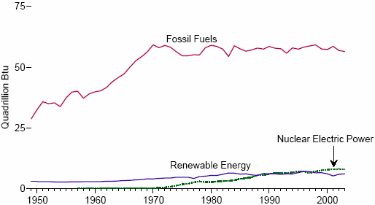
The future, unfortunately, is not very far off, and we will be best served by early investments of time and money into alternative energy research. Fossil fuels (oil, natural gas, and coal) account for nearly 80% of U.S. energy production, with the remainder comprising nuclear (10%) and biomass and other renewables (10%) (EIA). As the relative share of fossil fuels declines in coming decades, the difference must be made up by some other energy source, assuming no drastic reduction in energy consumption.
Fig. 1: Energy production by source, 1949-2003. (EIA).
Magnetic fusion energy, MFE, has the potential to replace fossil fuels and fission as the workhorses of the industry. It is, however, something of a “homerun” solution in that while it is a gamble to divert resources to its development when the likelihood of completing a net-energy yielding power plant in the next 50 years is very small, the payback if it does work is enormous. One kilogram of hydrogen fuel is enough to satisfy the energy needs of over 650 US citizens for an entire year, compared to nearly 14 kilotons of coal or 2 million gallons of gasoline (GSU).
There is an essentially inexhaustible supply of hydrogen on Earth, and the only other natural resource required, lithium, is abundant in the Earth’s crust. The reason why fusion is always 50 years away has nothing to do with having enough fuel – it is a problem of controlling and extracting energy from the fusion reaction. The homerun is to develop a reactor capable of containing a sustained fusion reaction.
With billions of dollars already spent and quite possibly another 100 billion dollars to go before a reactor can be deployed, one might consider whether fusion is really worth the investment. Fusion can be a profitable business, but not without internalizing the external costs of fission and burning fossil fuels. For fossil fuels, these costs include greenhouse gas release, health effects, and national security. For fission, instead of greenhouse gas release, one must consider waste management along with health and security. Fusion is safe, environmentally friendly, and reactors have no capability to generate material for use in weapons. The only radioactive byproduct is low-level waste with a half-life of between 10 and 100 years, as opposed to 5 billion years for U²³⁸ (WebElements). There is no need for a Yucca Mountain-style long-term storage and isolation facility. Fusion is superior to other renewables in the high energy density of its fuel.
In particular, magnetic fusion energy promises to fulfill the potential that fusion has to offer and to be both economically and technologically feasible. Past MFE work has nearly broken even in the energy balance, and a large-scale experimental reactor nearing completion will most likely sustain a fusion reaction under conditions allowing a huge net energy gain.
Fusion is a very attractive long-term energy option, but there is still much research and development to be done before it becomes a reality. Of course, an interim solution must be developed to replace fossil fuels and meet society’s energy demands while fusion technology matures from the current net-energy losing reactors to a full-fledged power plant.

Technical Background
In the 1910s there was much interest in uncovering the Sun’s seemingly unlimited energy source, and much theoretical and experimental work on the topic was done in the next several decades. Einstein’s E = mc² gestalt, Henry Russell’s work on the high interior temperature of stars in 1919, and Francis Aston’s measurements of the mass deficit between helium and its individual parts were synthesized in 1920 by Sir Arthur Eddington, who proposed that stars could burn hydrogen into helium as a source of energy. Hans Bethe’s 1939 paper Energy Production in Stars, in which he quantitatively described the mass conversion process that allowed stars to burn for billions of years and which won him the 1968 Nobel Prize for Physics, convinced naysayers around the world that fusion on Earth was possible (Europa).
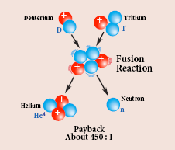
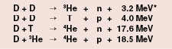
Fusion occurs when two relatively light nuclei fuse to form a larger nucleus in a reaction that produces energy. The reaction most studied for fusion power is between the heavy hydrogen isotopes deuterium and tritium. This reaction releases 17.6 MeV, out of which 80% is deposited in a fast neutron and the remainder in a helium nucleus. This particular reaction has the highest reaction cross-section of the possibilities listed in Fig. 2 (Wikipedia).
Fig. 2: D-T fusion reaction and energy values for several hydrogen-powered reactions (DOE Office of Science).
Despite the favorability of this reaction, the D-T nuclei must overcome the Coulomb barrier to fuse. Doing so requires between 1 and 10 keV of kinetic energy, so the nuclei must be maintained at a temperature of approximately 100 million degrees Celsius. At this temperature the fuel is a plasma that must remain stable and confined for some amount of time in order to extract energy. The time required, τ, is given by
$$nτ≈3×{\text{10}}^{\text{14}}s⋅{\text{cm}}^{−3}$$
where n is the plasma’s ion number density. The inverse relationship between density and confinement time allows some flexibility in the parameter space when developing a confinement scheme. Hot plasmas must only be contained for a short time, while colder plasmas require longer confinement.
This principle guided initial fusion research and has resulted in two different confinement schemes, each of which takes advantage of one of the extremes discussed above. Inertial confinement fusion, or ICF, uses a small, solid and gas D-T fuel pellet and cannot confine the plasma for very long so it must be maintained at a high density. For this purpose a huge amount of energy is deposited in a short time to implode the pellet and create a high-density plasma.
The opposing confinement scheme, already mentioned in the introduction, is known as magnetic fusion energy, or MFE. Instead of relying on the fuel’s own mass to hold the plasma in place, MFE uses a system of magnetic fields to confine the charged particles of the plasma in a toroidal reactor known as a tokamak. Fast neutrons, with no charge, ignore the field and are absorbed by a moderator and the reactor vessel itself, from which heat is drawn to power steam turbines to produce electricity. A sustained reaction, or burn, occurs when helium nuclei have enough energy to self-heat the plasma. This critical point is known as ignition and marks the point at which the power gain of the reactor becomes much greater than one. The gain may even go to infinity as the required amount of externally-sourced input power drops to zero. This effect is possible as soon as the plant is generating enough power to satisfy its own internal demand, including power for the field generating coils and other control systems.
The MFE fuel cycle is refreshingly simple. Gaseous deuterium, which occurs with an abundance of approximately 0.01 % (WebElements), is purified from hydrogen and injected along with tritium into the reactor. A lithium “blanket” enclosing the reactor is used as a breeder for tritium, and as tritium is produced from the reaction between lithium and a fusion neutron it is drawn out of the reactor, processed, and re-injected with the primary deuterium fuel. Thus, the only fuel requirements for an MFE reactor are deuterium and lithium, both of which can be found in great abundance naturally. Burning 10 g of deuterium extracted from 500 L of water and 15 g of tritium bred from 30 g of lithium would meet the lifetime electricity demand of 1 US citizen.

Current Barriers to MFE
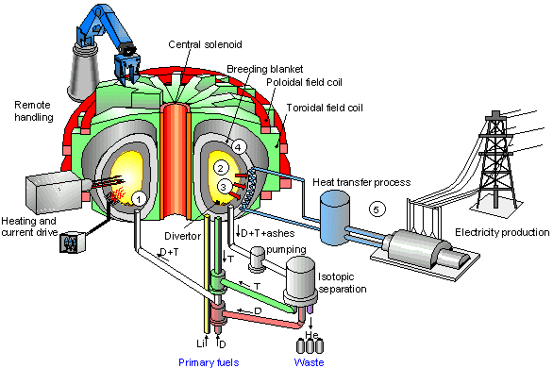
The unresolved problems with MFE requiring extensive, further research are the tritium breeding blanket, waste divertor, plasma control, and materials engineering. In order to produce its own fuel, the reactor must have an efficient mechanism to create and extract tritium from a lithium source. Currently, a lithium jacket surrounds the burning plasma and intercepts some of the neutrons exiting the interior of the vessel. Lithium-6 plus a neutron yields tritium, helium, and a small amount of energy (European Nuclear Society). However, recent studies have shown that lithium-7 may be a more efficient tritium breeder, especially in the presence of beryllium (Muroga, et al). The lithium-7 reaction also produces a neutron, which amplifies the effect of one fusion neutron and can cascade through a chain-reaction, compared to the 1-to-1 gain of lithium-6. Vanadium is used in the breeder to prevent the formation of radioisotopes by the fusion neutrons.
Fig. 3: Schematic of MFE tokamak. Note fuel injection area (1), plasma burn area (2), neutron path (3), breeding blanket and divertor (4), and electricity generation apparatus (5) (CEA).
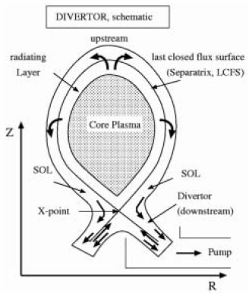
The divertor is a channel surrounding the plasma outside of the confining magnetic field. Its purposes are to draw off and expel plasma and vessel wall impurities and to act as a buffer between the plasma and the walls. Helium is produced in both the fusion and breeding reactions and is considered waste. As helium nuclei cool and exit the plasma or are created in the breeding process, they are drawn into the diverter stream and follow the walls to an exit at the bottom of the vessel. If wall impurities such as carbon and beryllium are allowed to build up in the plasma to a concentration of any more than 1 to 2 %, the plasma could become unstable and collapse (Janev 2005, 124).
Fig. 4: Schematic of divertor (Janev 2005, 122).
Sustained confinement of plasmas continues to be a challenge for MFE researchers. From the days of early tokamaks and huge stellarators the ability to control a plasma for more than several seconds has been an elusive goal. A major breakthrough was reached by the European effort when a plasma was maintained and confined for over six minutes. In order to make a case for an MFE power plant, it must be demonstrated that plasma confinement can be sustained indefinitely. The control systems must be able to reproducibly create a plasma and bring it to ignition and react instantaneously to changes in plasma conditions. Several tesla worth of magnetic field strength is required to confine a plasma (Hoang 2003). Most current fusion research in physics focuses on improving confinement.
A huge effort is being made to develop materials for MFE reactors and their components that withstand extreme temperature, radiation, and magnetic field. Reactor design is as much an engineering problem as it is a physics problem, and highlights the traditional cross-discipline cooperation that has always been present in fusion research. Innovative engineering is crucial to the MFE effort, which will not be a success unless a durable reactor can be constructed. Projections indicate that the reaction vessel must have a lifespan of at least 30 years to be economically viable (LLNL).

D-T is the fuel of tomorrow, and MFE is the engine
The feasibility of ICF as a continuous power source is not as clear as that of MFE. ICF has more applications in weapons research and stockpile stewardship, as the hot, dense ICF plasmas are similar to those created in nuclear explosions. MFE research closely parallels research of astrophysical plasmas, which can exist at extremely low density (as low as 1 cm⁻³) in the interstellar medium. The ability of plasma physicists to apply knowledge from studies of astrophysical and weapons plasmas to fusion energy research is a boon to the fusion program and extends research dollars. Fusion research is often funded indirectly through programs ostensibly focused on stockpile stewardship.
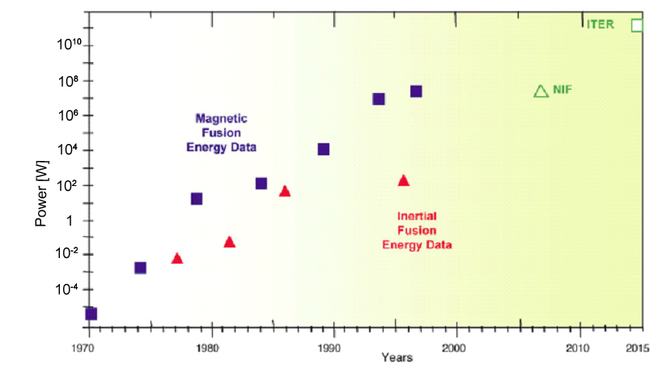
MFE has consistently out-performed ICF in terms of output power and energy control technology (DoE Office of Science). Neither has broken even, but MFE achieved a power gain of 0.65 on the EU’s JET tokamak in 1997 (JET). The experiment output 13 MW for 3 seconds while drawing 20 MW for operations such as initial heating and confinement. At ICF’s next generation facility, the National Ignition Facility or NIF, pellets must be burned at a rate of 10 per second to come close to matching the continuous output power of MFE. An inherent problem of ICF is that it releases a huge amount of energy in a very short time. The reactor must be able to withstand the peak power, radiation, and associated stress produced, which in the case of NIF is hundreds of terawatts or more (LLNL S&TR). MFE produces energy continuously and can therefore do so at a much lower peak power, perhaps several gigawatts for a functional power plant.
Fig. 5: Past and near-future projected gross power output of MFE and ICF (DOE Office of Science).
The next generation MFE facility is ITER, an international effort to build a large, 500 MW reactor by 2015 (ITER). ITER will be built in either Japan or Germany, and construction has started in both places. Aside from demonstrating the feasibility of producing large amounts of continuous power, ITER will serve as a test-bed for tritium breeder and divertor technology, plasma control and confinement mechanisms, and materials engineering. The power gain of ITER will be about 7 – 10 based on a power usage of 75 MW, and it is projected to maintain a burn for as long as an hour (DoE OFES). The facility will cost roughly $5 billion, which will be shared by the project’s six participant teams including the US, EU, China, Russia, Japan, and South Korea.

Conclusion
While MFE still has a long way to go being realized as a feasible replacement for fossil fuels, past work has demonstrated that it can work. The technology is not quite there now, but perhaps within two or three decades demonstration plants will have shown sufficient progress to convince the public that fusion is fully capable of meeting all of society’s electricity needs, perhaps in conjunction with hydrogen energy storage systems. A full-scale power plant may be 50 - 100 years away. Further research is needed particularly in the areas of materials engineering and plasma control technology. These two areas need the most work and are the first-steps in building a large reactor.
The economic feasibility of fusion has not been discussed because it is extremely difficult to project costs and other factors 5 to 10 decades out. However, some project that fusion could cost as little as 6.6 cents per kWh in 2050, based on heavy internalization of the external costs of fossil fuels (Tokimatsu, 1292).
Works Cited
Commissariat a l’Energie Atomique, From Experimental Devices to a Reactor. http://www-fusion-magnetique.cea.fr/gb/fusion/principes/principes05.htm

DoE Office of Fusion Energy Science, ITER. http://www.ofes.fusion.doe.gov/ITER/ITERProjectonepager.pdf

DoE Office of Science, Information Bulletin – PPPL. http://www.sc.doe.gov/.

EIA, Energy Production by Source, 1949-2003. http://www.eia.doe.gov/emeu/aer/pdf/pages/sec1_6.pdf

Europa, A Brief History of Fusion Research. http://europa.eu.int/comm/research/energy/fu/fu_int/article_1247_en.htm

European Nuclear Society, Fusion. http://www.euronuclear.org/info/encyclopedia/f/fusion.htm

Georgia State University, Energy a la Einstein. http://hyperphysics.phy-astr.gsu.edu/hbase/nucene/eneein.html#c1

Hoang, et al. Phys. Rev. Lett. 90(15) (2003) 155002(4)

ITER, The ITER Project. http://www.iter.org

Janev. Contemporary Physics 46(2) (2005) 121-140.

JET, The History of JET, http://www.jet.efda.org/pages/history-of-jet.html

LLNL, First NIF Experiments. http://www.llnl.gov/nif/project/news_first_exper.html

LLNL S&TR, The National Ignition Facility Comes to Life. http://www.llnl.gov/str/September03/pdfs/09_03.1.pdf

Muroga, et al. Neutronics Investigation into Lithium/Vanadium Test Blanket Modules. http://fti.neep.wisc.edu/tofeprogram/pdf/murogaATnifs.ac.jp1083289886.pdf

Tokimatsu, et al. Nucl. Fusion 42 (2002) 1289-1298.

WebElements, WebElements Periodic Table. http://www.webelements.com/

Wikipedia, Inertial Confinement Fusion. http://en.wikipedia.org/wiki/Inertial_confinement_fusion

