Eddie Huang
Energy and Environment
Final Paper
05 May, 2005

The Day with Fusion after Tomorrow

How plausible and necessary is a fusion future? Many believe that renewable energy answers our prayer for a cleaner tomorrow; others remain skeptical with the feasibility of large scale implementation of renewable technology. Electricity demand is undoubtedly on an increasing trend. Developing countries strive to reach a higher living standard, and require much supply of electricity. Cleaner air must be maintained for an adequate living standard. Some believe that fusion has a great potential to achieve the highest energy yield per mass in the world while its fuel is virtually inexhaustible. However, fusion power has the longest known lead time in the energy domain. Prediction of large amounts of energy could be released by fusing small nuclei together was made in 1929 based on Einstein’s discovery. Two decades later, plasma and confined nuclear fusion were introduced. However, for the next half decade, little progress was made while the research and development expenditure throughout the world remain high. For many more reasons, one may lose confidence in a future of fusion energy and acknowledge that it is only a good dream. Several resolutions for increasing electricity demand are taken into considerations. First, the dominance of coal and natural gas persists, which introduces a terrifying amount of greenhouse gases that make the Earth inhabitable. Second, reduce the greenhouse gas emission with a combination of renewable energy and nuclear energy, which becomes economically competitive after the external costs of greenhouse gases are included into the true cost of coal. Third, no new form energy resource that is competitive with the current technology is discovered. To examine the plausibility of a future of fusion energy, assumptions on the greenhouse gas emissions and social acceptance of “nuclear” must be made. The 550 parts per million by volume Carbon Dioxide concentration constraint must be in place through Kyoto COP3 Protocol target at 2010, and the 20% CO₂ reduction among Annex-I parties from 1990 level-CO₂ emission after 2020. Although the public voice is a great influence on the future of fission and fusion, it is not the focus in my argument. Hence, public acceptance of fission and fusion is assumed in the analysis.
World net electricity consumption is expected to nearly double to over the next two decades, according to the International Energy Outlook 2004 reference case forecast. The world’s population will continue to grow for several decades at least. Energy demand is likely to increase even faster, and the proportion supplied by electricity will also grow faster still. Total demand for electricity is projected to increase on average by 2.3 percent per year. Much of the growth in demand comes from the developing countries such as China. At present, developing countries, with more than 75 percent of the world’s population, account for only about one-third of the world’s electricity consumption. As these developing countries evolve and enhance their living standards, access to reliable supplies of electricity among the emerging economies will be necessary to fuel the robust economic growth projected for the region. The governments of developing countries recognize the need to increase citizens’ access to electricity; furthermore, they strategize to increase private and international electricity investment, and introduce rural electrification schemes to enhance standards of living and productivity of rural societies. Industrialized countries have a much slower growth rate in electricity demand, averaging 1.6 percent per year. In the industrialized world, the electricity sector is well established, and equipment efficiency gains are expected to temper the growth in electricity demand. Moreover, population in Japan and Western Europe are expected either to remain at current levels or to decline slightly, and as a result it is unlikely that demand for electricity in the residential sector will increase substantially. By all means, the world electricity demand is rising and human will answer to this trend. The question is, “How do we increase the supply the right way?”
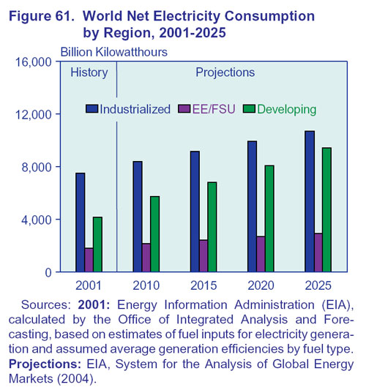
Two practical and obvious resolutions to the electricity predicament are to make more efficient the current fossil fuel technologies, and to utilize the inexhaustible renewable energy. The ongoing effort of enhancing fossil fuel technology will provide a strong and cleaner energy backbone while alternative energy sources are being researched and utilized more efficiently. Given that the emission targets set by Kyoto Protocol must be met, there is a limit to the amount of energy can be produced by fossil fuel because it will bear a certain level of greenhouse emissions. However, when fossil fuel technology is made more efficient, more fossil fuel energy can be produced before reaching the emission limit than in previous efforts. This margin in energy production buys us more time to improve on the economy and efficiency of renewable energies, which are mostly emission free and inexhaustible. Today, most of the worldwide electricity demand is satisfied basically by oil, natural gas and coal. If this pattern does not change, the conventional oil and gas resources will last for a couple of generations at present levels of consumption.
To reduce greenhouse gas emissions, the industry can make more efficient use of fossil fuels. Getting more electricity, transport, and industrial output for less coal, oil, or gasoline translates to more profit, less pollution, and less global warming; it will buy time for global climate system while alternative energy technologies can be developed and made cost-effective. Combined-cycle turbines use the heat from burning fuel and the thermal expansion of the exhaust gases to drive steam and gas turbines; it has the potential to boost the efficiency of electricity generation by 70 percent. Gasoline fuel cells and other advanced automotive technologies cut CO₂ emissions from transport. Natural gas releases less CO₂ per unit of energy than coal or oil. Hence, switching to natural gas is a quick way to cut emissions. In the long run, these technologies provide benefits from combined heat and power co-generation, uses of waste heat, improved energy management, and more efficient manufacturing processes that will more than compensate for their expensive initial outlays. Primary fuel use of electricity generation until at least 2025 is predicted to be coal since it constitutes for 51% of electricity supply. Therefore, the current dominant electricity source not only serves as the stepping stone to the next generation electricity generation technology, but also as the likely fundamental source for electricity in the future. To match the trend of increasing electricity demand while keeping the greenhouse gas emission to a specified target, improvements in efficiency of a coal or fossil fuel power plant must be developed and implemented. However, as much as the efficiency can reduce greenhouse gas emission, the emission cannot be eliminated. Therefore, we must rely on renewable energy sources to introduce the balance between greenhouse gas emission and cost.
Harnessing renewable energy such as wind and solar is an appropriate consideration in sustainable development. Apart from the plant construction, there is no depletion of mineral resources and any direct air or water pollution. Therefore, these renewable energy technologies show much promising long term supply of electricity. The five outstanding renewable energy sources include biomass, solar voltaic, geothermal, wind, and hydroelectric. Biopower is generated primarily from direct burn of biomass in boiler. There is a general decrease in harmful emissions and carbon dioxide neutral. Biopower generated from direct combustion has 25% electricity generation efficiency and two percent electricity share in the United States. At a cost of energy of nine cents per kilowatt-hour, biopower is not competitive in electricity supply. Solar voltaic exemplifies the renewable energy by showing much promising reliability, low maintenance and fuel cost as well as little sound pollution and greenhouse gas emission. Solar voltaic does however, have a much higher energy cost of 25 to 30 cents per kilowatt-hour (comparing to 4.2 cents/kW-h using coal), and an expensive initial cost of semiconducting materials and manufacturing. Cost reductions can be achieved by reducing manufacturing costs. As manufacturing capacity increases, costs of manufacturing decrease. However, achieving the break-even price of solar voltaic requires large implementation of such technology and it becomes economically impractical. Geothermal energy generates low emission and is competitive at the cost of energy from five to eight cents per kilowatt-hour, yet it constitutes for less than 0.5 percent of the U.S. electricity supply because it is location dependent. Wind energy is the world’s fastest-growing energy technology. Today, the United States has more than 6,300 MW of wind generating capacity, which can be further expanded in time with improvements such as variable-blade. Whether wind will be able to carry the burden of ceaseless growth of electricity demand is questioned because it is location and space dependent. Hydroelectric power refers to using the potential energy store in some liquid (usually water) to turn mechanical energy into electrical energy; it can be implemented on any scale with or without the use of dams. Yet this technology causes various environment hazards such as destruction and disruption of ecosystem. For the purpose of this analysis, I will assume that the growth of the renewable technology can only resemble the growth rate of our electricity demand due to the technological constraints. Therefore, while the renewable energies continue to grow, they do not significantly exceed their current electricity share in the United States of 20%. Renewable energy should be used as much as possible, but intrinsic limitations (diffuse, intermittent sources) mean that wind and sun can never economically replace sources such as coal, gas and nuclear for large-scale, continuous, reliable supply, and can only constitute a small fraction of electricity supply in the long run. The energy released in most nuclear reactions is much larger than that for chemical reactions, because the binding energy that glues a nucleus together is far greater than the energy that holds electrons to a nucleus. Therefore, nuclear reaction is considered the most promising for electricity production.

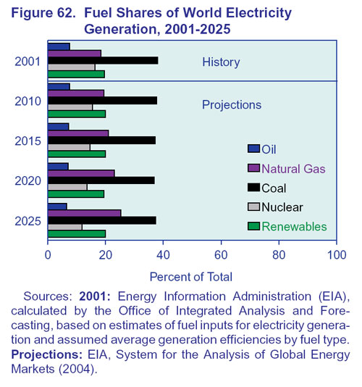
Figure 1

While the use of fossil fuel is limited by greenhouse emission regulations, and the use of renewable energy technologies are constrained by economical and environment factors, nuclear fission provides another possible solution to our electricity thirst. Nuclear fission technology is emission free and can be deployed on a large scale; it constitutes approximately 16% of the world’s electricity needs. The nuclear industry has excellent safety record, with over 11,000 reactor years of operation spanning four decades. Chernobyl and some 15 other Soviet designed and built reactors have been a safety concern of many years, but are much better now than in 1986. Many argue that nuclear reactors are vulnerable to terrorist attacks like that on the World Trade Centre in 2001, waste and spent fuel storage is even more so. However, any reactor licensable in the west has a substantial containment structure and most also have a very robust pressure vessel and internal structures. Evaluations since 2001 suggest that power reactors would be well equipped to survive an impact of that kind without any significant radiological hazard locally. Civil waste and spent fuel storage is also robust and often below ground level. Nuclear electricity is mostly competitive with coal. In 2004, the approximate cost to get one kilogram of UO₂ reactor fuel is $1,110 including conversion, enrichment, and fuel fabrication of U₃O₈; it yields 3400 GJ thermal which gives 315,000 kWh. Hence fuel costs 0.35 cents per kilowatt-hour and is comparable with coal, oil, and gas fired plants. If external costs are accounted, nuclear is very competitive. The cost of nuclear power generation has been dropping over the last decade because of declining fuel, operating and maintenance costs. The construction costs of nuclear power plants are significantly higher than for coal- or gas-fired plants because of the special materials, and to incorporate sophisticated safety features and back-up control equipment. These contribute much of the nuclear generation cost, but once the plant is built the variables are minor. One kilogram of natural uranium will yield about 20,000 times as much energy as the same amount of coal. Nuclear power plants are run more productively. Over the twenty years from 1970 there was a 25% reduction in uranium demand per kilowatt-hour output in Europe due to the increasing efficiencies. Since 1996 the number of operating reactors has remained steady, but the output from nuclear has increased significantly. This is because the ones that retired are mostly small, and the new ones are mostly large. Therefore, nuclear fission has a potential future to fueling our electricity demand.
Nuclear fission has unattractive features such as limited uranium resources and problematic waste disposal. Although the estimated electricity energy per kilogram fuel from enriched uranium in a ‘once-through’ procedure is much higher than from coal and natural gas, the currently known uranium supplies will run out range from 41 to 1000 years. To prolong the supply of nuclear fission, breeder and reprocessing are necessary, which then introduce other economic and security issues. In addition to the cost being at four to five times of the ‘once-through’ procedure, reprocessing heightens the risk national security due the production of plutonium. Therefore, fission technology may become very expensive and dangerous in the future. Furthermore, waste disposal is very problematic in nuclear fission. First, fission reaction produces radioactive wastes that last for hundreds of millions of years. Second, the amount of nuclear waste has reached to a high level that requires further transport to a large storage. Currently the fission-generated waste is stored at the plant sites, which have mostly reached their limit of the finite storing capacity. In the United States, the known amount of waste was approximately 52,000 tons in 2001 while the capacity of housing facility at Yucca Mountain is only 70,000 tons. Therefore, even with all the existing wastes stored at Yucca Mountain, the extra 18,000 tons will only last for half a century when the waste storages at the plat sites are refilled. Searching for alternative location has been proven to be difficult due to geographic and public acceptance, and is a matter time before space eventually runs out. Among the difficulties with storing the waste, transporting the waste from the plants to a central storage is a costly and time consuming process. Therefore, fission does not seem feasible as a long term electricity supply. On the other hand, fusion introduces a new age of electricity source that is inexhaustible, clean, high yield, and little waste issues.
Controlled nuclear fusion is a challenging task with a big payoff. Although not all is yet understood of the physics and engineering of a controlled fusion power plant, the basic principles have being elaborated in detail. Optimization of the process and making it economically viable are the main goals. For the first generation experiment, two hydrogen isotopes, deuterium and tritium fuse to produce an alpha particle, a neutron and 17 MeV of energy. The aim is to use the energy of alpha particles to maintain the plasma at a steady temperature, thus allowing the reactions to be self-sustaining and leave the neutrons – which carry 80% of the fusion energy – to boil water and drive steam turbines. To achieve fusion conditions, the nuclei must be in plasma state for the strong force to overcome the electrostatic force. Unlike fission, for the fusion reaction to propagate, conditions must be maintained such that the power is large enough to compensate the losses due to radiation, convection, and conduction, this is known as Lawson Criterion. The product of particle density, confinement time and temperature, nτ_{E}T, which is used to describe the performance of a reactor, must be greater than a certain value, in D-T case this value is 10²¹ m⁻³ s keV. Confinement time is a measure of how fast the plasma loses its energy. The loss rate is the smallest when the confinement time is the largest, this condition occurs when the plasma is large and well-insulated. A D-T reaction is proven to be the easiest to achieve due to the largest reaction cross section (the probability of an interaction between two particles) and the lowest operating temperature. In 1997, the Joint European Torus achieved a Q value (fusion power out over external power in) of 0.8 with 20MW input and 16MW output. The fundamental problem in controlled fusion reaction is to create conditions for a self-sustained and controlled burn of D-T nuclear fuel, such that the released fusion power is sufficient to compensate for all power losses and provide energy for maintaining the reaction rates unchanged. The imperfect magnetic confinement leads to interaction of plasma particles with the containment vessel walls resulting in the production of free wall material atoms that penetrate the plasma and contaminate the D-T fuel. The plasma radiation losses due to this impurity ion are the main channel of plasma energy loss. Although fusion reactor is not yet at the sustainable level, its evolution of the performance over the years matches that of computers “Moore’s law,” with the triple product nτ_{E}T doubling every 1.8 years, as shown in figure 2. Therefore, the fusion technology is far on the road to the sustained fusion conditions especially with ITER (International Thermonuclear Experimental Reactor.) ITER will allow us to explore the plasma conditions in a fusion reactor; it is expected to progress to possible modes of steady-state operation at Q value greater than five.
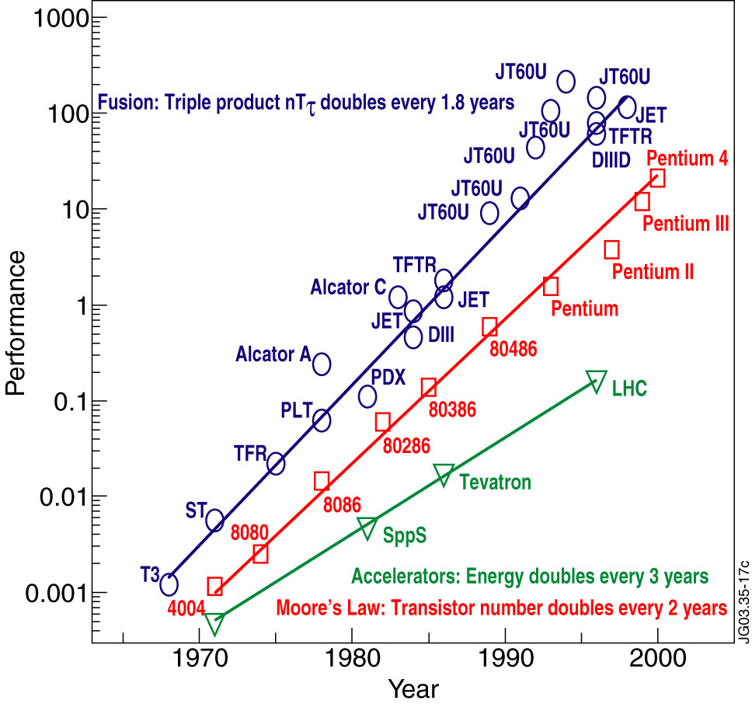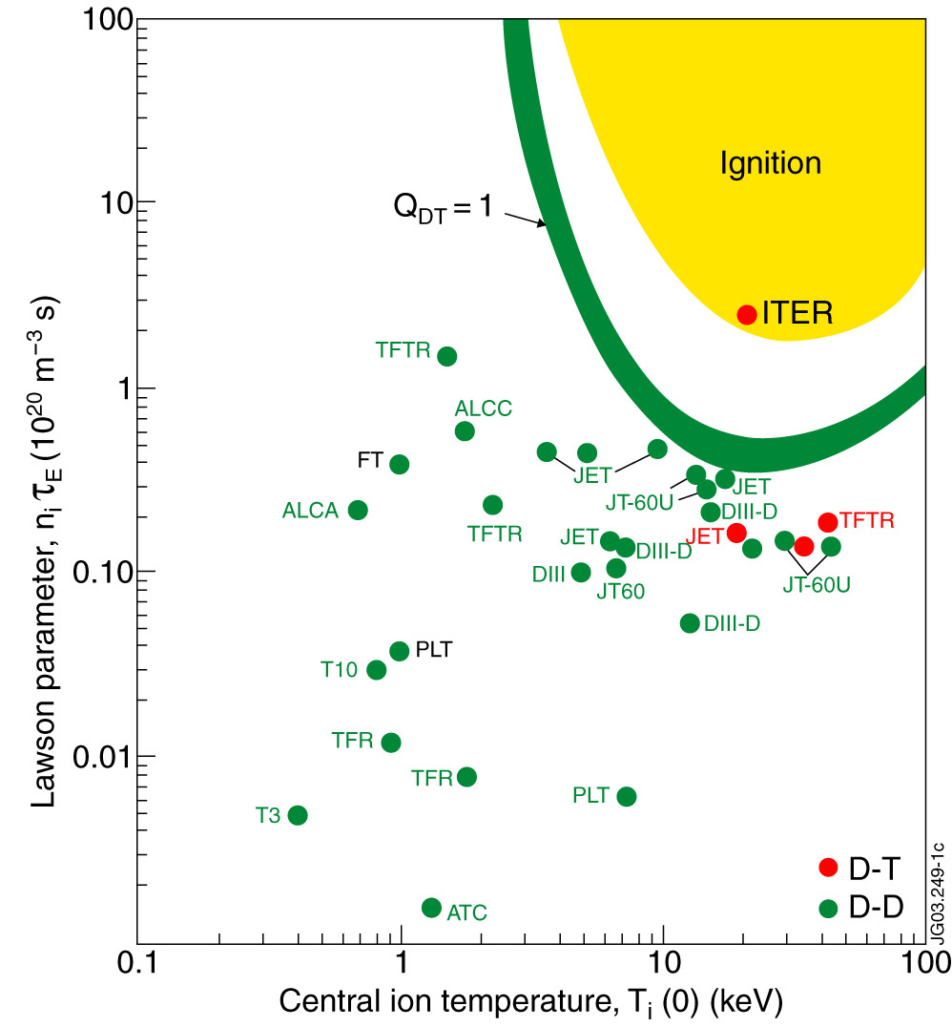
T
n τ_{E}
Figure 2 Figure 3

A fusion reactor burning just 1 kg of fuel per day could produce a sustained power output of 1 GW Ten grams of Deuterium which can be extracted from 500 liters and fifteen grams of Tritium, produced from 30 grams of Lithium would produce enough fuel for the lifetime electricity needs of an average person in an industrialized country. Fusion’s primary attraction is that the energy yield per mass of fusion is much higher than that of fission or any other energy sources; it is very environmentally friendly. Fusion has the potential to provide a virtually inexhaustible source of energy. It is inherently safe, and would produce no “greenhouse gasses.” Fusion condition must be maintained, thus, equipment failure quickly leads to plasma extinguishment. While fusion reaction involves a radioactive reactant, Tritium, the half life of Tritium is only twelve years. Furthermore, the D-D or D-³He reaction may eventually replace the D-T reaction to eliminate the radioactive Tritium. Furthermore, Deuterium is virtually inexhaustible, whereas Tritium does not occur naturally and requires breeding process from Lithium. According to EFDA (European Fusion Development Agreement), Lithium is plentiful in the earth’s crust. If the entire world’s electricity were to be provided by fusion, known reserves would last for at least 1000 years. Therefore, fusion is inexhaustible and its improving performance will eventually makes possible the self-sustained reactions.
The economics of fusion technology is questionable. Cost competitiveness and removal of capacity constraint factors are desired for use of nuclear fusion energy in a large scale. Non-fossil electricity generating technologies introduced at a high rate. Reliance on conventional coal is reduced gradually and electricity generation is switched to nuclear fission, hydrogen and geothermal power, photo voltaic, and nuclear fusion. Nuclear fission is introduced up to its maximum capacity limitation. It is revealed that under the 550 ppm constraint within the maximum construction speed, 66 mill/kWh is required for introducing nuclear fusion 2050. Nuclear fusion reactor and its power plant construction industries are assumed introduced according to the increase in demand for electricity after 2050 with maximum construction speed. The total world increase in nuclear fusion electricity capacity is set at about 100 GW year⁻¹. The estimation includes tritium breeding, which requires lithium treatment. Therefore, with D-D and D-³He reactions implemented, cost can be further reduced. Fusion has great potential to be economically competitive with coal when external costs are included. Therefore, fusion power is not only required, but a sound choice in price and environment impact.
The rise of electricity demand is inevitable. To prolong the wellbeing of human kind, this demand must be met while keeping the earth habitable. Therefore, coal and fossil fuel will be abolished, and renewable energy sources will be utilized to the maximum potential. Fission is attractive, but controversial; its fuel sources are limited, thus prevent fission to be a permanent electricity supply. Fusion must happen because of the shortcoming of the rest of the technologies. It is environmental friendly, economically feasible, and inexhaustible. The understanding of its physics and engineering will soon reach the level that enables great electricity generation efficiency. Therefore, nuclear fusion is very plausible and necessary in response to the future electricity trend.

International Energy Outlook 2004 <http:/www.eia.doe.gov/oiaf/leo/electricity.html>
International Energy Outlook 2004
International Energy Outlook 2004
International Energy Outlook 2004
“Energy Scenario,” ITER.org, September 2004. <thhp://www.iter.org/fr3.htm>.
Boyle, G, ”Renewable Energy and Electricity,” World Nuclear Association, February 2005. <http://www.world-nuclear.org/info/printable_information_papers/inf10print.htm>.
“Safety of nuclear power reactor,” World Nuclear Association. November 2003 <http://www.world-nuclear.org/info/inf06.htm> .
“Safety of nuclear power reactor.” November 2003.
“Economics of nuclear power,” World Nuclear Association. April 2005 < http://www.world-nuclear.org/info/inf02.htm>.
“Economics of nuclear power,” April 2005.
“Uranium markets,” World Nuclear Associate, October 2004, <http://www.world-nuclear.org/info/inf22.htm>.
Gia Tuong Hoang and Jean Jacquinot, “Controlled fusion: the next step,” Physics World, January 2004. <http://physicsweb.org/articles/world/17/1/6/1>
J.-M, Noterdaeme, “ Controlled Nuclear Fusion, a Challenging task with a Big Payoff,” EFDA JET, June 2003. <http://www.jet.efda.org/documents/presentations/noterdaeme.ppt>.
R K. Janev, “Atomic and molecular physics issues in current thermonuclear fusion research,” Compemporary Physics, Vol. 46, No. 2 (121-140),13 July 2004.
R K. Janev, “Atomic and molecular physics issues in current thermonuclear fusion research.”
S. L. Milora. “Summary: Technology and Power Plants,” Oak Ridge National Laboratory.
Gia Tuong Hoang and Jean Jacquinot, “Controlled fusion: the next step.”
“Fusion Basic,” JET, <http://www.jet.efda.org/pages/content/fusion1.html>.
Tokimatsu, Fujino, Asaoka, Ogawa, Okano, Yoshida, “Studies of Nuclear Energy Potential Based on a Long-term World Energy and Environment Model,”
K. Tokimatsu, “Studies of breakeven prices and electricity supply potentials of nuclear fusion by a long-term world energy and environment model,” Institute of Physics Publishing and International Atomic Energy Agency, Nucl. Fusion 42 (1289 – 1298), 2002.

